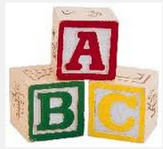
Designing Boxes:

A toy company is planning to sell a set of children’s alphabet blocks. Each block is a cube with 1-inch edges. Each block has the volume of 1 cubic inch.

2. Find all of the ways 23 blocks can be arranged into a rectangular prism. Fill out the table. Be sure to include units.

Box: | Length: | Width: | Height: | Volume: | Surface Area:
A
B
C
D
E
F
G

3. What is the smallest possible surface area using 23 blocks? How does the smallest surface area for 23 blocks compare to the smallest surface area for 24 blocks?

