INVESTIGATING A MAGNETIC FIELD

Materials: A bar magnet, a sheet of paper, a pencil, a pen or colored pencil, a small compass, a 1.5 V battery holder with wires, a battery for the holder, a length of insulated wire, a nail

Group roles: (record names)
Reader/recorder (reads instructions and writes answers to questions): _________________________
Compass mover (places and traces magnet, places and moves compass): _________________________
Winder (winds wire on nail, connects and holds battery): _________________________
Marker (marks positions of compass needle and draws field lines in group of 4): _________________________

The region of space around a magnet where its presence is felt is called a magnetic field.

Due to two poles of a bar magnet, a compass placed anywhere near a magnet will position itself so that its N is towards the S of magnet. If you move a compass on the sheet of paper to various locations, you will observe that the compass needle changes its direction accordingly. In this activity, you are required to trace the path of the north of the compass needle as you move the compass to various locations near the magnet. This is often called plotting the magnetic field lines. Magnetic field lines indicate the direction along which the compass needle will align itself.
1. Place the bar magnet in the center of a sheet of paper with its length parallel to the length of the sheet. Trace a rectangle around the magnet. Lift the magnet and label the rectangle with and “N” and “S” to match the poles of the magnet. Replace the magnet in the rectangle.

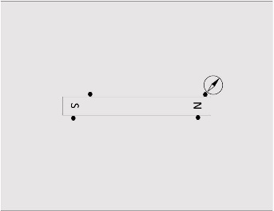
2. Mark some dots near the magnet. Place a compass at one of these dots. Its north end will point in the direction of the magnetic field at that spot. One end, the tip, of the compass needle is on a dot. Mark the position of the other end, the tail, on the paper with a sharp pencil. Move the compass so that the tip sits on the previous tail mark. Mark the tail point again. Continue to do so till the compass reaches the edge of the paper or gets back to the magnet.

3. Join the marks that you made with a smooth curve (connect the dots). The resulting curved line is called a magnetic field line and indicates the direction of the field at each point (the direction in which the north of the compass points). The direction of the field line is always from the magnet’s N pole to its S pole, so insert some arrows on the line to indicate this direction.

4. Repeat steps 2 and 3 for the other dots near the magnet to produce multiple field lines.

5. Notice that the lines spread out at the two poles and almost run parallel to the length of the magnet straight across from the magnet. The direction of the magnetic field at any point is the direction in which the N-end of the compass points when placed at that point.

6. The magnetic field is strongest where the lines are most crowded and weakest where they are farthest apart. Where do you think the field is strongest?

7. Do any of the magnetic field lines cross each other?

8. Keep your field map (piece of paper), but place your bar magnet far from your experiment area.

9. Electromagnets are used extensively as they can be produced easily and their strength is controlled by the amount of current used to produce them. They are used in electric doorbells and in electric motors as well as for lab experiments. A soft iron nail can easily be converted into a temporary magnet.

10. Now build an electromagnet. Strip the insulation from 1 centimeter of each end of a 1-meter long coated copper wire. Wind the wire around a nail and connect the bare ends of the wire to a 1.5 V battery.

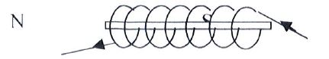

11. As the current passes through the wire, the two ends of the nail will become the N and S poles. The nail will behave just like a magnet as long as the current flows. Place your electromagnet in the rectangle that you drew around the bar magnet before. Use the compass to explore the magnetic field.

12. The nail has a head and a point. Which end is the north pole of the electromagnet?

13. Do the poles of the electromagnet match the poles that are marked on the paper?

14. What will happen to the poles of the electromagnet if you remove the ends of the wire from the battery and attach them to the opposite ends of the battery? Make a prediction. They try it and see.
Prediction:

Observed result:

15. Use a pen or colored pencil to draw magnetic field lines for the electromagnet. Which has a stronger magnetic field, the bar magnet or the electromagnet?

Adapted from Physics 150 Activities Manual, Dept. of Chemistry and Physics, University of Tennessee at Martin, 2016

