**Shoebox Spectroscope Worksheet w/ Partial Answers**

**Materials**: Shoebox (5 or more inches wide and 10 or more inches long), masking tape, 1.5”x1.5” diffraction grating, 3”x5” white index card, scissors, centimeter ruler, pen, calculator

**Group roles**: (record names)

Calculator/recorder (make table entries and calculations): _________________________

Measurer (measures the box and marks the index card): _________________________

Builder 1 (cut, fold and tape box): _________________________

Builder 2 (cut, fold and tape box in group of 4): _________________________

All group members will make observations and discuss what they see.

**Introduction**

Raindrops can be thought of as nature's spectroscope, forming a rainbow.

Light can tell us what combination of atoms and molecules are inside the light source. Each atom produces a unique pattern called a spectrum. One way to think of it is like an atom or molecule’s fingerprint. You will build a diffraction grating spectroscope and use it to identify a variety of gasses.

1) This construction uses scissors, so please be safe with yourself and your neighbor.

2) The plastic grating will not work very well, or at all, if it gets a finger print on it. Always hold the diffraction grating by one of the edges.

**Construction:**

Start by cutting a hole approximately one inch square on the left hand edge of one end of the shoebox. Call this end of the box end **A**. You might want to write the letter “A” on this end to help you remember. The hole should be about an inch down from the top of the box, as shown in Figure 1. On the other end of the box, called end **B**, cut another hole approximately one inch square directly opposite the first one. You might want to write the letter “B” on this end to help you remember. Again, see Figure1.

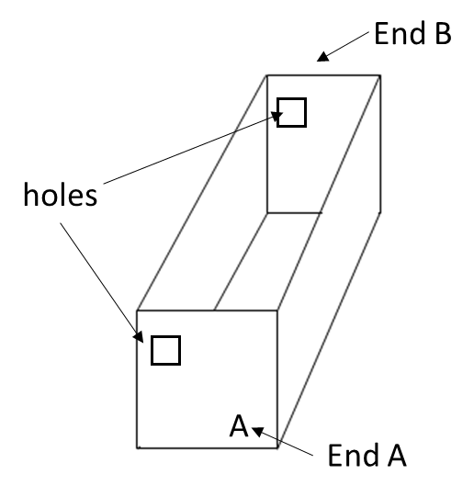

**Figure 1**

**Shoebox with End Holes**

Cover the hole in end **A** with the diffraction grating (DON’T TOUCH THE PLASTIC!). The spectroscope will only work if the lines in the plastic are vertical. If you have the plastic grating that is in a cardboard holder you can just make sure the writing is at the top. Use masking tape to attach the edges of the plastic grating to the outside of the box as shown in Figure 2. This is the opening into which you will look.

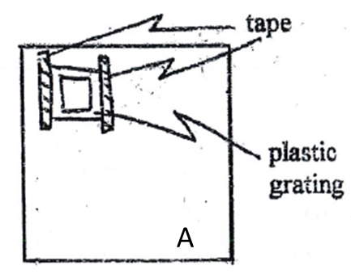

**Figure 2**

**Outside of End A**

Use a piece of masking tape to cover about half of the hole in end **B**. Apply the masking tape vertically to the outside of the box as shown in Figure 3. This is the opening through which light will enter the spectroscope.

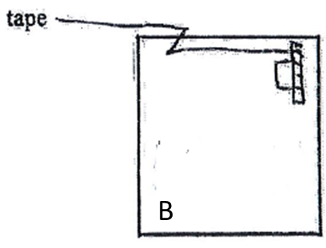

**Figure 3**

**Outside of End B**

Calibrate the index card to measure wavelength of observed light as follows:

**A)** Use a centimeter ruler to measure the distance between the two holes cut in the box. Call this distance L and record its value.

L=_____________________centimeters

**B)** Calculate the values of a, b, c, and d in centimeters from the equations in Table 1 below.

These values are the distances from the left edge of the index card to the positions at which the

corresponding colors will appear on the card.

**Table 1**

|  |  |  |  |
| --- | --- | --- | --- |
| **Color** | **Wavelength**  **(nanometers)** | **Equation** | **Values**  **(centimeters)** |
| Violet | 400 | a=0.200L | 6.0 |
| Blue-Green | 500 | b=0.250L | 7.5 |
| Yellow | 600 | c=0.300L | 9.0 |
| Red | 700 | d=0.350L | 10.5 |

* 1. Place vertical lines at the distances a, b, c, and d from the of the index card and identify the lines with the appropriate wavelengths as shown in Figure 4.



**Figure 4**

**Calibration Lines on Index Card**

Next, place the index card on the inside of End B so that only a small slit remains between it and the tape. See Figure 5. The spectroscope is now finished. Put the lid on the box and view the various light sources described below. If the image is not bright enough move the index card to increase the slit slightly. If you cannot read the wavelength values printed on the index card, open the top of the box slightly to allow some reading light to enter.

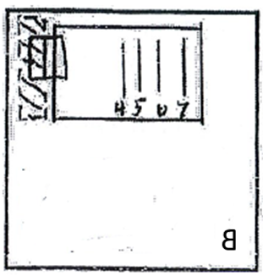

**Figure 5**

**Inside of End B**

**Procedure**

1. Look at various common light sources through the spectroscope. Examine the sun, a street lamp, a 100 watt light bulb, a fluorescent lamp, and any other available sources. Describe what you see.
2. What color is the most intense . . .for the sun? . . .for the 100 watt light bulb? . . .for the fluorescent light?
3. Which artificial source looks most like the sun?
4. Examine each of the gases present to identify them. Do this by recording in Table 2 below both the color and wavelength of the brightest colors produced by each gas (see the example below). Compare the wavelengths recorded with the reference chart on the wall.

**Table 2**

|  |  |  |  |  |  |
| --- | --- | --- | --- | --- | --- |
| Gas | Example | 1 | 2 | 3 | 4 |
|  |  |  |  |  |  |
|  |  |  |  |  |  |
|  |  |  |  |  |  |
|  |  |  |  |  |  |
|  |  |  |  |  |  |
|  |  |  |  |  |  |
|  |  |  |  |  |  |
|  |  |  |  |  |  |
|  |  |  |  |  |  |

1. Imagine that you wanted to collect the light spectrum with a detector, for example a camera, so that you could store it quickly and analyze it on a computer. This would turn your spectroscope into a spectrograph. Use the pictures of the shoebox below to describe how you would change the design to include a camera. You do not have to draw a camera. Instead you could just a small square or rectangle and label it “camera” on the drawing.

Camera 

