TEAM Lesson Plan Template
Teacher: Dr, Amanda Niedzialomski
Subject/Grade: Mathematics (Fractions) / 5th Grade
Lesson Title: Adding and Subtracting Paper Fraction Bars
STANDARDS | Identify what you intend to teach. State, Common Core, ACT College Readiness Standards and/or State Competencies; Enduring Understandings and Essential Questions.
MP2. Reason abstractly and quantitatively
MP3. Construct viable arguments and critique the reasoning of others
MP5. Use appropriate tools strategically
MP6. Attend to precision
MP7. Look for and make use of structure

5.NF.A.1 Add and subtract fractions with unlike denominators (including mixed numbers) by replacing given fractions with equivalent fractions in such a way as to produce an equivalent sum or difference of fractions with like denominators. For example, 2/3 + 5/4 = 8/12 + 15/12 = 23/12 or 3/5 + 7/10 = 6/10 + 7/10 = 13/10.

5.NF.A.2 Solve contextual problems involving addition and subtraction of fractions referring to the same whole, including cases of unlike denominators. Use benchmark fractions and number sense of fractions to estimate mentally and assess the reasonableness of answers. For example, recognize an incorrect result 2/5 + 1/2 = 3/7, by observing that 3/7 < 1/2.

OBJECTIVE(s)/Sub-Objectives | Connect prior learning to new learning. Clear, Specific, Observable, Demanding, High Quality, Measurable, Aligned to Standard(s), and Integrated with other subjects, build on prior student knowledge  Student-Friendly (I Can Statement)
I can find equivalent fractions.

I can find a common denominator for two fractions.

I can add two fractions with different denominators.

I can subtract two fractions with different denominators.

MATERIALS AND RESOURCES | Content-related: Clearly supports lesson objective(s); rigorous & relevant; Incorporates multimedia & resources beyond the textbook.
Materials
Fraction bar rulers (laminated)
Printed fraction bars/strips
Scissors
Highlighters
Fraction Addition and Subtraction Worksheets
What if the technology is not working? This is a low-tech activity.
Routine for distributing materials: Materials are placed at the tables where groups will be working. Paper fraction strips can be cut into the 18 cm strips ahead of time, or students can complete this task as part of the lesson.
ACCOMMODATIONS/ADAPTATIONS | Learning styles and interests. Anticipate learning difficulties, regularly incorporate student interests & cultural heritage; differentiate instructional methods.
Modifications/Plans for Diverse Learners
Differentiation
__x__ Content: Some students may benefit from limiting the lesson to fraction addition only.
__x__ Process: Some students may benefit from a review of fraction addition and subtraction with common denominators. Some students may benefit from the use of blocks to aid in simplifying fractions.
Accommodations
___ Preferential Seating ___ Extended Time ___ Small Group ___ Peer Tutoring
___ Modified Assignments ___ Other
Early Finishers: Early can explore sums and differences that are not represented by the fraction bar rulers. For example, ⅓ + ⅕. Students may also extend this activity to addition and subtraction of mixed fractions.

MOTIVATING STUDENTS/ANTICIPATORY SET | “Hook”: Engage students’ attention and focus on learning. Personally meaningful and relevant.
Show students the collage artwork of Madeline Rector.
Show this short video:
https://www.instagram.com/reel/CXW8XGUF9j8/?hl=en
Then look at more of her artwork at her instagram page:
https://www.instagram.com/madelinerector/?hl=en

Madeline makes artwork out small pieces of paper, and today we are going to learn math using small pieces of paper!

INSTRUCTIONAL PROCEDURES | Step-by-Step Procedures-Lesson Sequence: Basic to Complex. Lesson includes visuals, modeling, logical sequencing and segmenting (beginning, middle, ending); essential information; concise communication; grouping strategies; differentiated instructional strategies to provide intervention & extension; seamless routines; varied instructional strategies; key concepts & ideas highlighted regularly.
Introduction See hook.
Main Activity Teacher models ⅓ + ¼ using the fraction paper strips and the fraction bar rulers. Cut out a ⅓ rectangle and a ¼ rectangle. Begin by comparing each rectangle to the fraction bar rulers. Can we find any equivalent fractions? We can observe that ⅓ is equivalent to 2/6 and 4/12; and ¼ is equivalent to 2/8 and 3/12. Record these findings on the worksheet. Observations from the rulers go in the gray boxes:
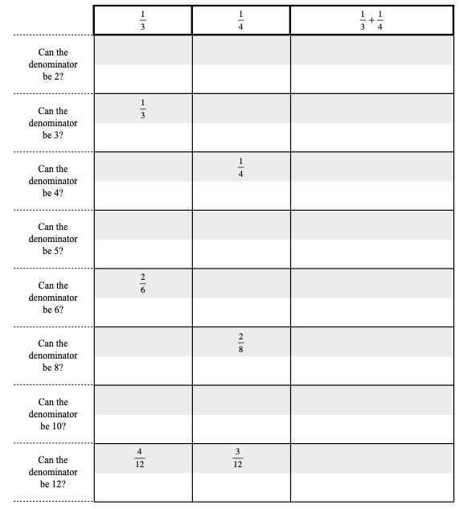
Underneath each of these gray boxes is a white box, where we explain the gray box above it with an equation. For example, we observed using the rulers that ⅓ is equivalent to 2/6. We have learned that this is true because we can multiply the numerator and the denominator by the same number, and still have an equivalent fraction. So we write the equation $\frac{1×2}{3×2}=\frac{2}{6}$ in the white box underneath 2/6. We do this for all equivalent fractions we found:
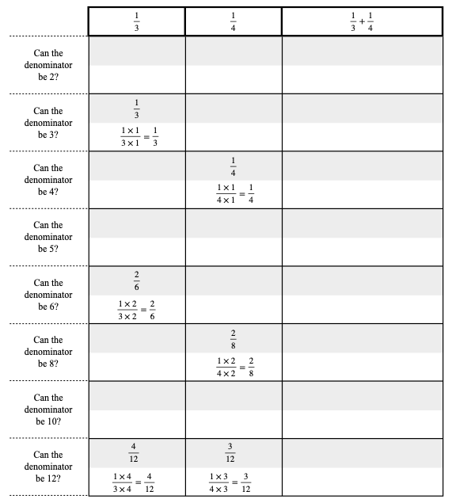
Highlight the row(s) where both fractions are represented. These are fractions equivalent to the original fractions, but they have a common denominator. Because of this we can add them. Write the equation of the sum in the appropriate white box. Confirm the result by measuring the two papers stacked next to each other on the fraction rulers.
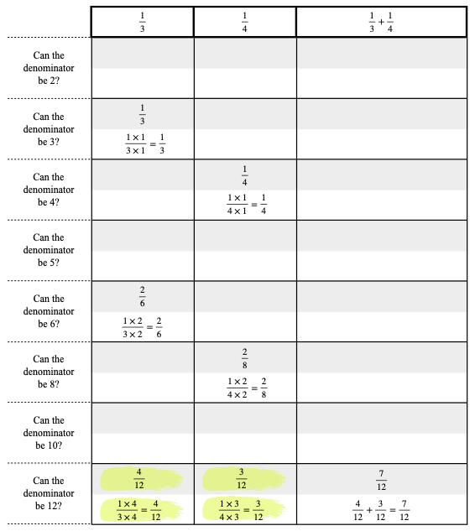
Check that the sum of the paper pieces is not equivalent to any other fractions using the rulers. (Even though 12 was the only common denominator in this example, the simplified final answer might not have a denominator of 12.) The simplified answer will have the smallest denominator out of all equivalent options. Circle the final answer:
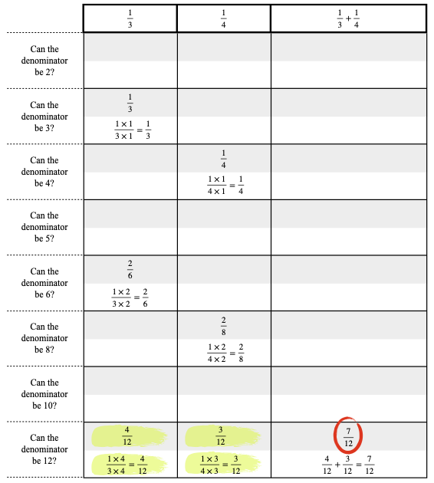
Repeat this process with the subtraction example ⅚ - ½. (Note: It is easier to work with ⅚ cut as a single rectangle, rather than 5 separate pieces of paper that each represent ⅙.)
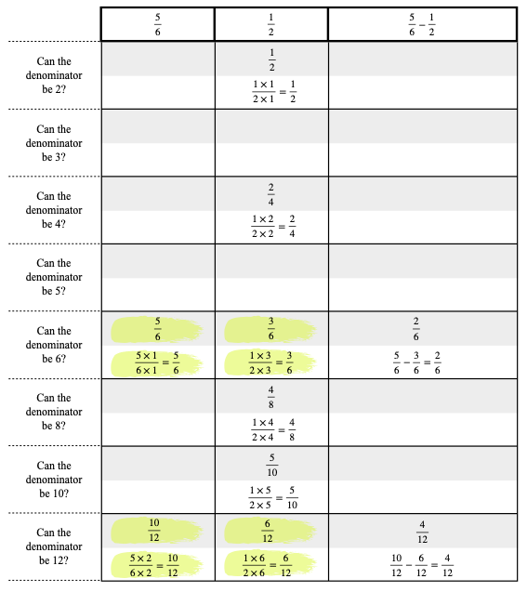
Point out that this time, we have more than one common denominator option. The simplified answer will be the one with the smallest denominator, but first we must check that the difference is not equivalent to any other fractions in the table. Take the ⅚ rectangle and place the ½ rectangle on top of it, with one end aligned. Cut the ⅚ rectangle along the edge of the ½ rectangle (on the side they are not aligned). The ⅚ rectangle is now in two pieces: one of size ½, and the other of size ⅚-½. Measure the rectangle of size ⅚-½ against the fraction rulers. You will find that it is equivalent to 4/12 and 2/6, as we predicted, but it is also equivalent to ⅓. ⅓ is the simplified answer. Circle this answer on the worksheet, and write the equation that explains it in the white box below it:
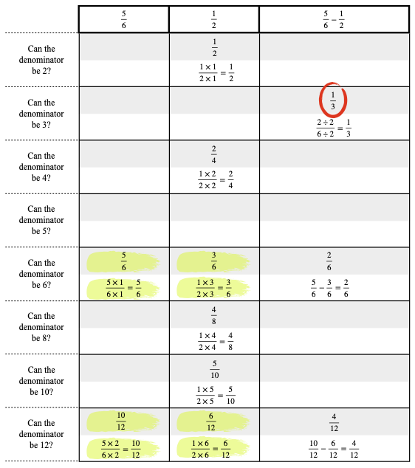
Now the students work similar examples on their own worksheets, sharing materials and discussing results within their groups.
Motivating Students
_x_ Verbal Reinforcement: The teacher will monitor students’ work throughout the activity to provide reinforcement.
Presenting Instructional Content
_x_ Lecture/Notes: Students take notes as the teacher models the examples at the beginning of the lesson.
_x_ Hands-On: Students use the paper fraction strips and fraction bar rulers as physical models of equivalent fractions and finding common denominators.
_x_ Work Examples: Students work through several addition and subtraction examples.
Instructional strategies:
Modeling and Guided Practice - The teacher will model the process of using the paper strips and completing the worksheets for addition and subtraction exmaples. The teacher will also show how to use the fraction bar rulers. The teacher will monitor students’ work and ask questions to prompt them if they are stuck.
Check for Understanding (CFU) –
What am I doing for students that progress at different rates?
Encourage students to help each other. If students finish early, have students think about fractions without the fraction bar rulers.
What do I do if they get it?
Move onto adding and subtracting mixed fractions.
What do I do if they don’t get it?
Review addition and subtraction of fractions with common denominators. Review reducing fractions. Limit the activity to addition only.
QUESTIONING/THINKING/PROBLEM SOLVING (embedded throughout) | Balanced mix of question types. Utilizes Blooms Taxonomy/Webb’s Depth of Knowledge; high frequency; purposeful & coherent; require active responses; balance based on volunteers/non-volunteers, ability, & gender; lead to further inquiry & self-directed learning. Implement four types of thinking (Analytical, Practical, Creative, & Research-based) & Teach/Reinforce problem-solving types. Provide opportunities for students to generate ideas & alternatives; analyze, evaluate & explain information from multiple perspectives & viewpoints.
Questioning
Knowledge:
What is the denominator of this fraction?
When are two fractions equivalent?

Comprehension:
Is ⅔ equivalent to 4/6?

Application:
What are some fractions that are equivalent to ¼?
Find equivalent fractions with a common denominator for ¼ and ⅓.

Analysis:
What is the sum ¼+⅓?
What is the difference ⅔-¼?

Synthesis:
What is a process that we can use to find a common denominator?
How can you tell if a fraction is simplified?

Evaluation:

Thinking
_x_ Analytical – Students compare rectangles to find equivalent fractions. Students analyze equivalent fractions in order to find common denominator pairs, then use these pairs to add or subtract.
_x_ Research-based – Students add and subtract fractions by measuring paper strips using fraction bar rulers.

Problem Solving
__x__ Drawing conclusions/Justifying Solutions: Students draw conclusions based on their observations using the fraction rulers, then further justify those observations numerically.
__x__ Observing and Experimenting: Students experiment with fraction bar rulers to find sums and differences.

GROUPING | Maximize student understanding & learning Varied group composition (race, gender, ability, & age); clearly understood roles, responsibilities & group work expectations; accountability for group & individual work; student opportunities for goal setting, reflection & evaluation of learning.
- Heterogeneous groups of 2-4.
- Product. Students complete the fraction addition and subtraction worksheets.

ASSESSMENT | Formative and/or summative assessment. A variety of assessments, including rubrics, measure achievement of objectives and informs instruction.
Assessments:
__x__ Teacher Made Test: The activity worksheets can be used for assessment. In a future test, students will be asked to add and subtract fractions with different denominators.

*Students should achieve _____% mastery of this objective: ________________________________

CLOSURE | Reflection/Wrap Up. Summarizing, reminding, reflecting, restarting, connecting.
During the conclusion part of creating an effective lesson plan teachers must sum up the ideas learned from the lesson. A teacher should also relate this information to future and past coursework to provide students with a broad understanding of the ideas learned. It is important to allow students enough time to ask questions, assert assumptions, and summarize the lesson during this part of the lesson plan.
- Review/Summary: wrap up what has been learned and accomplished in the lesson (even if they are in the middle of an exercise, it is still important to summarize to the point where they are now). Ideally involve students in this synthesis.
- Preview for next lesson: link what they did to day with where they are going next.
- Upcoming assignments: remind them of any upcoming assignments.
Today we…. Turn to your partner and…. Let’s review our I Can statements……
Here is your exit ticket for today…..
Follow-up Activities/Extension These may be designed to create a longer or more intense lesson. For example, if the class is able to cover the material in a lesson much faster than expected, extensions may prove helpful. Extensions may also be useful in various parts of a lesson where the teacher (and class) decides they should spend more time on a skill or topic.

Reflection: You must reflect on every lesson you teach.

NOTES:
This work is licensed under the Creative Commons Attribution-ShareAlike 4.0 International License. To view a copy of this license, visit http://creativecommons.org/licenses/by-sa/4.0/ or send a letter to Creative Commons, PO Box 1866, Mountain View, CA 94042, USA.

