TEAM Lesson Plan Template
Teacher: Dr. Amanda Niedzialomski
Subject/Grade: Mathematics (Fractions)/3-4
Lesson Title: Building Equivalent Fractions
STANDARDS | Identify what you intend to teach. State, Common Core, ACT College Readiness Standards and/or State Competencies; Enduring Understandings and Essential Questions.
MP1. Make sense of problems and persevere in solving them
MP2. Reason abstractly and quantitatively
MP3. Construct viable arguments and critique the reasoning of others

[Parts of this activity are appropriate for each of the following standards. Emphasize those parts and omit other parts as necessary to adapt the activity for a particular group of students.]

3.NF.A.3 Explain equivalence of fractions and compare fractions by reasoning about their size. b. Recognize and generate simple equivalent fractions (e.g., 1/2 = 2/4, 4/6 = 2/3) and explain why the fractions are equivalent using a visual fraction model

4.NF.A.1 Explain why a fraction a/b is equivalent to a fraction (a x n)/(b x n) or (a ÷ n)/(b ÷ n) using visual fraction models, with attention to how the number and size of the parts differ even though the two fractions themselves are the same size. Use this principle to recognize and generate equivalent fractions. For example, 3/4 = (3 x 2)/(4 x 2) = 6/8.

Optional extension activity would include:
4.NF.A.2 Compare two fractions with different numerators and different denominators by creating common denominators or common numerators or by comparing to a benchmark such as 0 or 1/2 or 1. Recognize that comparisons are valid only when the two fractions refer to the same whole. Use the symbols >, =, or < to show the relationship and justify the conclusions.

OBJECTIVE(s)/Sub-Objectives | Connect prior learning to new learning. Clear, Specific, Observable, Demanding, High Quality, Measurable, Aligned to Standard(s), and Integrated with other subjects, build on prior student knowledge  Student-Friendly (I Can Statement)
I can find equivalent fractions.

I can reduce a fraction.

I can put three fractions in order from smallest to largest.

MATERIALS AND RESOURCES | Content-related: Clearly supports lesson objective(s); rigorous & relevant; Incorporates multimedia & resources beyond the textbook.
Materials
Bananas or pictures of bananas (two bunches, each with 4 bananas)
Snap cubes, legos, or similar manipulatives that can link together (at least 24* linked blocks per student)
*24 blocks is significant because it equals 2*2*2*3. Any number with at least 4 prime factors will work well.
Colored paper (1 sheet per student)
Building Equivalent Fractions Worksheet (see attachment)
What if the technology is not working? This is a low-tech activity.
Routine for distributing materials: For the initial whole-group discussion, the teacher uses the bananas as an example (with one student participator). For the individual student activity, place sets of 24 blocks (already linked) on student tables and have the students distribute them. Pass out the worksheets and colored sheets of paper.
ACCOMMODATIONS/ADAPTATIONS | Learning styles and interests. Anticipate learning difficulties, regularly incorporate student interests & cultural heritage; differentiate instructional methods.
Modifications/Plans for Diverse Learners
Differentiation
__x__ Process: For some students, it may be helpful to specify the size of the part they should use to reconfigure the blocks, rather than leaving it to them to discover the size of parts that are possible.

__x__ Product: For some students, it may be helpful to have the teacher inspect their blocks, rather than drawing the fraction models on the worksheet

Accommodations
___ Preferential Seating ___ Extended Time ___ Small Group ___ Peer Tutoring
___ Modified Assignments ___ Other
Early Finishers: Students who finish the given fraction early can work on other fractions:
For Activity 1, students can work on 1/4.
For Activity 2, students can work on 18/24.
For either activity, students can experiment with finding what different fractions are possible to represent with the 24 blocks.

MOTIVATING STUDENTS/ANTICIPATORY SET | “Hook”: Engage students’ attention and focus on learning. Personally meaningful and relevant.
Show the students two bunches of bananas, with each bunch having four bananas. Ask for a student volunteer, and announce that you will give this student half of the bananas. Hand them one of the bunches. Represent this example as a fraction model by drawing the two bunches of bananas and circling one of them. Write next to this model the fraction 1/2 and explain: out of 2 total bunches, 1 was selected to give to the student.

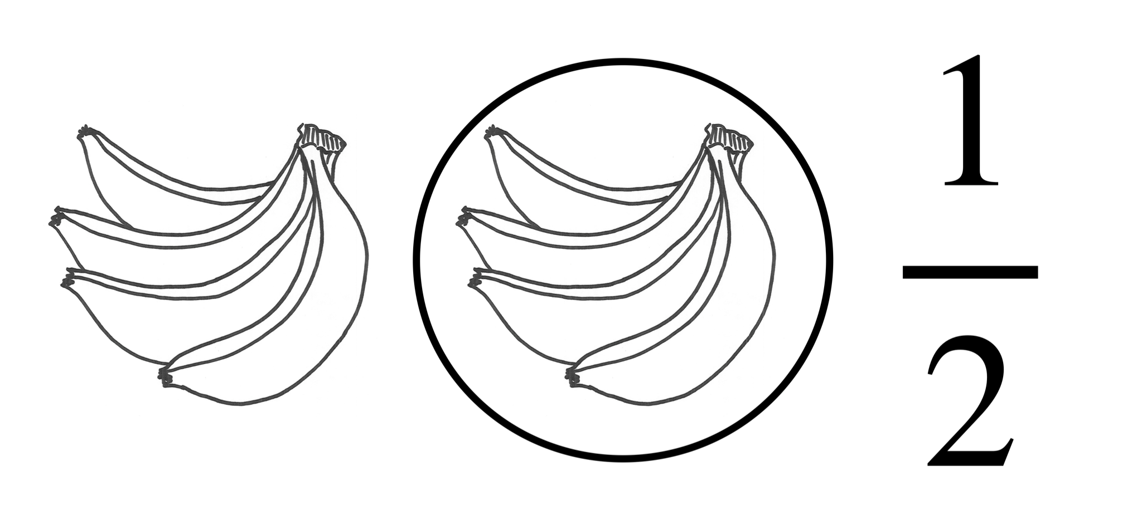

Now ask for the bananas back, momentarily. Separate each of the bunches into smaller bunches of two bananas each. Now give the student the same bananas again, this time in two bunches of two. Did you still give the student half of the bananas? How does this change the model? Show this new scenario as a model by drawing four bunches of two bananas and circling two of them. Write next to this model the fraction 2/4 and explain: out of 4 total bunches, 2 were selected to give to the student.

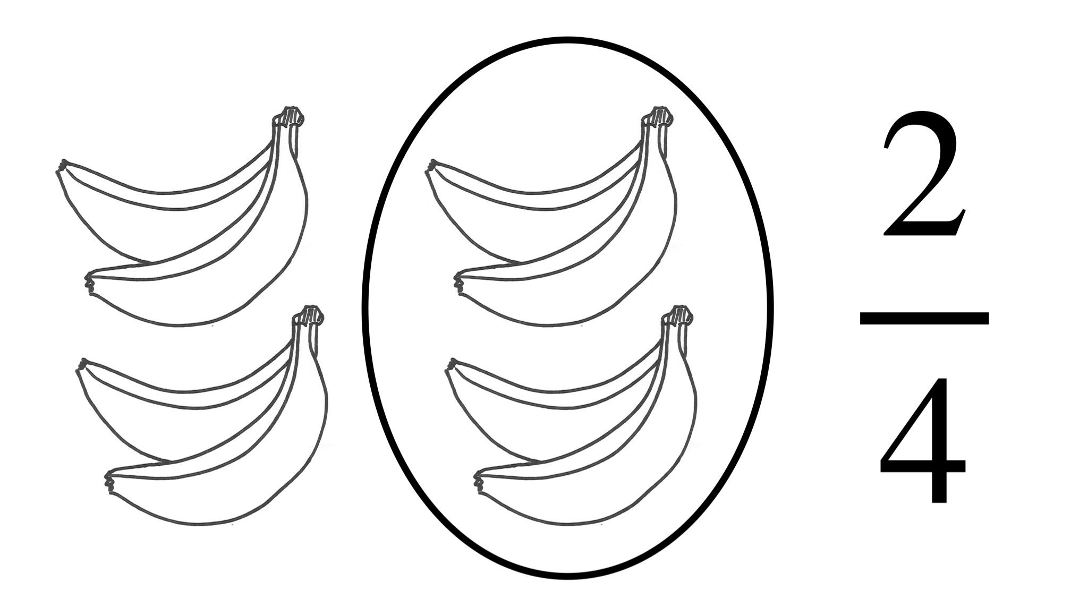

Repeat the process one more time: retrieve the bananas from the student, separate all bunches into individual bananas, return the same 4 bananas to the student, and show this scenario as a fraction model by drawing eight individual bananas and circling four of them. Write 4/8 next to this model and explain: out of 8 total bananas, 4 were selected to give to the student.
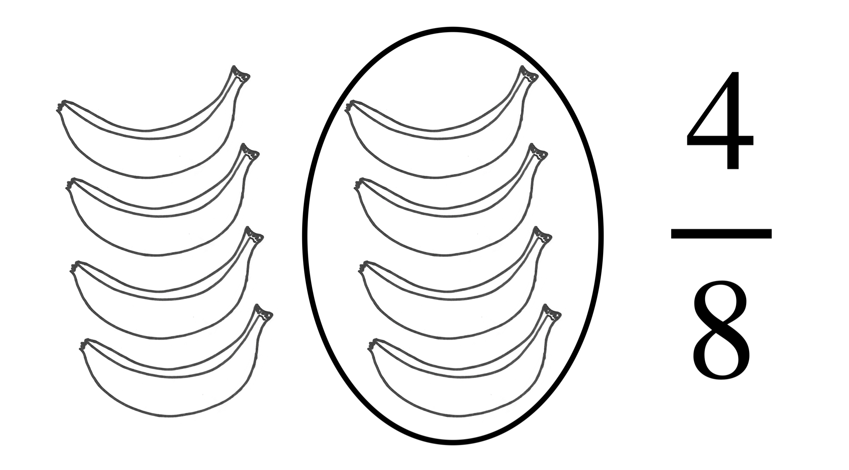

Discuss:
- The student always received the same four bananas; each time the student received half the total amount of bananas.
- The “whole” in this scenario is all the bananas, which does not change. What we are changing each time is the size of the “part.” Emphasize these terms.
- Emphasize the importance of the consistency of the size of the part in how we count the bananas each time. (All bananas are in bunches of the same size – equal shares).
- How do the numerical fractions connect to these ideas? The denominators count the number of parts that give you the whole (all the bananas). The numerators count the number of parts that represent the portion of the whole that is given to the student.
- This illustrates the equivalence of the three fractions: 1/2=2/4=4/8.

INSTRUCTIONAL PROCEDURES | Step-by-Step Procedures-Lesson Sequence: Basic to Complex. Lesson includes visuals, modeling, logical sequencing and segmenting (beginning, middle, ending); essential information; concise communication; grouping strategies; differentiated instructional strategies to provide intervention & extension; seamless routines; varied instructional strategies; key concepts & ideas highlighted regularly.
Introduction Today we will learn about equivalent fractions… using bananas! See hook description above.
Activity 1 Explain that the 24 connected blocks represent the whole in this exercise. First, students should use the blocks to represent 2/3 of this whole by separating the 24 blocks into 3 equal parts (where each part has 8 connected blocks). Two of those parts are selected (by each student) and placed on the colored paper, and this outcome is recorded on their worksheet. Students represent blocks on the colored paper by circling those blocks on the worksheet. Help students understand the meaning of part, visual model, and fraction for this first row of the worksheet.

Now ask the students to alter the size of the part in as many ways as they can find to create equivalent fractions (in a similar way to the banana example). Each new representation is recorded on the worksheet. Emphasize that while changing the size of the part, the blocks on the paper must remain on the paper, and the blocks not on the paper must stay off of the paper. Also, emphasize that all blocks must be grouped in the same size part (regardless of their location on or off the paper). A worksheet could look like the following:

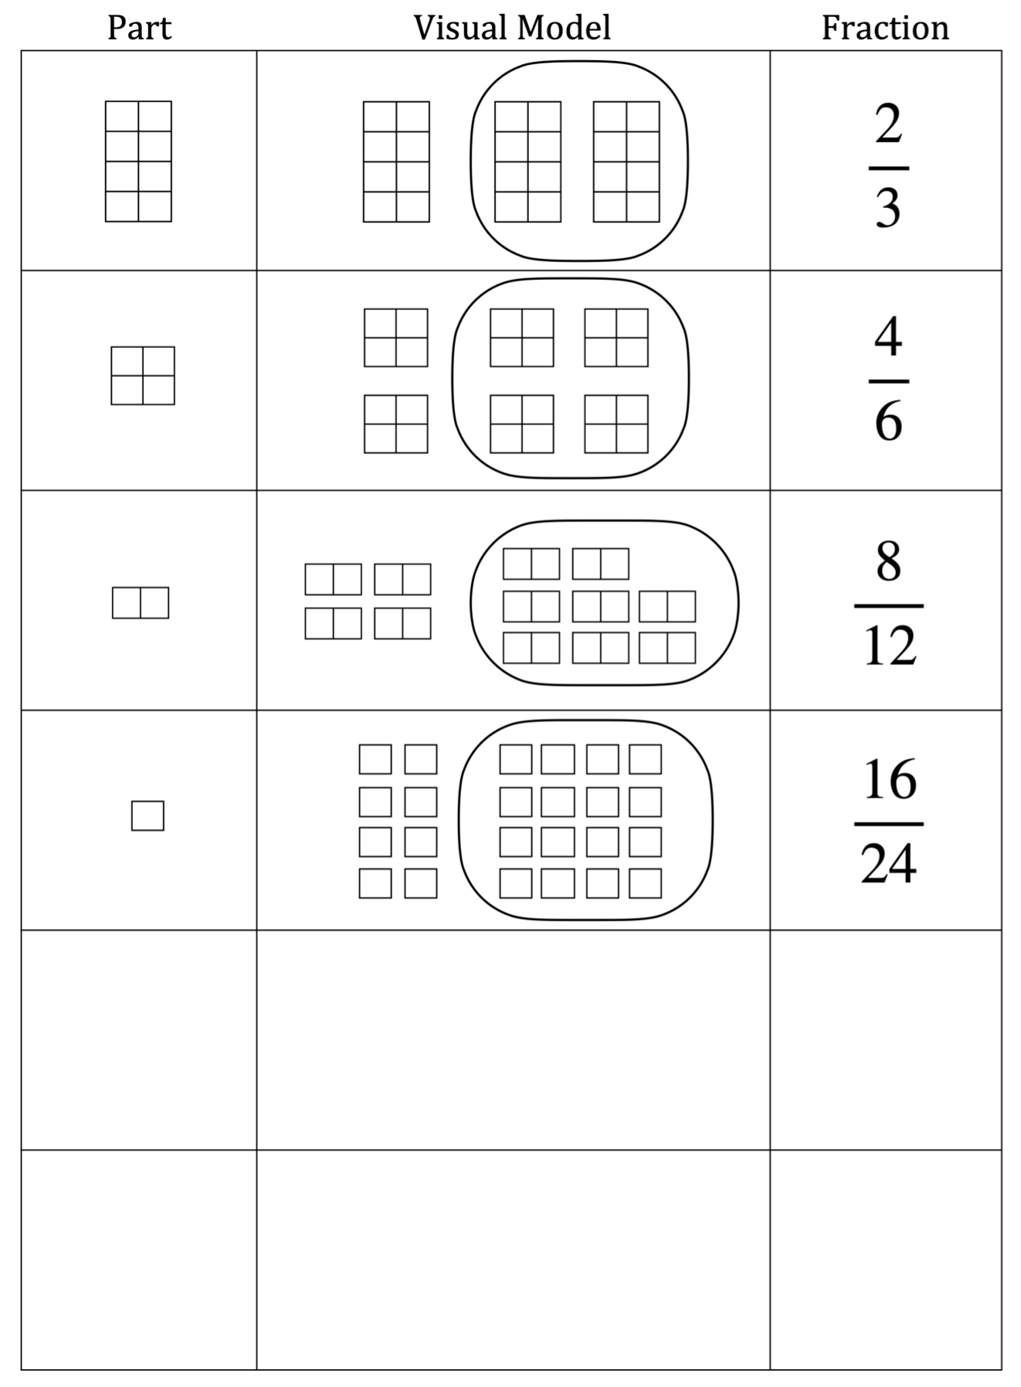
Note that it may not be possible to fill all rows of the worksheet each time.

Early finishers can reconnect all 24 blocks, get a new worksheet, and begin the process again with 1/4. (Using the 24 blocks, the following equivalent fractions can be represented: 1/4, 2/8, 3/12, and 6/24.)

Once students have finished their worksheets for 2/3, regain the whole group’s attention. Discuss/ask about the 2/3 worksheet:
- What is the whole in the first row of your worksheet? What is the whole in the second? Is the whole always the same? Yes, the whole is 24 blocks in each case.
- How many blocks were on the colored sheet of paper each time? 16 blocks.
- Did the size of the part change each time? Yes.
- What is the numerical fraction counting each time? How are the numbers connected to the blocks? Each numerical fraction records the number of parts selected (on the sheet of paper) out of the total number of parts. For example, if the part is two connected blocks, then we have 8 parts selected out of the total 12 parts, resulting in the fraction 8/12.

Now that students have completed their worksheets for 2/3, have a discussion about the equivalence of the resulting numerical fractions. Show specifically that each fraction found on the worksheet is equivalent to the original fraction 2/3:
2/3 = 4/6 2/3 = 8/12 2/3 = 16/24

4th Grade further discussion
Ask students to discuss with a neighbor if they notice a pattern with the equivalent fractions. In this case, they may notice that the numbers on the right are all even. They may notice that the numbers on the right are bigger than the left. They may notice that the numerators and denominators double each time. Anything they notice is great! Eventually, we want them to notice that the fractions on the right can be obtained by multiplying the numerator and denominator of 2/3 by the same factor:
$\frac{2×2}{3×2}=\frac{4}{6}$ $\frac{2×4}{3×4}=\frac{8}{12}$ $\frac{2×8}{2×8}=\frac{16}{24}$
Could we also multiply numerator and denominator by other factors? We can! Since we have $\frac{2×3}{3×3}=\frac{6}{9}$, 6/9 is also equivalent to 2/3. The fraction 6/9 just isn’t a fraction that we could represent with 24 blocks using our visual model. (Why is that? Because 24 is not divisible by 9, we cannot represent the whole of 24 blocks as 9 equal parts using the blocks.)

The pattern does not prove the result, but it does help us to understand what is true in general:
fraction $\frac{a}{b}$ is equivalent to fraction $\frac{a×n}{b×n}$.

Activity 2 This activity is parallel to Activity 1; it illustrates a similar but distinct concept that is important in its own right. In Activity 1, we start with a reduced fraction (and corresponding largest part size), and then rearrange the blocks into smaller parts to exhibit equivalent fractions. In Activity 2, we will start with the smallest part size (individual blocks) to represent an unreduced fraction, and then rearrange the blocks into larger parts to exhibit equivalent fractions. Finding the largest part possible connects to the task of reducing a fraction.

Task the students with separating their blocks into 24 disconnected blocks, divided into two equal groups of 12 blocks each. Students then place one group of 12 on the colored paper, and the other group remains on the table (off the paper). They then record this outcome on their worksheet. They should draw the meaning of one part, to draw the visual fraction model of 12/24 they have created, and to write the numerical fraction represented: 12/24. They represent blocks on the colored paper by circling them on the worksheet.

The task is now to alter the size of the part in as many ways as they can find to create equivalent fractions. Each new representation is recorded on the worksheet. Emphasize that while changing the size of the part, the blocks on the paper must remain on the paper, and the blocks not on the paper must stay off of the paper. Also, emphasize that all blocks must be grouped in the same size part (regardless of their location on or off the paper). A worksheet could look like the following:

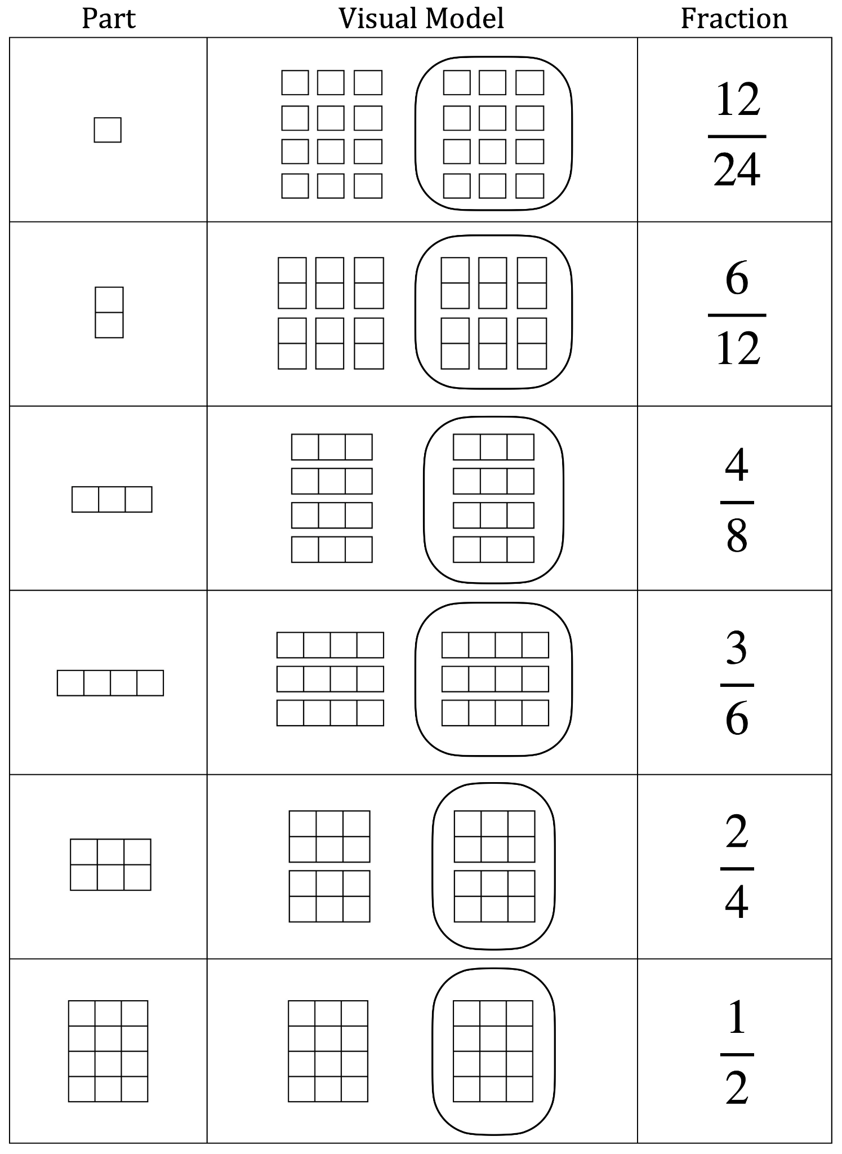

Early finishers can disconnect all 24 blocks, get a new worksheet, and begin the process again with 18/24. (Using the 24 blocks, the following equivalent fractions can be represented: 18/24, 9/12, 6/8, and 3/4.)

Now that students have completed the worksheet for 12/24, discuss the equivalence of the resulting numerical fractions. Show specifically that each fraction found on a worksheet is equivalent to the original fraction 12/24:
12/24 = 6/12 12/24 = 4/8 12/24 = 3/6 12/24 = 2/4 12/24 = 1/2

Talk to the students about reduced (or simplified) fractions. The numerical fraction with the smallest numerator and denominator (which, in our model, corresponds to the largest part size that can be made with the blocks) is the reduced fraction. All the other fractions are equivalent, but they are not reduced.

4th Grade further discussion
Ask students to discuss with a neighbor if they notice a pattern with the equivalent fractions. (If they have done Activity 1, ask them to consider what happened in that activity.) Any patterns they notice are great. Eventually, we want them to notice that the fractions on the right can be obtained by dividing the numerator and denominator of 12/24 by the same factor:
$\frac{12÷2}{24÷2}=\frac{6}{12}$ $\frac{12÷3}{24÷3}=\frac{4}{8}$ $\frac{12÷4}{24÷4}=\frac{3}{6}$ $\frac{12÷6}{24÷6}=\frac{2}{4}$ $\frac{12÷12}{24÷12}=\frac{1}{2}$

The pattern does not prove the result, but it does help us to understand what is true in general:
fraction $\frac{a}{b}$ is equivalent to fraction $\frac{a÷n}{b÷n}$.

Activity 3 (Optional extension activity using 4.NF.A.2.)
Divide the students into groups of 3 or 4, with each student in the group having 24 blocks. The fractions 3/8, 1/3, and 5/12 can all be represented using the 24 blocks in the same way as was done in Activities 1 and 2. Begin by having the students construct the visual fraction models for each of these fractions, and drawing the visual fraction model for each on a piece of paper. Each student in the group will create one fraction model, and as a group all three fractions should be done. Task the students with putting these three fractions in order from smallest to largest. Remind them that we know how to tell if a fraction is larger than another when they have either numerator or denominator in common, but these fractions have all different numerators and denominators. How can we do this?

Allow time for student group self-discovery. Students may notice that the number of blocks on the paper each time could show which fraction is larger than another. Guide the students as necessary to use the methods in Activity 1 to rearrange the blocks to find equivalent fractions of each of the original three fractions that allow them to be compared (this will require the group members to work together). There is more than one way to accomplish this, but one way would be to compare the fractions in equivalent forms with denominators all equal to 24:

3/8 = 9/24 1/3 = 8/24 5/12 = 10/24

So the list of fractions in order of smallest to largest is 8/24, 9/24, 10/24 (or 1/3, 3/8, 5/12). Review the symbol < and have the students use it to rewrite the list as an inequality:
8/24 < 9/24 < 10/24,
so 1/3 < 3/8 < 5/12.

The groups write these conclusions down on a piece of paper.

Motivating Students
_x_ Review: Review terms and basics of fractions, like the meaning of whole, part, equal shares, and that a fraction is counting the number of selected parts out of the whole.
_x_ Verbal Reinforcement: The teacher will monitor students’ work throughout the activity to provide reinforcement.
Presenting Instructional Content
_x_ Hands-On: The students can hold and reconfigure their blocks.
_x_ Discussion: Class discussions about equivalence of fractions and reducing fractions and how the blocks relate to these concepts.
_x_ Discovery Learning: Through the block visual fraction models, students discover the rationale behind equivalent fractions and create a model for factoring numbers to reduce fractions.
Instructional strategies:
Modeling and Guided Practice – The teacher will model the concept using the bananas example, and guide students through the first row of the worksheet with the blacks. The teacher will monitor students’ work and ask questions to prompt them if they are stuck.
Check for Understanding (CFU) –
What am I doing for students that progress at different rates?
Encourage students to help each other. If students finish early, have them work on other fractions. Students can experiment with finding different fractions that are possible to represent with the 24 blocks.
What do I do if they get it?
Discuss the patterns present between the numerical fractions, and the connection between the blocks and the numerical fractions. Discuss ways to numerically produce equivalent fractions, reduced fractions, and common denominators.
What do I do if they don’t get it?
Suggest sizes of parts by questioning. For example: “Using all the blocks, can you separate the blocks into piles of 9? How about piles of 8?” If they still do not get it, specify the size of the part they should use to reconfigure the blocks, rather than leaving it to students to discover the size of parts that are possible.
QUESTIONING/THINKING/PROBLEM SOLVING (embedded throughout) | Balanced mix of question types. Utilizes Blooms Taxonomy/Webb’s Depth of Knowledge; high frequency; purposeful & coherent; require active responses; balance based on volunteers/non-volunteers, ability, & gender; lead to further inquiry & self-directed learning. Implement four types of thinking (Analytical, Practical, Creative, & Research-based) & Teach/Reinforce problem-solving types. Provide opportunities for students to generate ideas & alternatives; analyze, evaluate & explain information from multiple perspectives & viewpoints.
Questioning
Knowledge:
What does whole mean?
What is a part?
What are equal shares?

Comprehension:
What is the whole in this example?
Using all the blocks, can you separate the blocks into piles of 9?
Using all the blocks, can you separate the blocks into piles of 8?, what about 7?, what about 6?
What is the size of the part here?
How many parts make up the whole?

Application:
What numerical fraction is represented by this model?

Analysis:
How many different part sizes are possible in this case?
What are the different fractions that could be represented using these 24 blocks?
Why can we not represent 6/9 using our visual model with 24 blocks?
What is the connection between the blocks and the numerical fraction?
What patterns do you notice between these equivalent fractions?

Synthesis:
Can we describe the relationship between these equivalent fractions?
How can we recreate these equivalent fractions using just numbers?

Evaluation:
How can we know which fraction is the smallest?
How can we change these fractions so that they have the same numerator or denominator?

Thinking
__x__ Creative – Students can represent the fractions in different ways (using different part sizes, and different ways to connect the blocks to create the part size. One student might stack the blocks, while another creates a square, etc.)
__x__ Analytical – Students use the definition of a fraction to go from a visual model to a numerical fraction. Students use the ideas of the models to answer numerical questions.
Problem Solving
__x__ Drawing conclusions/Justifying Solutions: Students will draw conclusions about the relationships for numerical fractions based on the block visual fraction models.
__x__ Observing and Experimenting: Students can experiment to discover what part sizes are possible with the given block configurations. They can experiment to find what fractions can be represented using the 24 blocks. Students are asked to observe patterns in the equivalent numerical fractions they have found.
__x__ Generating Ideas: Based on the block models, students are asked to generate ideas about how to produce the same equivalent fractions using numerical operations.

GROUPING | Maximize student understanding & learning Varied group composition (race, gender, ability, & age); clearly understood roles, responsibilities & group work expectations; accountability for group & individual work; student opportunities for goal setting, reflection & evaluation of learning.
In Activities 1 and 2, students do not work in groups. For Activity 3,

- Heterogeneous groups of 3 or 4.
- Each group member is assigned one of the three fractions to work on.
- Teacher will assign a fraction to each group member to ensure all fractions are covered by the group.
- Product. Students will write the fractions in order from smallest to largest.

ASSESSMENT | Formative and/or summative assessment. A variety of assessments, including rubrics, measure achievement of objectives and informs instruction.
__x__ Teacher Made Test: The activity worksheets can be used for assessment. In a future test, the activity can be reproduced using images of squares that the students circle to create the visual fraction model.
__x__Teacher Observation: The teacher will directly observe if the groups have ordered the three fractions correctly.
*Students should achieve _____% mastery of this objective: ________________________________

CLOSURE | Reflection/Wrap Up. Summarizing, reminding, reflecting, restarting, connecting.
- Review/Summary: Today we learned that there is more than one way to represent a fraction. 1/2 and 2/4 are two different ways of expressing the same quantity. Turn to your partner and name a fraction equivalent to 2/3.

Reflection: You must reflect on every lesson you teach.

NOTES:

This work is licensed under the Creative Commons Attribution-ShareAlike 4.0 International License. To view a copy of this license, visit http://creativecommons.org/licenses/by-sa/4.0/ or send a letter to Creative Commons, PO Box 1866, Mountain View, CA 94042, USA.

