Summer 2016
UTM High School STEM Workshop

Workshop Facilitator: Dr. Chris Caldwell
Subject/Grade: Factoring Quadratic Polynomials, High School
Estimated time: ½ hour

Standard(s): Tennessee Math Standards (boldface added)
High School,
A2.A.APR.A.2, M3.A.APR.A.2, B.A.APR.B.2: Identify zeros of polynomials when
suitable factorizations are available, and use the zeros to construct a rough graph of the
function defined by the polynomial. TN's Scope & Clarification: Tasks include quadratic,
cubic, and quartic polynomials and polynomials for which factors are not provided. Note
TN's A1.A.APR.B.2 is the same but perhaps limited to quadratics. Note: This is CSS.Math.Content.HSA.APR.B.3. Several state standards (GA, CT, . . . ) connect this standard to the Rational Zero Theorem, but this can often be avoided with graphical calculators, especially in the context of a multiple choice test.
2. A1.A.REI.B.3, M2.A.REI.B.2, B.A.REI.B.2: Solve quadratic equations and inequalities
in one variable.
(a) Use the method of completing the square to rewrite any quadratic equation in x
into an equation of the form (x 􀀀 p)2 = q that has the same solutions. Derive the
quadratic formula from this form.
(b) Solve quadratic equations by inspection (e.g., for x2 = 49), taking square roots,
completing the square, knowing and applying the quadratic formula, and factoring,
as appropriate to the initial form of the equation. Recognize when the quadratic
formula gives complex solutions.
3. A2.A.REI.B.3: Solve quadratic equations and inequalities in one variable.
(a) Solve quadratic equations by inspection (e.g., for x2 = 49), taking square roots,
completing the square, knowing and applying the quadratic formula, and factoring,
as appropriate to the initial form of the equation. Recognize when the quadratic
formula gives complex solutions and write them as a _ bi for real numbers a and b.
4. A1.A.SSE.B.3 Choose and produce an equivalent form of an expression to reveal and explain properties of the quantity represented by the expression.
(a) Factor a quadratic expression to reveal the zeros of the function it defines.
(b) Complete the square in a quadratic expression in the form Ax2 + Bx + C where
A = 1 to reveal the maximum or minimum value of the function it defines.
(c) Use the properties of exponents to rewrite exponential expressions.
This is simplified from CCSS.MATH.CONTENT.HSA.SSE.B.3.
5. A1.A.APR.A.1, M2.A.APR.A.1, B.A.APR.A.1, Understand that polynomials form a system analogous to the integers, namely, they are closed under the operations of addition, subtraction, and multiplication; add, subtract, and multiply polynomials.

Objective: Take turns answering and then asking a question using prompts on cards. In the multiply version of the game, a student must either multiply the polynomials in the previous student’s question to recognize the polynomial on her card, or must factor the polynomial on her card to recognize the factors when the question is read. In the factor version of the game, a student must either factor the polynomial the previous student reads to recognize the factors on his card or must multiply the polynomials on his card to recognize the polynomial when the question is read.
- I can factor a quadratic polynomial.
- I can multiply two linear polynomials to get a quadratic polynomial.

Assessment: The teacher can monitor whether the response to the each question is correct. Each answer will need to be correct (or there must be a very unlikely set of independent, reinforcing mistakes) for each student to get a chance to speak.

Motivating Students/Anticipatory SET: Draw a picture to accompany the story. Mr. Surface plans to lay tile in a rectangular room. In the plan of the room that he has, the room is to be 12 feet by 18 feet. In reality, the homeowner had the builder add five feet to each wall. Mr. Surface has to figure out how much tile he will need for the actual room.
(12 + 5)(18 + 5) = 12x18 + (12+18)x5 + 5x5 = 216 + 150 + 25 = 391
Mr. Surface realizes that other homeowners in the same housing development with the same home design is subject to changing his mind. What if the homeowner adds 3 feet to each wall? What about 7 feet? What about some other number? He would like a formula for whatever number of feet is added to the planned length of each wall. If $x$ is the number of feet, the formula would be.
(12 + x)(18 + x) = ${\left(12+x\right)\left(18+x\right)=12×18+\left(12+18\right)x+x^{2}=216+30x+x}^{2}$
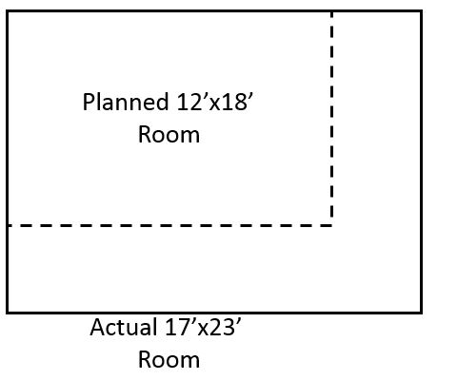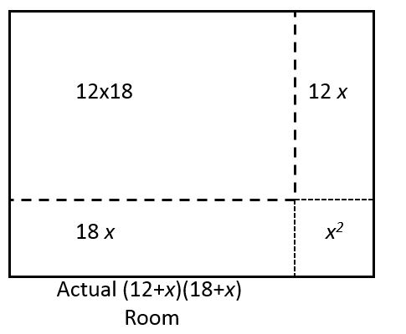

Instructional procedures:
- Students should work individually. They should sit or stand as they choose to be comfortable.
- Let students know whether pencil and paper, calculators, or both, are allowed during the game. In most cases, students should at least have pencil and paper during the game.
- Shuffle the deck of cards.
- Deal one card to the teacher, then deal the rest of the deck to the students, giving each student at least two cards. More cards per student is OK.
- The teacher should keep the answer key in hand to follow the game, unsticking the game if necessary.
- The teacher begins play by reading, “Who has __________,” filling in the blank with the polynomial or factor pair at the bottom of the teacher’s card.
- One of the students will have the answer to the question (in the alternate form) at the top of the student’s card. That student reads “I have __________,” filling in the blank with the factor pair or polynomial at the top of the student’s card. The student continues reading “Who has ______,” from the bottom of the card.
- Play continues until the answer is on the teacher’s card (meaning each card has been read) or the teacher calls “Time.”
- Collect the cards to keep until the next time the game is played.

Materials and Resources: A copy of Dr. Caldwell’s notes “I Have . . ., Who Has . . . ”
One complete (or properly shortened) deck of “I Have . . . , Who Has . . . ?” cards. An answer sheet corresponding to the deck chosen.

Questioning/Thinking/Problem Solving:
- If one of us reads the factors backwards, will it change the answer?
- What property of arithmetic tells us about the relationship between multiplication and addition allowing us to multiply two binomials?
- How would we multiply if we had three factors instead of two?
- Notice that each of the “I have . . . “ polynomials had a coefficient of 1 on the x² term. What would have happened if either of the coefficients on x in the linear factors had been a 2 or 3 or some other number?
Prepare to prompt a student who is having difficulty by providing steps for the student to multiply two linear factors:
1) Multiply the constant terms to get a constant term
2) Add the constant terms to get the coefficient on x

Also consider prompting a stuck student by reminding the student that the answer is obtainable by either factoring OR multiplying.

Grouping:
The game is played by individuals in a recitation-type whole group setting.

Accomodations/Adaptations:
If a hearing impaired student is to play the game, prepare a space on a white board to write answers. Write all of the unchanging parts in advance. For the multiply version of the game this might look like

“I have ___x² ___x _____” “Who has (x ____ )(x______) “

As each student answers and asks a question, the student should move to the board, erase what is in the blanks, then fill in the blanks with the appropriate operations and coefficients/constants. Then, facing the class, the student should read the answer and question from the card before returning to the student’s seat. Notice that for some answers the coefficient on x is zero and does not appear on the card, but would need to be written on the board for consistency.

A vision impaired student could be paired with a partner to read the student’s card. If equipment and expertise is available, the cards could be rendered in Braille.

Closure: Ask students to indicate (by raising their hands) if they tended to answer questions by multiplying. Ask students to indicate (by raising their hands) if they tended to answer questions by factoring. Which operation do they find easier? Remind students that, for the polynomials in general form, the coefficient on x is the sum of the constant terms in the factors, while the constant term is the product of the constant terms in the factors.

Teacher Reflection: To be completed after conducting the lesson.

