Designing an Airbag with the Ideal Gas Law

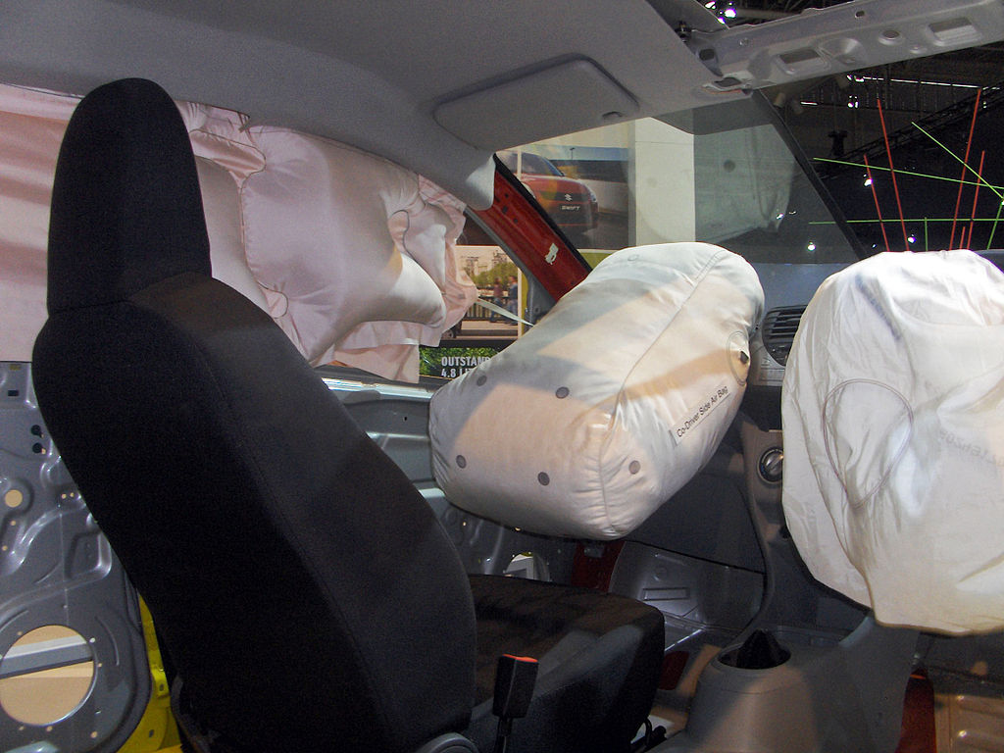

In this activity, your objective is to design a model airbag using a resealable sandwich bag, sodium bicarbonate (baking soda), and hydrochloric acid. The reaction produces salt, water, and carbon dioxide gas according to the reaction equation below. Balance the equation.

____NaHCO₃ (s) + ____HCl (aq) → ____NaCl (aq) + ____H₂O (l) + ____CO₂ (g)

Your airbag must meet the following criteria.

- Criteria for airbag design
- The airbag must fully inflate.
- The airbag must remain sealed.

- Constraints for the airbag design
- The only reactants available are 1 Molar hydrochloric acid and sodium bicarbonate.
- You will have only two attempts to test your airbag model. Plan carefully!

List five things you need to know in order to successfully inflate the airbag.

____________________________________________________________________________

____________________________________________________________________________

____________________________________________________________________________

____________________________________________________________________________

____________________________________________________________________________

Tennessee Department of Education worksheet. Used by permission.
In the space below, write a step-by-step procedure for preparing and testing your model airbag. Include any necessary calculations. The procedure should be written in a way so that a student who is absent today could read your procedure and know exactly how to prepare the airbag for testing.

____________________________________________________________________________

____________________________________________________________________________

____________________________________________________________________________

____________________________________________________________________________

____________________________________________________________________________

____________________________________________________________________________

____________________________________________________________________________

____________________________________________________________________________

____________________________________________________________________________

____________________________________________________________________________

____________________________________________________________________________

____________________________________________________________________________

____________________________________________________________________________

____________________________________________________________________________

____________________________________________________________________________

Test Your Prototype!
Ask your teacher to look at your calculations and airbag design. After getting the teacher’s approval, put on your safety glasses, obtain the reactants, and test your model airbag. Put your small bag inside the large bag before inflation.

Evaluate the outcome of your airbag design. Was your airbag successful? Why or why not? If not, what improvements could be made to your procedure in order to make it successful next time?

____________________________________________________________________________

____________________________________________________________________________

____________________________________________________________________________

____________________________________________________________________________

____________________________________________________________________________

Post-lab Question

Imagine that your airbag design has been accepted by an international automobile manufacturer. Unfortunately, after a few years, it is determined that the airbags are malfunctioning. There have been reports of the airbags exploding upon deployment. Malfunctions tend to occur in the summer, especially in very hot regions of the world where the temperatures in the car may reach 50° Celsius.

Using your understanding of kinetic molecular theory, and the variables involved in the ideal gas law, identify the problem with your airbag design and propose a possible solution. You may provide a particle diagram to illustrate your answer.

Guided Design

1. Look at the balanced chemical equation from the page 1. Which of the five substances is going to inflate your airbag?

2. What is the volume, in milliliters, of your airbag?

3. Convert this value to liters.

4. Use the ideal gas equation to determine how many moles of the gas you will need to fill the airbag. You will need to measure the atmospheric pressure and temperature in the classroom today.

5. Based on that many moles of carbon dioxide gas, how many moles of sodium bicarbonate will you need? Use a mole ratio to convert moles of the carbon dioxide into moles of NaHCO₃.

6. How many grams of NaHCO₃ is this?

7. Based on your answer to #4, how many moles of 1 Molar HCl solution will you need?

8. Determine how many liters of HCl you should use in your airbag. Then, convert the value to milliliters. (The concentration, 1 Molar, means that there is 1 mole of HCl for every 1 liter of solution. You may use a proportion to determine how many liters of HCl you will need in order to obtain the desired number of moles of HCl.)

Guided Design

1. Look at the balanced chemical equation from the page 1. Which of the five substances is going to inflate your airbag?
CO₂
2. What is the volume, in milliliters, of your airbag?
Example: 850. mL

3. Convert this value to liters.
Example: 0.850L

4. Use the ideal gas equation to determine how many moles of the gas you will need to fill the airbag. You will need to measure the atmospheric pressure and temperature in the classroom today.
PV=nRT
n=PV/RT = (767mmHg)(0.850L) / (62.4 L-mmHg/molK)(293 K)
n= 0.0357 moles CO₂

5. Based on that many moles of carbon dioxide gas, how many moles of sodium bicarbonate will you need? Use a mole ratio to convert moles of the carbon dioxide into moles of NaHCO₃.

0.0357 moles CO₂ * 1 mol NaHCO₃ / 1 mol CO₂ = 0.0357 moles NaHCO₃

6. How many grams of NaHCO₃ is this?

0.0357 moles CO₂ * 84.01 grams/mol = 2.99 grams NaHCO₃

7. Based on your answer to #4, how many moles of 1 Molar HCl solution will you need?

0.0357 moles CO₂ * 1 mol HCl / 1 mol CO₂ = 0.0357 moles HCl

8. Determine how many liters of HCl you should use in your airbag. Then, convert the value to milliliters. (The concentration, 1 Molar, means that there is 1 mole of HCl for every 1 liter of solution. You may use a proportion to determine how many liters of HCl you will need in order to obtain the desired number of moles of HCl.)

1 mole HCl / 1 Liter of solution = 0.0357 moles HCl / x Liters of solution
x = 0.0357 Liters of solution, or 35.7 mL of HCl solution

