Standard
CHEM1.PS1.14 Use Lewis dot structure and electronegativity differences to predict the polarities of simple molecules (linear, bent, trigonal planar, trigonal pyramidal, tetrahedral). Construct an argument to explain how electronegativity affects the polarity of basic chemical molecules.

Tennessee Academic Standards for Science: Page 71

Three-dimensional Learning Performance for Lesson
Students will develop and use models* in order to predict the polarity of simple molecules (linear, bent, trigonal planar, trigonal pyramidal, tetrahedral)** highlighting the relationship between molecular structure and the polarity of compounds.***

Science and Engineering Practice for Lesson
Developing and Using Models*
The goal of this three-dimensional learning performance is for students to develop strategies for using three-dimensional structures of molecules in order to predict the polarity of compounds. In this lesson, an emphasis should be placed on the relationship between the symbolic representations (chemical formulas and Lewis structures) and the microscopic particle representation (the 3D molecular structure).

The ability to predict polarity serves as an important part of a larger model for students to understand how the composition of a compound influences a substance’s physical properties, as shown below.

Chemical formula → Lewis structure → VSEPR Shape→ Polarity → Physical Properties

Most of this lesson focuses on the third step of this model, connecting VSEPR shape to polarity; however, near the end of the lesson, the questioning triggers students to expand the model to connect a chemical formula to the prediction of polarity.

Disciplinary Core Idea for Lesson
Physical Science 1.A Structure and Properties of Matter**
“The structure and interactions of matter at the bulk scale are determined by electrical forces within and between atoms.”

A Framework for K–12 Science Education: Page 109

Crosscutting Concept for Lesson
Structure and Function***
This lesson focuses on the student’s development of strategies to use molecular models to predict the polarity of a molecule. This system of strategies serves as a very powerful tool in the student’s ability to connect the symbolic model of a compound (it’s Lewis structure and VSEPR shape) to the observed macroscopic properties.

Prior Knowledge

Beginning
Middle
End
Location Within Instructional Unit

- Chemical formulas
- Drawing Lewis structures of simple molecules
- VSEPR shapes

In seventh grade science, students have explored the nature of molecules as combinations of atoms under standard 7.PS1.2. In addition, students have been introduced to the concept of intermolecular attractions in 7.PS1.6. This lesson provides students with a reason for those intermolecular attractions in terms of the polarity of molecules; polar molecules tend to exhibit greater intermolecular attractions while nonpolar molecules tend to exhibit less intermolecular attractions.

Furthermore, this lesson involves two separate strands for understanding polarity. The first strand addresses electronegativity differences. Before teaching this lesson, it is necessary to have introduced students to the concept of electronegativity during a unit on periodic trends. The second strand incorporates the shape of molecules. It is expected that this lesson on polarity would follow a previous lesson on using VSEPR theory to predict molecular shape.

Materials
- Two Styrofoam cups
- Two disposable aluminum pie-pans
- Acetone
- Distilled water
- Gumdrops of various colors, at least 10 per group
- Toothpicks of various colors, at least 8 per group
- Marshmallows

Lesson Sequence and Instructional Notes

1. Teacher Demonstration:

To begin this lesson, a demonstration where acetone dissolves a Styrofoam cup provides an opportunity for students to discuss the relationship between molecular structure and physical and chemical properties of compounds.

First, pour a small amount of acetone in one pie pan. Pour enough acetone so that it covers the surface of the pie pan up to approximately 1 centimeter. Pour a similar amount of distilled water in the second pie pan. Draw the Lewis structures for acetone and for water on the board.

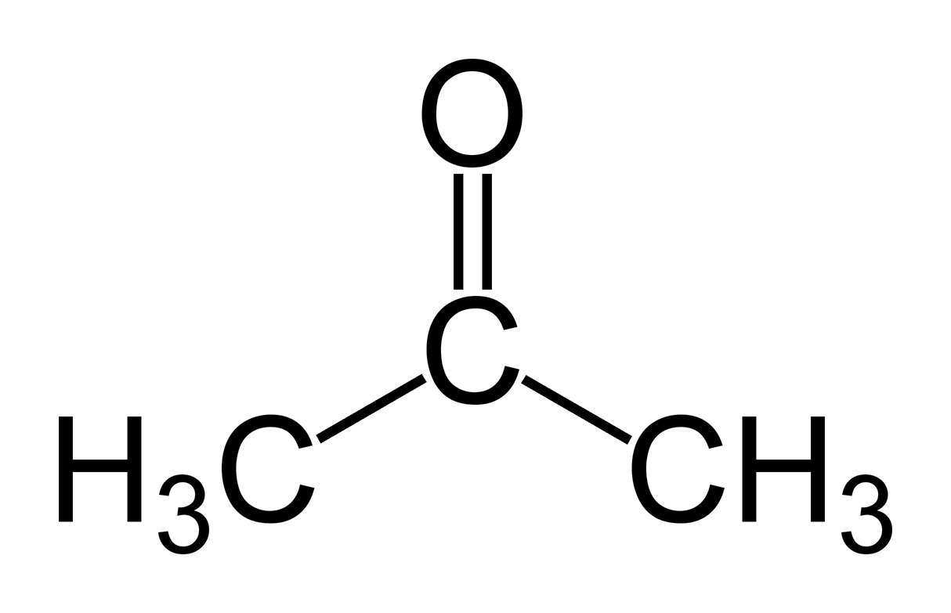  Figure 1: acetone | 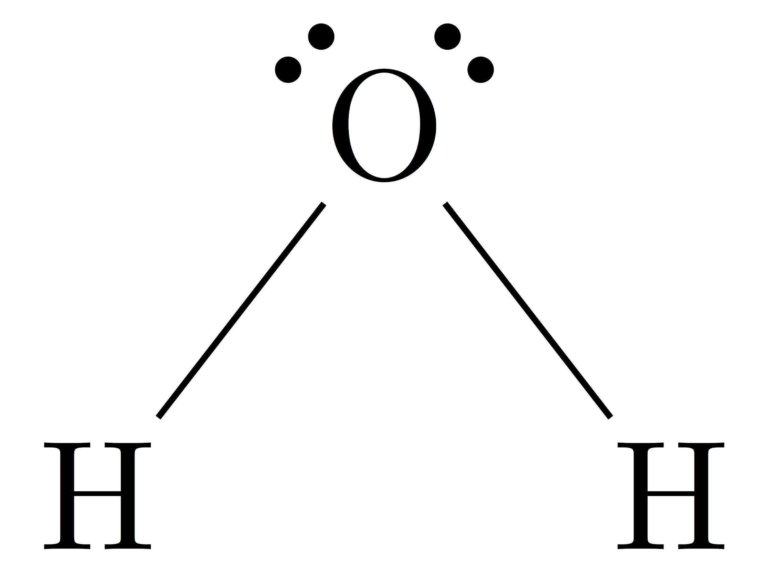  Figure 2: water

Have students discuss with their groups two ways that the molecules’ structures are similar and two ways that the molecules are different. Select students to share a similarity and difference they observed.

Place the Styrofoam cup in the acetone-filled pie pan. Have students make observations as the acetone dissolves the Styrofoam. (The acetone contains nonpolar segments, and therefore, it dissolves the nonpolar monomers of the Styrofoam.) Then, repeat the experiment with the second Styrofoam cup in the pie-pan of water. (Nothing happens this time because water is a polar molecule while the Styrofoam is nonpolar. The polar solvent water will not dissolve the nonpolar units of the Styrofoam.) Instruct students that the difference in the result is related to the polar nature of water and the nonpolar nature of acetone. This is why acetone will dissolve fingernail polish as well. Then, introduce students to today’s assessment by telling them that they will study the effect of molecular shape and electronegativity differences on the polarity of molecules.

2. Gumdrop Models Activity:

Next, distribute copies of the student activity. Each group will need two copies, as they will create a model for a polar molecule and for a nonpolar molecule. In addition, provide students with a table of elements’ electronegativity values. They may find one in their textbooks, or on a website, such as ptable.com. Show students examples of gumdrop models and review the names of each of the shapes. NOTE: These examples do not use colored toothpicks to show polarity. These are only provided in order to give students a examples of the VSEPR shapes using gumdrops and toothpicks.

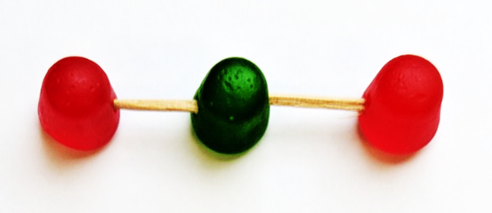 | Linear
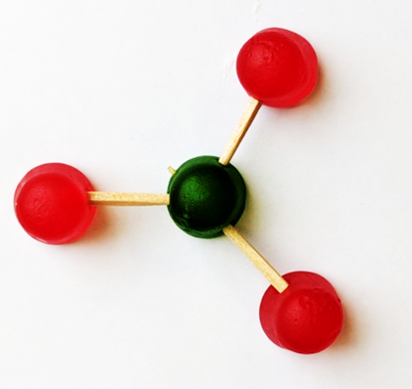 | Trigonal planar
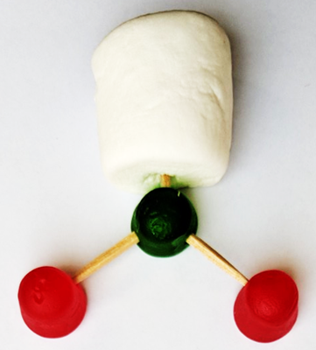 | Bent -- trigonal planar
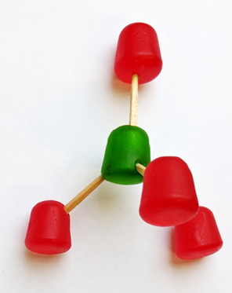 | Tetrahedral
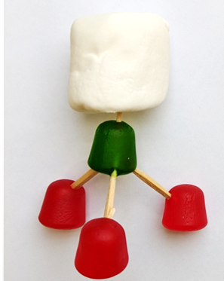 | Trigonal pyramidal
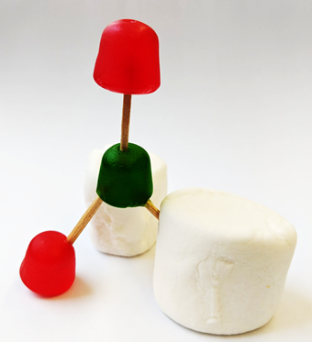 | Bent -- tetrahedral

Explain to students the following guidelines for making their models.
- First, they will draw the Lewis structure of their assigned molecule.
- Next, they will use the table of electronegativities to determine whether each bond is polar or nonpolar.
  - If the difference in electronegativity is less than or equal to 0.4, the bond is said to be nonpolar.
  - If the difference in electronegativity is greater than 0.4, the bond is said to be polar.
- Polar bonds are represented by using yellow toothpicks to connect the atoms.
- Nonpolar bonds are represented by using blue toothpicks to connect the atoms.
- Each element should be represented by a different color of gumdrop.
- Lone pairs, or nonbonding electrons, are represented by a marshmallow, connected with a plain toothpick.
- To save toothpicks, have the students break each toothpick in half. This cuts down on toothpicks and adds structural stability to the models.

At this time, give each group two slips of paper cut from the table below. Give each group one polar compound and one nonpolar compound. Cut these into individual slips so that it isn’t quite so obvious to students that the polar one is first and the nonpolar one is second.

Polar Compounds | Nonpolar Compounds
CH₂O | CH₄
CF₂H₂ | CCl₄
HCN | CO₂
NCl₃ | CF₄
SO₂ | CBr₄
H₂O | CH₄
CH₂O | CCl₄
NCl₃ | CO₂
SO₂ | CF₄
H₂O | CCl₄

Give students about 20 minutes to work through the gumdrop modeling activity. When they finish each model, ask them to get your attention so you can check their Lewis structures, models, and polarity predictions. If your school uses an online learning management system, you may ask students to take a photo of their models on the sheets and upload the photos to the learning management system as their activity submission.

Some examples of student work appear below.
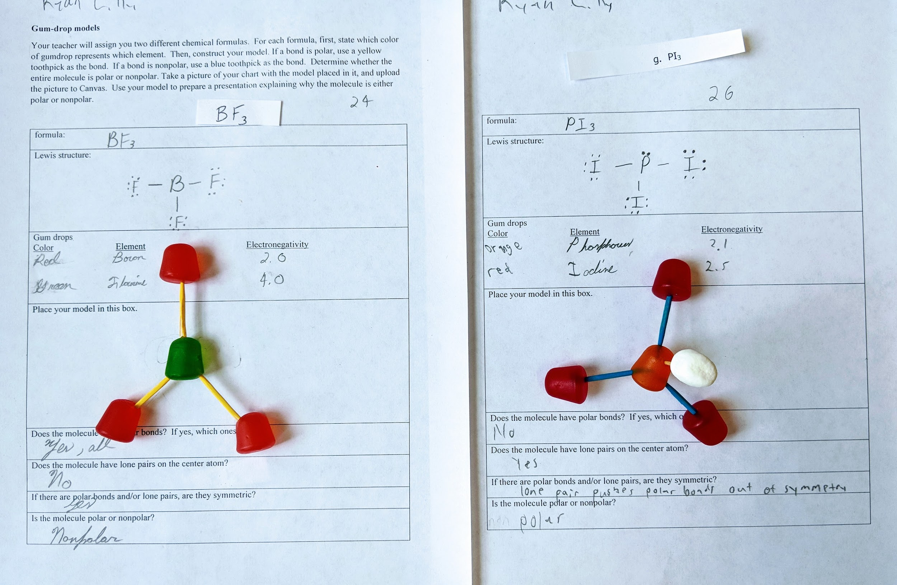This example shows work of a student who was successful in drawing a Lewis structure, building a VSEPR model, and predicting polarity. (BF₃ has been removed from the list of compounds since some chemistry classes may not study the incomplete octet nature of boron as a central atom.)

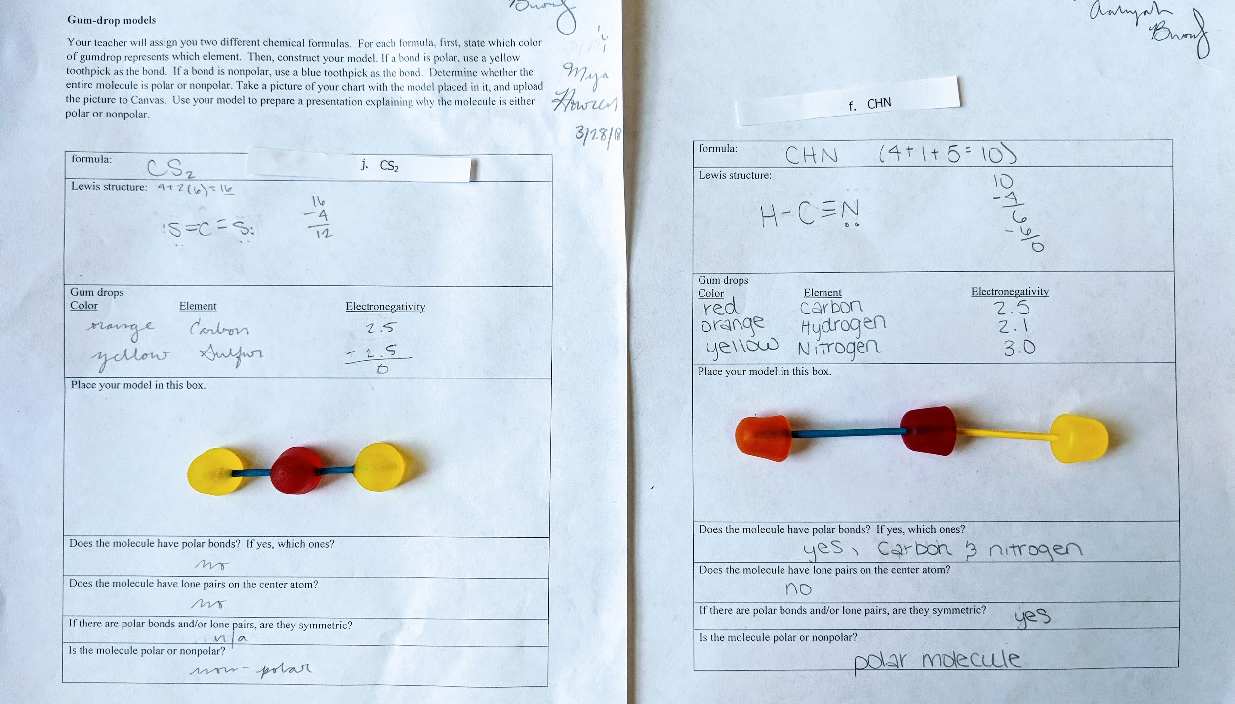This example shows student work comparing two linear molecules, one polar and one nonpolar.

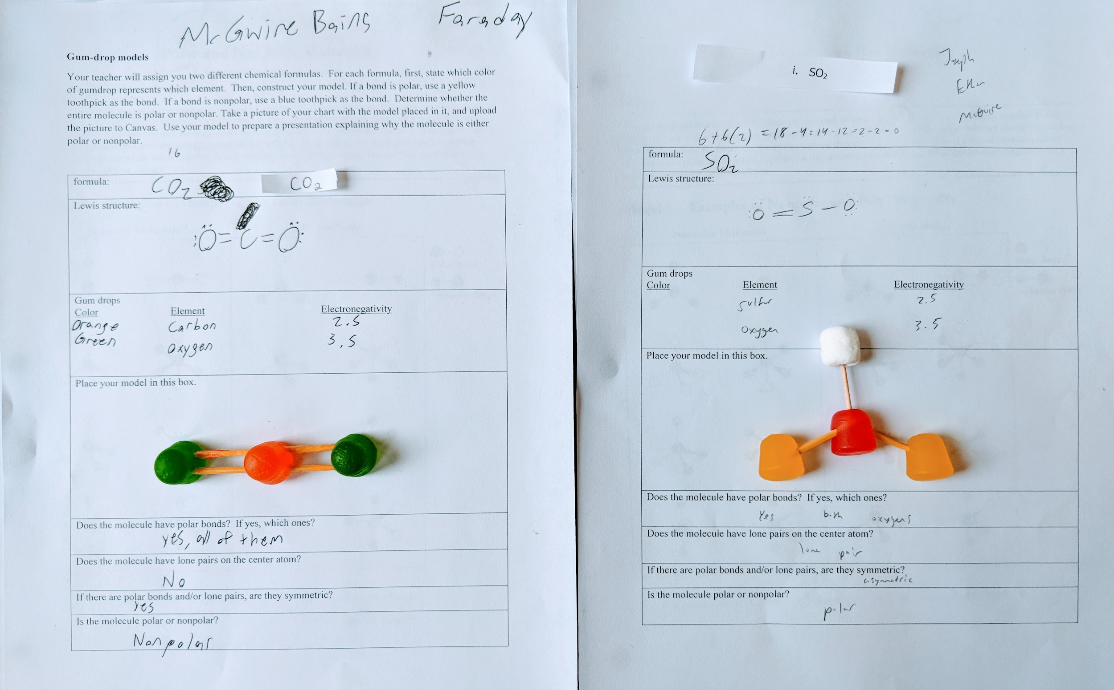In this example, the students chose to use two toothpicks to represent the double-bond in carbon dioxide. This student was also successful in using their models to predict polarity.

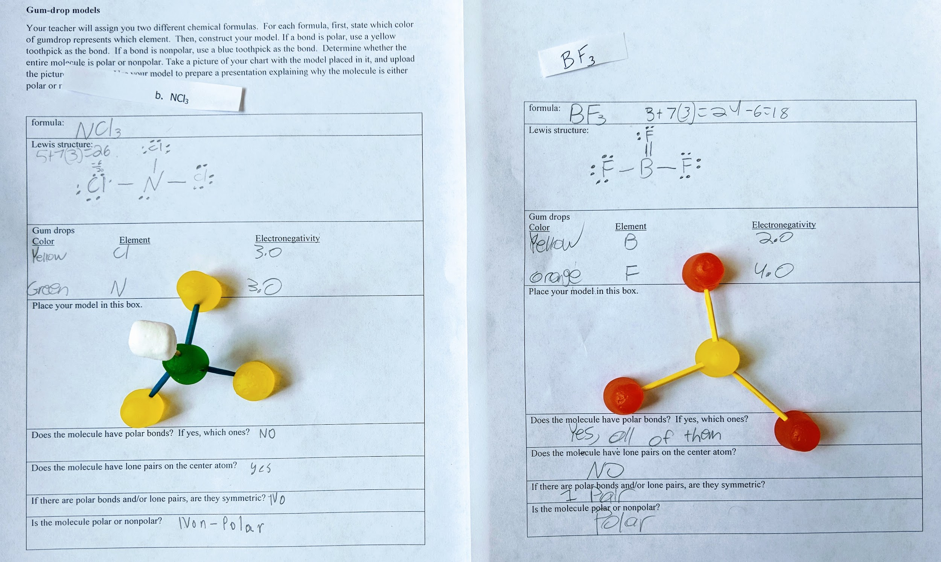This example shows work where a student built models correctly, but did not predict polarity correctly. For NCl₃ , the student recognized the lack of symmetry, but still called the molecule nonpolar, perhaps because the bonds are nonpolar bonds. Then, for BF₃ , it appears that the students predicted a T-shape in the Lewis structure, and this caused them not to see the symmetry around the central atom.

4. Back to the POGIL:

Then, give students time to work with their groups as they answer questions 11-18. If you have a board that allows students to write on top of a projected image (a SMART board or just a projector on a whiteboard), you may project questions 17 and 18 on the board and assign a molecule to each student group to complete as a way for the class to compare answers.

(As a note, in question 18, the structure for XeF₄ goes beyond the scope of Chemistry I standards. It is not considered a simple molecule due to its expanded octet. Depending on the ability level of the student, the teacher may choose to include this structure, omit it, or provide it as a “bonus” question.)

After each group has contributed their answer to questions 17 and 18 on the board, review the answers as a class. Walk around the classroom and take a look at each group’s responses. If there is a difference among groups, ask a group member to explain why they have a different answer. Guide the class to a consensus with the correct answer.

5. Closure and Connection to Previous Lessons:

Question 19 serves as a closure question. This provides a challenging, final assessment without the scaffolding provided in the previous questions. Students who demonstrate ability to answer these questions correctly are demonstrating full understanding of how molecular structure relates to polarity.

(Question 19d, phosphorus pentachloride, also goes beyond the scope of Chemistry I question as it includes a structure with an expanded octet. This question may be omitted depending on the ability level of the student.)

Citations and Resources

Figure 1: The original uploader was Ben Mills (https://commons.wikimedia.org/wiki/Acetone#/media/File:Acetone-structural.png)

Figure 2: The original uploader was Daviewales (https://upload.wikimedia.org/wikipedia/commons/1/18/H2O_Lewis_Structure_PNG.png)

Trout, L. (2015). POGIL activities for AP chemistry: developed through the High School POGIL Initiative. Batavia, IL: Flinn Scientific, Inc.

