Diffusion and Osmosis Investigation

Objectives
- To estimate the osmotic content in a sample of plant tissue.

Background
In this lab we will investigate the processes of diffusion and osmosis. Diffusion is the movement of molecules from a high concentration to a low concentration – something we almost take for granted, because we observe this in many everyday situations. For example, you can smell perfume or cologne in the air behind somebody because it has diffused from their neck (high concentration) into the air (low concentration). The movement of food coloring or dye in water is similar – shortly after its addition, it appears in high concentration in the center of the sample, but after time, the dye diffuses completely to give you a uniform sample where the concentration is the same in all areas. We use the term osmosis to specifically refer to the diffusion of water. You may have heard your fellow students suggest they sleep with a textbook under their pillow, that they might absorb the material “by osmosis”. You should correct them by saying that this would be “diffusion” since the material is not water!
Living cells need to maintain the levels of chemical substances dissolved within them, and this is achieved only by regulating the flow of these materials through the cell membrane. Some substances pass through the membrane easily, while others do not. In this lab, we will investigate the movement of water molecules through a cell’s plasma membranes.
Solutions are formed when a molecule is individually suspended and surrounded by solvent molecules. In biological systems, the solvent is almost always water. The solute is the substance dissolved in the solvent. In the case of seawater, for example, the salts dissolved in seawater are the solute, and water is the solvent. Thus, you could view the cytoplasm as a very complex solution, in which a host of molecules (ions, metabolites, proteins, etc.) are dissolved in a water solvent.
Solutions are frequently described in comparative terms, meaning that the concentration of solute in one solvent would be compared to the concentration of solute in another. We use the term hypertonic to describe a solution that is more concentrated than another and the term hypotonic to describe a solution that is less concentrated than another. Solutions that have the same concentration of solute are described as isotonic. Thus, in the case of osmosis, water will move from a higher concentration of water (which is the hypotonic side since this has a lower concentration of solute) to a lower concentration of water (which is the hypertonic side).
Molecules tend to flow from an area of high concentration to an area of lower concentration, as the entropy of the system is increased by having more disorder (in the form of dispersed solute molecules). This principle is also true for the water molecules that make up a solution. This means that if two solutions of different ionic strength are separated by a membrane that is permeable to water, but not the ions in solution, the water will move from the lower ionic strength (higher concentration of water) to the higher ionic strength (lower concentration of water).

Materials

Table Salt

Weigh Boats

Knife & Cutting Board

Rulers

Digital balance
Potatoes
Distilled water
0.1 – 0.6M NaCl solutions

Procedure (preparation prior to lab)
Solution | Mass (g) of NaCl for 250mL
0M | 0.00
0.1M | 1.45
0.2M | 2.93
0.3M | 4.38
0.4M | 5.85
0.5M | 7.30
0.6M | 8.78
- Prepare 250mL samples of each salt concentration by weighing out the amount of salt indicated for each solution. Dissolve the salt in a volume slightly less than 250mL and bring the volume up to 250mL when all the salt has dissolved. Repeat for each of the six salt solutions:
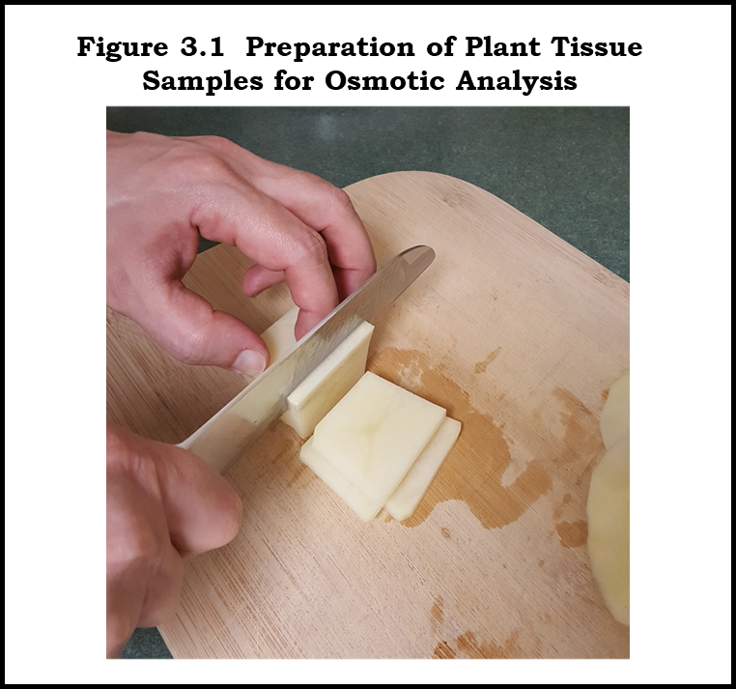
- Carefully peel a potato and prepare 7 slices of potato of uniform thickness and size. Use a ruler to ensure your slices are as uniform as possible.

Procedure (estimation of osmotic content of plant tissues)
- The osmotic content of the blood of a healthy individual should be about the same as a NaCl solution between 275 and 325 mM. Do you think the osmotic content of a potato will be more than, less than, or about the same as blood?

- Label 7 clean weigh boats with 0M, 0.1M, 0.2M, 0.3M, 0.4M, 0.5M and 0.6M NaCl solution. Pour approximately 50mL of each solution into the 7 labelled weigh boats.
- Weigh each slice to the nearest 0.01g, using the digital balance, and place each slice in a different weigh boat of solution. Record the masses in the table provided below.
- Allow the slices to soak in their respective solutions for 30-60 minutes.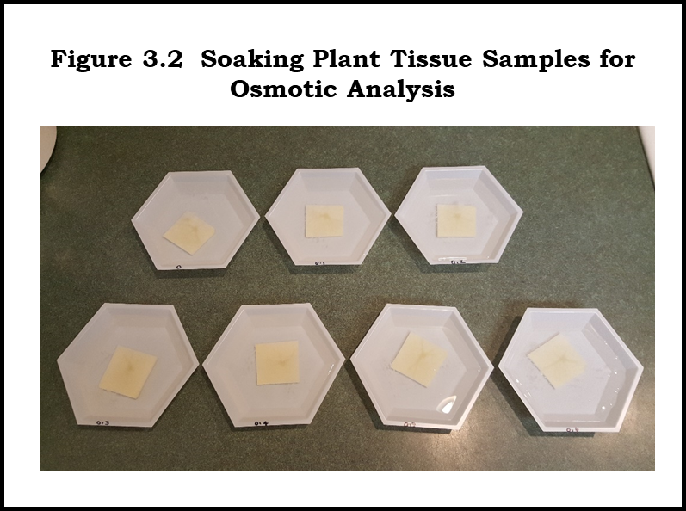
- Pat each slice dry and record the mass again.
- Calculate the change in mass for each slice by subtracting the initial mass from the final mass.
- Calculate the % change in mass for each slice as follows:
% change in mass = 100 x (Change in mass/Initial mass)
- Plot the % change in mass vs. NaCl concentration. If you fit a straight line to this data, the line should cross the concentration (horizontal) axis at the isotonic point.
Slice | [NaCl] | Initial mass (g) | Final mass(g) | Change in mass (g) | % Change in mass
1
2
3
4
5
6
7

- Plot % change in mass as a function of [NaCl].

- Use the equation of the line from the plot generated above to calculate the isotonic concentration of your plant tissue sample.

Review Questions
- Intravenous delivery of drugs typically involves hanging a bag of a solution (Ringer’s lactate or salt solution) and supplementing this solution with whatever the patient needs. What would happen if you prepared a patient’s IV bag with distilled water?
- A simple home remedy for a red wine spill on a linen tablecloth is to take the top off the saltshaker and empty it on the stain. You can then brush off the salt crystals and remove the stain much more easily. Can you explain why this remedy works in terms of diffusion and osmosis?
- Why is it important that the slices of potato you generated in this lab have a consistent and regular shape? What would happen if you didn’t take care to do this? If you did this, would there be a way to make sure you still obtain the correct result from the experiment?
- Before the invention of refrigeration, food would be preserved by smoking and salting, or the addition of sugar, as we see in foods like fruit preserves and beef jerky today. Can you explain why this is an effective measure against bacterial growth?

