TEAM Lesson Plan Template
Teacher: Dr. Amanda Niedzialomski
Subject/Grade: Mathematics (Fractions) / 3rd Grade
Lesson Title: Dry-Erase Fraction Fundamentals
STANDARDS | Identify what you intend to teach. State, Common Core, ACT College Readiness Standards and/or State Competencies; Enduring Understandings and Essential Questions.
MP2. Reason abstractly and quantitatively
MP5. Use appropriate tools strategically
MP6. Attend to precision

[Parts of this activity are appropriate for each of the following standards. Emphasize those parts and omit other parts as necessary to adapt the activity for a particular group of students or class need.]

3.NF.A.1 Understand a unit fraction, 1/b, as the quantity formed by 1 part when a whole is partitioned into b equal parts; understand a non-unit fraction, n/b, as the quantity formed by n parts of size 1/b. For example, 3/4 represents a quantity formed by 3 parts of size 1/4.

3. NF.A.2 Understand a fraction as a number on the number line. Represent fractions on a number line.
a. Represent a fraction 1/b on a number line diagram by defining the interval from 0 to 1 as the whole and partitioning it into b equal parts. Recognize that each part has size 1/b and that the endpoint locates the number 1/b on the number line. For example, on a number line from 0 to 1, students can partition it into 4 equal parts and recognize that each part represents a length of 1/4 and the first part has an endpoint at 1/4 on the number line.
b. Represent a fraction n/b on a number line diagram by marking off n lengths 1/b from 0. Recognize that the resulting interval has size n/b and that its endpoint locates the number n/b on the number line. For example, 5/3 is the distance from 0 when there are 5 iterations of 1/3.

3.NF.A.3 Explain equivalence of fractions and compare fractions by reasoning about their size.
a. Understand two fractions as equivalent (equal) if they are the same size or the same point on a number line.
b. Recognize and generate simple equivalent fractions (e.g., 1/2 = 2/4, 4/6 = 2/3) and explain why the fractions are equivalent using a visual fraction model.
c. Express whole numbers as fractions and recognize fractions that are equivalent to whole numbers. For example, express 3 in the form 3 = 3/1; recognize that 6/1= 6; locate 4/4 and 1 at the same point on a number line diagram.
d. Compare two fractions with the same numerator or the same denominator by reasoning about their size. Recognize that comparisons are valid only when the two fractions refer to the same whole. Use the symbols >, =, or < to show the relationship and justify the conclusions.

OBJECTIVE(s)/Sub-Objectives | Connect prior learning to new learning. Clear, Specific, Observable, Demanding, High Quality, Measurable, Aligned to Standard(s), and Integrated with other subjects, build on prior student knowledge  Student-Friendly (I Can Statement)
I can represent 1/6 as a portion of a shape.

I can represent 3/5 as a portion of a shape.

I can graph 6/8 on the number line.

I can compare 3/4 and 6/8 on the number line.

MATERIALS AND RESOURCES | Content-related: Clearly supports lesson objective(s); rigorous & relevant; Incorporates multimedia & resources beyond the textbook.
Materials
Dry-Erase Pockets
Dry-Erase Markers
Dry-Erase Sleeves
Rulers
Dry-Erase Fraction Fundamentals Printouts (Circles, Squares, Single Number Lines, Double Number Lines)
Fraction Fundamentals Worksheets (Circles, Squares, Number Line)
Strips of paper, 18 cm in length

What if the technology is not working? This is a low-tech activity.
Routine for distributing materials: Dry-erase pockets, markers, and erasers are placed on the tables where small groups will be working. The remaining materials are distributed as needed.
ACCOMMODATIONS/ADAPTATIONS | Learning styles and interests. Anticipate learning difficulties, regularly incorporate student interests & cultural heritage; differentiate instructional methods.
Modifications/Plans for Diverse Learners
Differentiation
__x__ Process: Some students might benefit from using printed fraction rulers, rather than making fraction rulers by folding strips of paper.
__x__ Product: For some students, it may be helpful to have the teacher inspect their dry-erase markings, rather than drawing the fraction models on the worksheet

Accommodations
___ Preferential Seating ___ Extended Time ___ Small Group ___ Peer Tutoring
___ Modified Assignments ___ Other
Early Finishers: All activities can be extended by considering mixed fractions or improper fractions. Early finishers working on unit fractions can expand to non-unit fractions. Early finishers working on squares can expand to other shapes. Early finishers working with folded fraction rulers and the number line can practice dividing the number line in the dry-erase pocket using the ruler instead.

MOTIVATING STUDENTS/ANTICIPATORY SET | “Hook”: Engage students’ attention and focus on learning. Personally meaningful and relevant.
Talk about two kids sharing one cookie, and breaking it in “half.” What is the problem that always follows? One “half” is bigger, and both kids want the bigger half! Illustrate this by breaking an actual cookie, or by showing a picture of a cookie in two unequal pieces, like this one:
https://unsplash.com/photos/kzloZDPHzeg
Discuss the real meaning of half: the cookie must be in two equal pieces; then each piece is half of the cookie. How could you split a cookie into two equal halves?

INSTRUCTIONAL PROCEDURES | Step-by-Step Procedures-Lesson Sequence: Basic to Complex. Lesson includes visuals, modeling, logical sequencing and segmenting (beginning, middle, ending); essential information; concise communication; grouping strategies; differentiated instructional strategies to provide intervention & extension; seamless routines; varied instructional strategies; key concepts & ideas highlighted regularly.
Introduction What does it mean to take half of something? See hook. Talk about the terms “whole” and “equal parts.”
Activity 1: Circles and Unit Fractions Students are presented with 4 circles on the circles printout, and they can think of them as 4 cookies, like the hook. (Students can decorate the circles to look like cookies, as an optional part of the activity.) Ask the students to place the circle sheet in the dry-erase pocket, and divide the circles into two pieces by drawing with the dry-erase marker. For one of the circles, the students should try their best to divide the circle into two equal parts; they may use a ruler to help. For the other three circles, students draw lines or curves that divide the circle into unequal parts. Then they compare results with their partner(s). A partner should identify the circle that is divided into two equal parts. Then each student records their circle divided into two equal parts on their worksheet in pencil (worksheets are separate from the circles printout; see attachment). Students shade one piece and write the numerical fraction that the shaded piece represents: 1/2. Students then erase their marks and perform a similar process for n = 3, 4, 5, 6, 8, 10, and 12 to produce visual models for 1/n, recording their results on their worksheets. It can be difficult to divide a circle into equal parts; students can experiment with strategies on their dry-erase pockets and compare results with their partner(s). Rather than continuing to intentionally draw circles with unequal parts, students can practice drawing equal parts on the 4 circles and choose the best result. A whole class discussion can happen to compare strategies. Is it best to divide the circle in half first? For what numbers can you divide the circle in half? Which are the easiest numbers to divide the circle into? Which are the hardest? What is it about these numbers that makes the process easier or harder?

Activity 2: Squares and Equal Parts Students are presented with 4 squares on the squares printout; they place the printout into the dry-erase pocket. Have a discussion about equal parts. How would you describe the term “equal parts”? What characteristics of the parts have to be the same?
Ask the students to think of different ways to divide a square into 4 equal parts, and to draw them with a dry-erase marker. (They could divide it into 4 smaller squares, divide it along the diagonals, divide it into vertical strips, or divide it into horizontal strips – these are some, not all, of the options.) Students discuss options with their partner(s). Then the different ideas of the class are collected and drawn on the board, and supplemented by the teacher, if desired. Discuss how you can know if the parts are equal. One way to know is that the 4 parts are the same size and shape. But does the shape have to be the same for the parts to be equal? Show the students this example, and ask if it is divided into equal parts:

Discuss: Equal parts do not need to have the same shape. If equal parts do not have the same shape, what makes them equal? The shapes must have the same “size.” What is the math word for “size” in this case? Area! Equal parts have the same area.
Using some of these divisions, students record visual models for 1/4, 2/4, 3/4, and 4/4, along with their numerical fraction counterparts, on their worksheets (worksheets are separate from the squares printout; see attachment). Encourage the students to show different ways of dividing the square into equal parts on their worksheets.

Now the squares are divided into 5 parts. Each student should try to find different ways to divide the square into 5 equal parts, as well as examples of dividing the square into 5 unequal parts. Partners discuss their ideas; students should give reasons why their examples of 5 equal parts are, indeed, equal. Then students record visual models and numerical fractions of the form b/5 on their worksheets. Was it as easy to find different ways of dividing the square into 5 equal parts as it was for 4? Why do you think that is?
Repeat this process for dividing the squares into n parts and recording the visual fraction models and numerical fractions for n = 6, 8, 10, and 12.

Activity 3: Fractions on the Number Line Start with a discussion about the number line. We often think of the number line as a line with whole numbers marked on it:
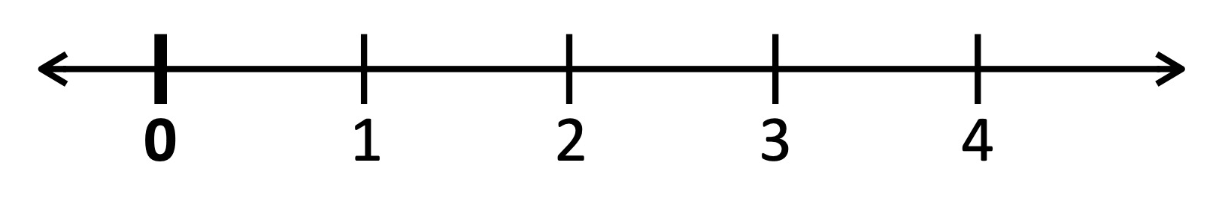
The number line measures how far away a point is from 0, so we can also think of the number line as a ruler that keeps going forever:
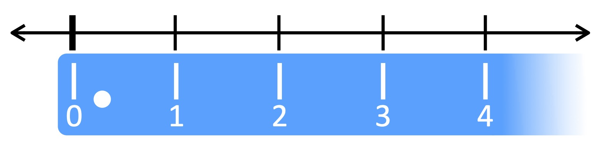
And a ruler has more markings than just 1, 2, 3, … right?
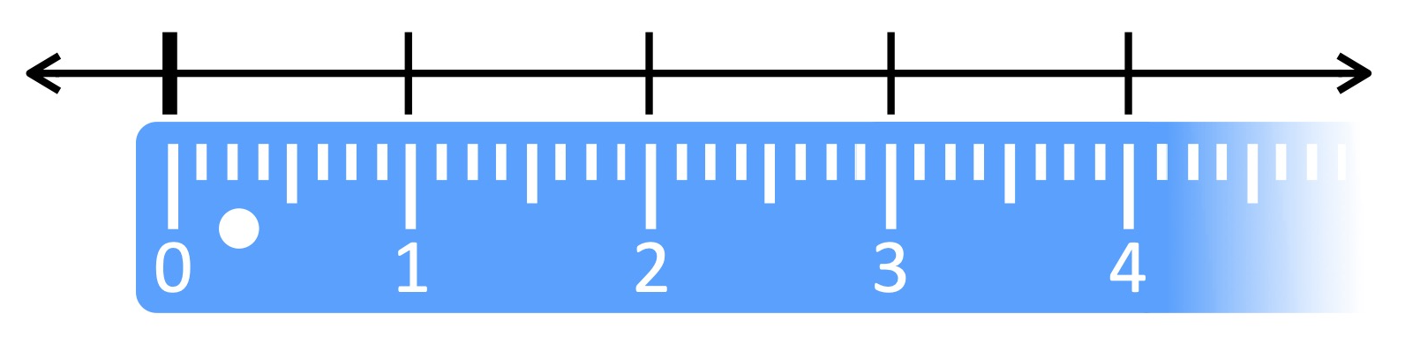
Not everything we measure is a perfect 2 inches long. Some things are between 2 and 3 inches. The same thing is true of points on the number line.
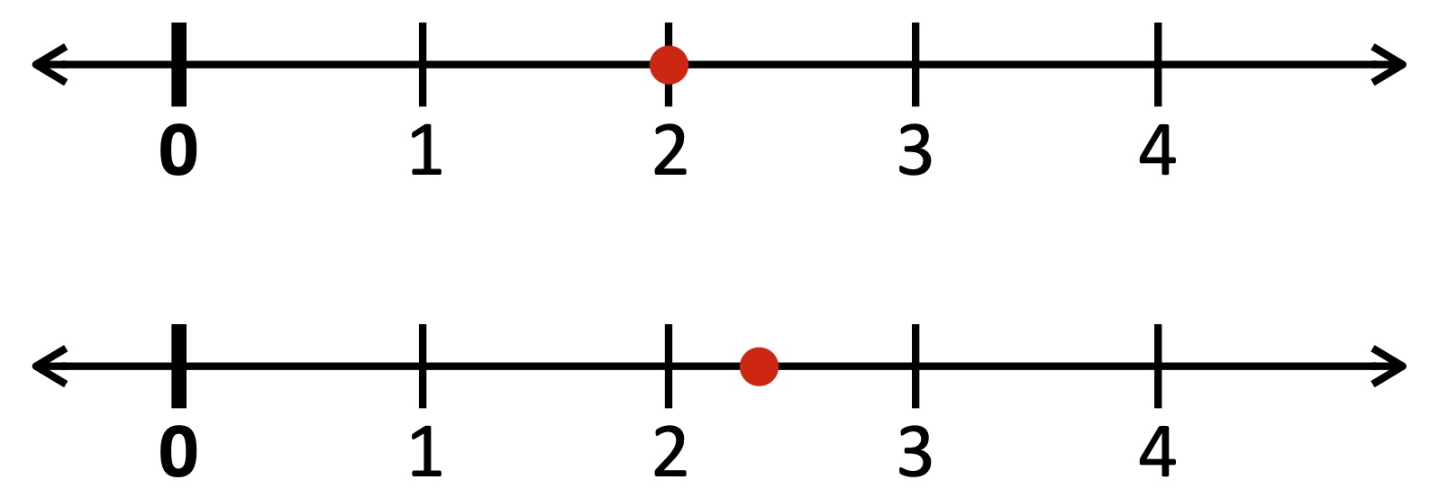
Any place we touch the number line, there is a number right there! We are going to graph fractions on a number line, between 0 and 1.

Distribute the single number line printouts and have the students place them in the dry-erase pockets. First, have students discuss with their partner(s) how to graph the point ¼, and have them do so with their dry-erase markers. After a few minutes of partner discussion, regain the attention of the class for a whole-group discussion. Ask for student volunteers to explain how they graphed ¼. In the same way that equal parts are important when representing a fraction as a part of a shape, equal parts are important for graphing numbers on the number line. In how many parts do we need to divide the line between 0 and 1? How can we make sure we are dividing the line into equal parts? Would a tool help you?

Students might think a ruler would be helpful. Explain that they are not going to get rulers… yet. Pass around several of the 18 cm strips of paper per group. Don’t explain their purpose initially; ask them if they notice anything special about these strips of paper. They are the same length as the line between 0 and 1. Ask students to experiment with them and discuss with their partner(s) how the paper might be helpful in obtaining 4 equal parts on the number line. If a student has the right idea, have them show the rest of the class: we can fold the paper in half crosswise, and then fold it in half crosswise again; when we then unfold the paper, the folds have divided the paper into approximately 4 equal parts. Students can then mark these folds with a pen to make them easier to see and use the strip of paper as a “ruler” to divide the number line. Have the students use their folded paper strips to check the accuracy of the ¼ they initially marked with the dry-erase marker.

Students mark this folded strip with “¼” and set it aside as their fourths ruler. Demonstrate to the class how to use the strips of paper to create other fraction rulers: ½, ⅓, ⅕, ⅙, and ⅛. This video may be helpful:
Elementary Math Resources | Make Fraction Strips for Grade 3 or Grade 4 Math Students
https://youtu.be/BeajGDksGtQ

Now students work semi-independently, consulting their partner(s) as needed, to complete the number line worksheets in pencil. (The worksheet asks them to graph a variety of fractions on the number line between 0 and 1, see attachment.) Early finishers can get rulers and practice dividing the number line in the dry-erase pocket using the ruler instead. Suggest that they use cm, and record their measurements. What is the distance between 0 and 1? At what measurement should a mark be placed for ½? For ¾? What is the distance between marks if we divide the line into 5 equal parts?

Once students have finished their worksheets, distribute the double number line printouts and have the students place them in the dry-erase pockets. Ask the students to use their fraction rulers to graph 3/4 on one number line, and 6/8 on the other. What do they notice? These two points are the same distance from 0. That means they are equivalent. Write 3/4 = 6/8 on the board. Tell the students to leave 3/4, but to erase 6/8. Instead of 6/8, graph 4/6. What do they notice now? Which point is further away from 0? The first point, 3/4, is further away from 0. This means 3/4 is greater than 6/8. It also means 6/8 is less than 3/4. Write 3/4 > 6/8 and 6/8 < ¾ on the board. Now task the groups with making a list of similar comparison statements, and writing their results on a sheet of paper. Students should use a variety of denominators, and look for equivalent and nonequivalent fractions. After several minutes of students working on this, have the groups take turns sharing a few of their comparison statements, and compile the list on the board. Ask the students to look at the list and think about the numbers involved. What are some things you notice? Students could notice many things. Do you notice anything interesting when the two fractions have the same denominators? What if they have the same numerators? Do you notice anything interesting about the equivalent fraction pairs? Anything they notice is great. We are developing your curiosity and the practice of looking for patterns!

Motivating Students
_x_ Verbal Reinforcement: The teacher will monitor students’ work throughout the activity to provide reinforcement.
_x_ Other: Some students may be motivated by the novelty of working with the dry-erase markers and pockets. Some may be motivated by the opportunity to be creative (e.g., by decorating their circles to look like cookies).
Presenting Instructional Content
_x_ Discussion: Class discussions about the importance of equal parts, the difference between equal parts and identical parts, and the concept that the number line represents many more numbers than the marked whole numbers.
_x_ Guided Practice: The teacher will monitor students’ work, as they practice representing fractions as portions of shapes and points on the number line, and provide reinforcement.
_x_ Discovery Learning: Students discover the meaning of equivalent fractions by comparing them on the number line.
Instructional strategies:
Modeling and Guided Practice - The teacher will monitor students’ work and ask questions to prompt them if they are stuck. The teacher will model folding strips of paper to create fraction rulers and model how to use the rulers to graph points on the number line.
Check for Understanding (CFU) –
What am I doing for students that progress at different rates?
Encourage partners to help each other. Offer students struggling with the folded strips of paper printed fraction rulers. Offer rulers with cm markings to students proficient with the folded strips of paper.
What do I do if they get it?
Move on to mixed or improper fractions.
What do I do if they don’t get it?
Focus on one way to divide the shapes into equal parts instead of multiple ways. For example, divide the squares into horizontal strips each time.
QUESTIONING/THINKING/PROBLEM SOLVING (embedded throughout) | Balanced mix of question types. Utilizes Blooms Taxonomy/Webb’s Depth of Knowledge; high frequency; purposeful & coherent; require active responses; balance based on volunteers/non-volunteers, ability, & gender; lead to further inquiry & self-directed learning. Implement four types of thinking (Analytical, Practical, Creative, & Research-based) & Teach/Reinforce problem-solving types. Provide opportunities for students to generate ideas & alternatives; analyze, evaluate & explain information from multiple perspectives & viewpoints.
Questioning
Knowledge:
What does whole mean?
What is a part?
What is a fraction?

Comprehension:
How would you describe the term “equal parts”?
What characteristics of the parts have to be the same?
What is the whole in this example?
What is the size of the part here?
How many parts make up the whole?
Can you divide this shape into 6 equal parts?

Application:
How could you split a cookie into two equal halves?
Can you represent 5/6 as a portion of a shape?
Can you graph 2/4 on the number line?
In this picture of a square, how do we know that the small rectangles and squares have equal sizes?

Analysis:
Is it best to divide the circle in half first?
For what numbers can you divide the circle in half?
Which are the easiest numbers to divide the circle into? Which are the hardest?
What is it about these numbers that makes the process easier or harder?
How can we make sure we are dividing the line into equal parts?
How do these graphs compare?

Synthesis:
How could we use this strip of paper to divide the line into equal parts?
Can we describe the relationship between these equivalent fractions?

Evaluation:

Thinking
_x_ Creative – Student can divide the shapes in different ways, displaying examples of both equal parts and unequal parts.
_x_ Analytical – Students compare the graphs of different fractions on the number line and make conclusions about the fractions.
_x_ Research-based – Students explore different ways to divide the number line into equal parts.
Problem Solving
__x__ Predicting Outcomes: Students predict the location of ¼ on the number line, and then test their prediction using a fraction ruler.
__x__ Observing and Experimenting: Students observe the graphs of multiple fractions on the number line and make statements about their equivalence or nonequivalence.
__x__ Creating and Designing: Students create different examples of dividing shapes into equal parts.

GROUPING | Maximize student understanding & learning Varied group composition (race, gender, ability, & age); clearly understood roles, responsibilities & group work expectations; accountability for group & individual work; student opportunities for goal setting, reflection & evaluation of learning.
- Heterogeneous groups of 2 or 3.
- Product. Students will complete the worksheets for circles, squares, and number line

ASSESSMENT | Formative and/or summative assessment. A variety of assessments, including rubrics, measure achievement of objectives and informs instruction.
Assessments:
__x__ Teacher Made Test In a future assessment the teacher can ask the students to represent a fraction as a portion of a shape, identify a fraction given a visual fraction model, graph a fraction on the number line, or identify a fraction based off of a point on the number line.
__x__Teacher Observation The teacher will directly observe the students’ success with this partner activity.

*Students should achieve _____% mastery of this objective: ________________________________

CLOSURE | Reflection/Wrap Up. Summarizing, reminding, reflecting, restarting, connecting.
During the conclusion part of creating an effective lesson plan teachers must sum up the ideas learned from the lesson. A teacher should also relate this information to future and past coursework to provide students with a broad understanding of the ideas learned. It is important to allow students enough time to ask questions, assert assumptions, and summarize the lesson during this part of the lesson plan.
- Review/Summary: wrap up what has been learned and accomplished in the lesson (even if they are in the middle of an exercise, it is still important to summarize to the point where they are now). Ideally involve students in this synthesis.
- Preview for next lesson: link what they did to day with where they are going next.
- Upcoming assignments: remind them of any upcoming assignments.
Today we…. Turn to your partner and…. Let’s review our I Can statements……
Here is your exit ticket for today…..
Follow-up Activities/Extension These may be designed to create a longer or more intense lesson. For example, if the class is able to cover the material in a lesson much faster than expected, extensions may prove helpful. Extensions may also be useful in various parts of a lesson where the teacher (and class) decides they should spend more time on a skill or topic.

Reflection: You must reflect on every lesson you teach.

NOTES:

This work is licensed under the Creative Commons Attribution-ShareAlike 4.0 International License. To view a copy of this license, visit http://creativecommons.org/licenses/by-sa/4.0/ or send a letter to Creative Commons, PO Box 1866, Mountain View, CA 94042, USA.

