Summer 2016
UTM High School STEM Workshop

Workshop Facilitator: Dr. Chris Caldwell
Subject/Grade: Factoring and multiplying polynomials. High school algebra
Estimated time: 1 hour

Standard(s): A1.A.SSE.A.2 Use the structure of an expression to identify ways to rewrite it.
A1.A.SSE.B.3 Choose and produce an equivalent form of an expression to reveal and explain properties of the quantity represented by the expression.★ a. Factor a quadratic expression to reveal the zeros of the function it defines. b. Complete the square in a quadratic expression in the form Ax2 + Bx + C to reveal the maximum or minimum value of the function it defines. c. Use the properties of exponents to rewrite exponential expressions.

Objective: Assemble twelve hexagons into three columns of four so that expressions on touching sides are equivalent.
- I can tile a surface with hexagons
- I can factor a quadratic polynomial
- I can multiply two binomials to get a quadratic polynomial in general form

Assessment: A member of each group will act as timer to record the time taken to solve the puzzle. When a group of students completes their puzzle, they will note the time taken. They will then check their puzzle against the answer key. If correct, they will record their time.

Motivating Students/Anticipatory SET: After moving students into groups of 3-4, draw a grid of four hexagons on a board or screen. Label the sides of the hexagons as follows:
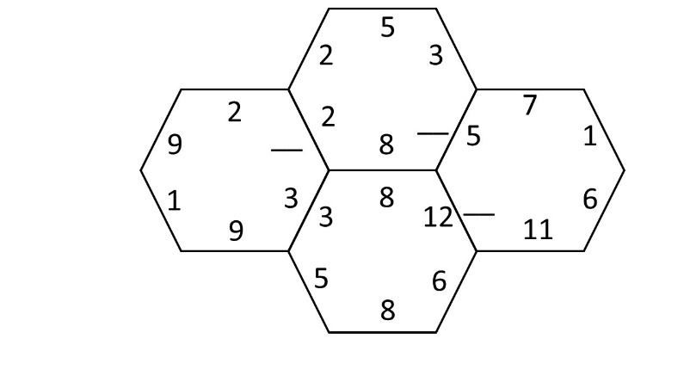
Ask, “If we want the numbers on each pair of adjacent sides to match, which number goes in each blank?” Now, what if the numbers were polynomials?

Instructional procedures:
- Place students into groups of 3-4
- Display the grid of four hexagons and have the whole group determine the numbers to place in the blanks.
- Review the “I can” statements.
- Distribute the hexagon polynomial puzzle 1 (or 2, or 3) to each group.
- Have each group get out the hexagons for puzzle 1 (or 2, or 3).
- Display the blank solution pattern:
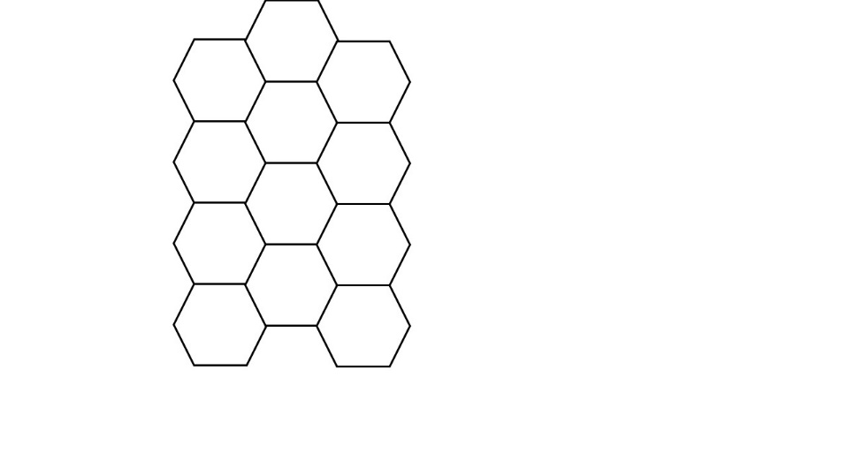
- Explain that the word “one” on each piece is merely to identify the puzzle. It need not remain upright. Students should ignore the word “one” while solving the puzzle.
- Assign a time keeper in each group. Tell the groups to get the teacher’s attention for the answer key once they have solved the puzzle. Have them start.
- Monitor the groups. If a group is stuck, suggest that they try using the quadratic formula.
- If a group completes the puzzle, quickly check their solution to see if their solution is reasonable. If so, allow them to check their solution using the answer key. If they have errors, point to one, ask, “What is wrong here?” and have them continue to solve the puzzle.
- If a group correctly solves the puzzle early, have them record their time, place their puzzle pieces back in the envelope, give them the next puzzle, ensure a timekeeper is assigned, and have them begin again.
- Continue play for approximately 40 minutes, announcing “five minutes” at about the 35 minute mark.

Materials and Resources: Bags or envelopes in which to store puzzle pieces. A copy of each Hex puzzle to keep as an answer key. For each group of students, a copy of each Hex puzzle, printed on card stock, laminated if possible, and cut into separate hexagons. Printing each puzzle on a different color of card stock will help in sorting the pieces. Store the hexagons in the bags or envelopes.

Questioning/Thinking/Problem Solving:
- Could we make a puzzle like this one using squares?
- Could we make a puzzle like this one using pentagons?
- Could we make a puzzle like this one using circles?
- Did you solve the puzzle by factoring the quadratic polynomials, by multiplying the binomials, or a combination of both?
- Which puzzle is easier, the one with different variables, or the one where every variable is “x?” Why?
- After collecting the puzzle pieces, distribute blank hexagon pieces. Have groups make their own polynomial factoring puzzle (this could take another class period).
- How do we recognize a real zero of a polynomial from the graph of that polynomial?

Grouping:
Small groups of three to five students

Accomodations/Adaptations:
For students with visual impairments, assemble the twelve hexagon pieces into the correct solution shape and have the student feel the pattern before beginning. As the group solves the puzzle, have a classmate read expressions from the hexagons as the visually impaired student touches the sides of the hexagon.

Closure: The whole group will review the “I can” statements.

Teacher Reflection: To be completed after conducting the lesson.

