TEAM Lesson Plan Template
Teacher: Andrew Morency
Subject/Grade: High School Biology 1
Lesson Title: Paper model of tRNA
STANDARDS | Identify what you intend to teach. State, Common Core, ACT College Readiness Standards and/or State Competencies; Enduring Understandings and Essential Questions.
BIO1.LS1.4 Demonstrate how DNA sequence information is decoded through transcriptional and translational processes within the cell in order to synthesize proteins. Examine the relationship of structure and function of various types of RNA and the importance of this relationship in these processes

This lesson emphasizes:
Science practice: Developing and using models
CCC: Structure and function [ or cause and effect ]

Learning performance: Students will construct a three dimensional model of tRNA and use it to examine the structure and function of tRNA highlighting the CCC of structure and function.

OBJECTIVE(s)/Sub-Objectives | Connect prior learning to new learning. Clear, Specific, Observable, Demanding, High Quality, Measurable, Aligned to Standard(s), and Integrated with other subjects, build on prior student knowledge  Student-Friendly (I Can Statement)
I can construct a three dimensional model of transfer RNA (tRNA).

I can find the anticodon on my model of tRNA

MATERIALS AND RESOURCES | Content-related: Clearly supports lesson objective(s); rigorous & relevant; Incorporates multimedia & resources beyond the textbook.
Activities & Materials
_x_ Whiteboard/markers or Computer/projector/Smartboard, scissors, colored pencils, tape
_x_ Paper tRNA model (worksheet) and instructions available at https://cdn.rcsb.org/pdb101/learn/resources/trna/trna-model.pdf
_x_ Internet Resource https://earth.callutheran.edu/Academic_Programs/Departments/BioDev/omm/jsmolnew/trna/trna.html
Routine for distributing materials Place materials at centers and have students move to the table.

ACCOMMODATIONS/ADAPTATIONS | Learning styles and interests. Anticipate learning difficulties, regularly incorporate student interests & cultural heritage; differentiate instructional methods.
Modifications/Plans for Diverse Learners (NOTE: Clearly identify where you will use each of these in your lesson; do not just check the box!)
Differentiation
----- Content
----- Process
----- Product
----- Tiered Assignments
----- Flexible Grouping
----- Learning Centers ____ Other __________________________________________

Accommodations
___ Preferential Seating ___ Extended Time ___ Small Group ___ Peer Tutoring
___ Modified Assignments ___ Other
Early Finishers:

MOTIVATING STUDENTS/ANTICIPATORY SET | “Hook”: Engage students’ attention and focus on learning. Personally meaningful and relevant.
Ask students to compare and contrast a shovel and a rake. Both are long-handled tools. The tool ends are often made of steel. However, the shapes are different, and the tools perform different jobs. Different forms of RNA have different shapes to do different jobs.

Show and move the image of a tRNA molecule at
https://earth.callutheran.edu/Academic_Programs/Departments/BioDev/omm/jsmolnew/trna/trna.html

Show the picture of the cloverleaf structure of tRNA at https://en.wikipedia.org/wiki/Transfer_RNA Point out to students that they will build a 3D model of that molecule.

INSTRUCTIONAL PROCEDURES | Step-by-Step Procedures-Lesson Sequence: Basic to Complex. Lesson includes visuals, modeling, logical sequencing and segmenting (beginning, middle, ending); essential information; concise communication; grouping strategies; differentiated instructional strategies to provide intervention & extension; seamless routines; varied instructional strategies; key concepts & ideas highlighted regularly.
Introduction.
RNA is similar to DNA. Ribose and Deoxyribose are sugars. Deoxyribose has had an oxygen an oxygen atom Detached. RNA and DNA have a sugar backbone, a phosphate group between sugars, and nitrogenous bases.
The differences are that RNA is usually single stranded, use the sugar Ribose, and have Uracil instead of Thymine. Use a Venn diagram to demonstrate these similarities and differences.
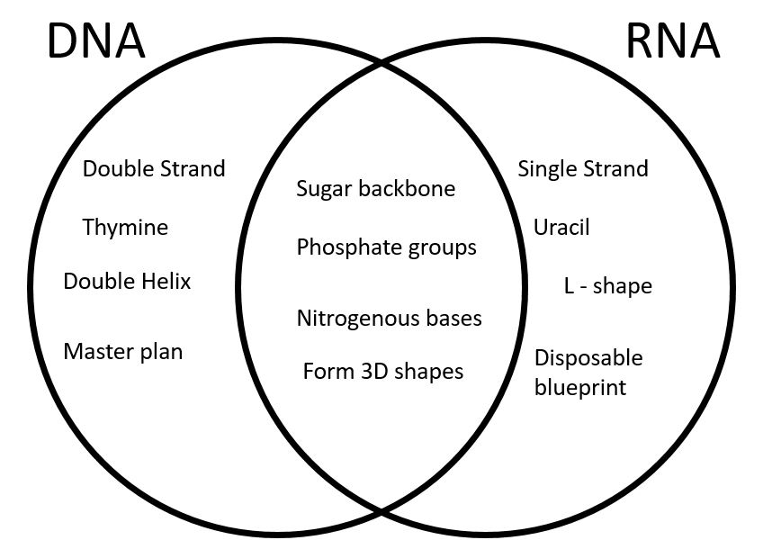
Here are some types of RNA:
- mRNA: messenger RNA that will be used as instructions to build proteins (the messenger!)
- tRNA: transfer RNA that carries amino acids to their proper place and help build the protein (helps transport the amino acids so they can be joined together)
- rRNA: ribosomal RNA that helps form the ribosome by combining with different proteins
RNA can fold into 3D shapes, and these shapes affect its function, or what it does. Today we will explore the 3D shape of a particular tRNA molecule. tRNA has a 5’ terminal phosphate group, an acceptor stem which is a 7- to 9-base pair stem, a CCA tail with a 3’ end, an anticodon arm, and some other loops or arms.
Middle:
Arrange students in centers with worksheets, tape, and scissors, and group roles cards. Ensure that each student knows his or her role. Display a completed 3D model of tRNA and inform students that it is what they are trying to achieve. Have students begin work, and monitor their progress. Point out where cuts need to be made, remind students not to cut all the way across the strip, and model mountain folds and valley folds.

End:
Once the majority of groups have completed their 3D model and all groups have made significant progress, ask students to identify different parts of the model. Use questions listed in the “Comprehension” block in the questioning section below. Choose a group, have a group member stand and display the group’s model and point out the appropriate feature.
Motivating Students
_x_ Verbal Reinforcement Encourage students as they create their models
Presenting Instructional Content
_x_ Lecture/Notes A brief lecture at the beginning reminds students of tRNA’s structure.
_x_ Venn Diagram Compare and contrast DNA and RNA
_x_ Hands-on. This is a hands-on activity to understand the 3D structure of tRNA.
Instructional strategies:
Modeling and Guided Practice – The teacher will model (pedagogical verb) some steps of the model (SEP noun) construction, particularly mountain and valley folding.
Check for Understanding (CFU) –
What am I doing for students that progress at different rates?
What do I do if they get it?
What do I do if they don’t get it?
QUESTIONING/THINKING/PROBLEM SOLVING (embedded throughout) | Balanced mix of question types. Utilizes Blooms Taxonomy/Webb’s Depth of Knowledge; high frequency; purposeful & coherent; require active responses; balance based on volunteers/non-volunteers, ability, & gender; lead to further inquiry & self-directed learning. Implement four types of thinking (Analytical, Practical, Creative, & Research-based) & Teach/Reinforce problem-solving types. Provide opportunities for students to generate ideas & alternatives; analyze, evaluate & explain information from multiple perspectives & viewpoints.
Questioning
Knowledge:
About how many nucleotides long is a tRNA molecule? [ 76 to 90, but any answer from 75 to 100 may be considered reasonable. It has to be long enough to fold, but it is not thousands of nucleotides long. By simply looking at the paper model one reaches the answer “76”]
What does the U on the paper strip stand for? [ Uracil ]
What on the paper model represents the phosphate groups of tRNA? [the little circles]
What on the paper model represents the ribose sugar? [ the little pentagons]
Name three types of RNA. [ messenger (mRNA), transfer (tRNA), ribosomal (rRNA) ]

Comprehension:
Where is the 5’ terminal phosphate group on your 3D paper model?
Where is the anticodon on your 3D paper model?
Where is the acceptor stem on your 3D paper model?
Where is the CCA3’ terminal group on your 3D paper model?

Application:
Why does the tRNA molecule fold the way that it does? [ Nucleotides bind with each other in the same way they do across a DNA ladder, but in tRNA some of the nucleotides bind with areas in the same strand that are not adjacent to themselves. ]
Does the extra oxygen on RNA’s sugar make it more or less stable than DNA? [ think fire ]
How does the position of the CCA3’ terminal group contribute to its function?

Analysis:
What features of RNA does this model ignore?
What was the point of using this model?

Synthesis:
What features of tRNA does this model represent well?
Evaluation:

Thinking(NOTE: Clearly identify where you will use each of these in your lesson; do not just check the box!)
_x_ Practical – Students have to read and follow instructions to create their model
_x_ Analytical – Students compare and contrast DNA and RNA, and they compare different parts of the tRNA model to identify relevant pieces
*What am I going to do to give Ss opportunity to?
1. Generate variety of ideas:
2. Analyze problems from multiple viewpoints:

Problem Solving
_x_ Predicting outcomes Students are asked to explain how the position of the CCA3’ terminal group affects its function in building proteins.
_x__ Categorization Students have to categorize parts of their models as the acceptor arm, anticodon loop, etc.
_x__ Identifying Relevant/Irrelevant Information Students are asked which features of tRNA are ignored in this model, that is, which are not relevant. They also have to decide which pieces of information will help them identify certain parts of the tRNA on the model.

GROUPING | Maximize student understanding & learning Varied group composition (race, gender, ability, & age); clearly understood roles, responsibilities & group work expectations; accountability for group & individual work; student opportunities for goal setting, reflection & evaluation of learning.
- Heterogeneous groups of 4 or 5.
- Roles include Reader/task focuser, Cutter 1, Taper, Folder. Everyone colors and does some cutting and some folding.
- Provide place cards at the center identifying Reader, Cutter 1, Folder 1, Taper, and Colorist/Cutter – as a student sits down, she will see her role and its description. See the attached group roles cards.
- Students should move to a center with scissors, tape, and the worksheet to complete this task.
- The group produces a 3D model of tRNA and identifies its anticodon.

ASSESSMENT | Formative and/or summative assessment. A variety of assessments, including rubrics, measure achievement of objectives and informs instruction.
Assessments: aligned with state stds; measurement criteria; measure student performance in more than 2 ways (project, experiment, presentation, essay, short answer, multiple choice test) (NOTE: Clearly identify where you will use each of these in your lesson; do not just check the box!)
___ ThinkLink Probe ___ Study Island ___ Teacher Made Test ___ Unit/Chapter Test ___ Project ___ Quiz
___ Group Assignment ___ Study Guide ___ Oral Presentation ___ Graphic Organizer ___ Exit Ticket
___ Journal ___ Questions/Answers
___Teacher Observation (thumbs up/thumbs down, etc.)___ Solution to Real World Problem
___ Other _________________________________________
*Students should achieve _____% mastery of this objective: ________________________________

CLOSURE | Reflection/Wrap Up. Summarizing, reminding, reflecting, restarting, connecting.
During the conclusion part of creating an effective lesson plan teachers must sum up the ideas learned from the lesson. A teacher should also relate this information to future and past coursework to provide students with a broad understanding of the ideas learned. It is important to allow students enough time to ask questions, assert assumptions, and summarize the lesson during this part of the lesson plan.
- Review/Summary: wrap up what has been learned and accomplished in the lesson (even if they are in the middle of an exercise, it is still important to summarize to the point where they are now). Ideally involve students in this synthesis.
- Preview for next lesson: link what they did to day with where they are going next.
- Upcoming assignments: remind them of any upcoming assignments.
Here is your exit ticket for today….. What is the anticodon on the model that you built?

Follow-up Activities/Extension These may be designed to create a longer or more intense lesson. For example, if the class is able to cover the material in a lesson much faster than expected, extensions may prove helpful. Extensions may also be useful in various parts of a lesson where the teacher (and class) decides they should spend more time on a skill or topic.

Reflection: You must reflect on every lesson you teach.

NOTES:

This work is licensed under the Creative Commons Attribution-ShareAlike 4.0 International License. To view a copy of this license, visit http://creativecommons.org/licenses/by-sa/4.0/ or send a letter to Creative Commons, PO Box 1866, Mountain View, CA 94042, USA.

