TEAM Lesson Plan Template
Teacher: Andrew Morency
Subject/Grade: High School Biology 1
Lesson Title: Egg carton/Pop bead translation
STANDARDS | Identify what you intend to teach. State, Common Core, ACT College Readiness Standards and/or State Competencies; Enduring Understandings and Essential Questions.
BIO1.LS1.4 Demonstrate how DNA sequence information is decoded through transcriptional and translational processes within the cell in order to synthesize proteins. Examine the relationship of structure and function of various types of RNA and the importance of this relationship in these processes

This lesson emphasizes:
Science practice: Developing and using models
CCC: Structure and Function

Learning performance: Students will use a model to replicate the translation process within a cell to synthesize a protein highlighting the structure and function of the mRNA and tRNA molecules and ribosomes.

OBJECTIVE(s)/Sub-Objectives | Connect prior learning to new learning. Clear, Specific, Observable, Demanding, High Quality, Measurable, Aligned to Standard(s), and Integrated with other subjects, build on prior student knowledge  Student-Friendly (I Can Statement)
I can model translation from mRNA to a sequence of amino acids

I can determine tRNA anti-codons from mRNA codons

I can use a codon wheel or chart to determine which amino acid corresponds to an mRNA codon

MATERIALS AND RESOURCES | Content-related: Clearly supports lesson objective(s); rigorous & relevant; Incorporates multimedia & resources beyond the textbook.
Activities & Materials
_x_ Whiteboard/markers or Computer/projector/Smartboard
_x_ Manipulatives: Jar of pop beads
_x_ Per group: Worksheet, Pencil, Codon wheel or chart, Three 3x2 egg carton sections (each section a different color, sections taped together, sections labeled A, P, E; top labeled 60S and bottom labeled 40S), a K’nex mRNA strand with 12 or 15 nucleotides beginning AUG and ending with an end codon, either UUA, UAG, or UGA (see pictures at the end of this lesson plan), Scissors, A half dozen 1” x 11” strips of paper (see tRNA template document), Six to eight pop beads.

Routine for distributing materials Students should begin class seated with their groups at tables with the materials.

ACCOMMODATIONS/ADAPTATIONS | Learning styles and interests. Anticipate learning difficulties, regularly incorporate student interests & cultural heritage; differentiate instructional methods.
Modifications/Plans for Diverse Learners (NOTE: Clearly identify where you will use each of these in your lesson; do not just check the box!)
Differentiation
----- Content
----- Process
-----Product
----- Tiered Assignments
----- Flexible Grouping
----- Learning Centers ____ Other __________________________________________

Accommodations
___ Preferential Seating ___ Extended Time ___ Small Group ___ Peer Tutoring
___ Modified Assignments ___ Other
Early Finishers:

MOTIVATING STUDENTS/ANTICIPATORY SET | “Hook”: Engage students’ attention and focus on learning. Personally meaningful and relevant.
Write on the board what each part of the K’NEX kit represents, by color (or project this information using the K’NEX Colors PowerPoint presentation).

INSTRUCTIONAL PROCEDURES | Step-by-Step Procedures-Lesson Sequence: Basic to Complex. Lesson includes visuals, modeling, logical sequencing and segmenting (beginning, middle, ending); essential information; concise communication; grouping strategies; differentiated instructional strategies to provide intervention & extension; seamless routines; varied instructional strategies; key concepts & ideas highlighted regularly.
Introduction.
Write major points on a board, or project them as you discuss:
In an earlier lesson on transcription, we saw how an mRNA sequence is produced from a DNA sequence. We noted that the mRNA strand might have to be trimmed a bit (those introns and exons). We also acknowledged that the mRNA molecule has to get outside the nucleus somehow. In another earlier lesson, we saw how a tRNA molecule has a CCA3’ tail to which an amino acid may attach. Today we are looking at translation, the creation of proteins, which happens outside the nucleus after the mRNA molecule moves outside the nucleus.
The nucleotides on the new mRNA molecule are read in groups of 3. The group of 3 nucleotides, or letters, such as AUG, AAC, and so on, is called a codon. Proteins are built based on these codons. That is, the codons call for a particular amino acid, and a string of amino acids is a peptide. A long enough chain, at least 50 amino acids, is a protein.
How many possible codons are there? Let students think about this. [ There are 4 possibilities for the first letter, 4 for the second, and 4 for the third. We have 4 x 4 x 4 = 64 possibilities. ]
There are only 20 different amino acids, so some codons encode (call for) the same amino acid.
Ribosomes are organelles outside the nucleus where proteins are made. Ribosomes are made of rRNA and collections of proteins. In eukaryotes we use 80S ribosomes. 80S ribosomes are made of two subunits, 40S and 60S. mRNA travels from the nucleus to the ribosome to assemble a new protein. This assembly process is called translation. (Transcription is like making a copy of an English text in English (nucleotides to nucleotides). Translation is like making a copy of the English text in Russian (nucleotides to amino acids).
mRNA attaches to the ribosome. At the first attachment, a start codon attaches to the P site. All other codons first attach at the A (arrive) site. Amino acids are assembled at the P (push together) site, and codons leave the ribosome at the E (exit) site. Notice the sites on your ribosome models.
Middle: We are going to model translation. You should be seated at a table with three or four classmates with a Worksheet, a codon wheel, a ribosome (egg carton contraption), a strand of mRNA (K’nex contraption), some pop beads, some tape and scissors, and some little strips of paper. Find and read your roles cards.
Watch me while I show you how to make an anticodon loop and attach an amino acid. Demonstrate labeling, cutting, folding, and taping a pop bead. Now, follow my instructions.
- Recorders, cut some strips of tape and hang them on the edge of the table
- mRNA movers, place the start codon in the middle P position in the 40S part of your ribosome. The second codon should lie in the A position. You should have a purple phosphate group pointing to your left. There should be one nitrogenous base for each of three little eggcups in the middle P site.
- mRNA movers, read the colors, from left to right, from the start codon in the P site [ this should be white purple gray ]
- Codon Wheel passers, look at the board (to see the colors) and determine which nitrogenous bases are in the codon. Use the codon wheel to determine the corresponding amino acid. Figure out the anticodon. Tell the tRNA maker and the Recorder the codon, the amino acid, and the anticodon
- Recorders, write the codon, the amino acid, and the anticodon on the worksheet
- tRNA makers, write the anticodon sequence in the boxes on a paper strip. Fold the strip into a loop and secure by interlocking the slits. Tape a bead to the paper. Pass the anticodon loop to the tRNA passer who should pass it to the Protein builder.
- Protein builder, place the anticodon loop in the P site. Verify that the anticodon fits the codon. If not, discuss this with the last person to read the codon wheel.
- Codon Wheel passers, pass the wheel.
- Recorder, you should have the codon wheel.
- mRNA movers, read the colors, from left to right, from the codon in the A site
- Recorders, look at the board (to see the colors) and determine which nitrogenous bases are in the codon. Use the codon wheel to determine the corresponding amino acid. Figure out the anticodon. Tell the tRNA maker the codon, the amino acid, and the anticodon. Write the codon, the amino acid, and the anticodon on the worksheet.
- tRNA makers, write the anticodon sequence in the boxes on a paper strip. Fold the strip into a loop and secure by interlocking the slits. Tape a bead to the paper. Pass the anticodon loop to the tRNA passer who should pass it to the Protein builder.
- Protein builders, place the anticodon loop in the A site. Verify that the anticodon fits the codon. If not, discuss this with the last person to read the codon wheel.
- mRNA movers, slide the mRNA molecule and the attached anticodon loops (with their tRNAs and amino acids) one codon (three nucleotides) to the left. The first codon should now lie in the E site and the second codon should be in the P site.
- Protein builders, detach the first amino acid from its anticodon loop and attach it to the second amino acid in the P site. The first anticodon loop can drift away.
- Codon Wheel passers, pass the wheel.
- mRNA movers, read the colors, from left to right, from the codon in the A site
- Whoever has the codon wheel, look at the board (to see the colors) and determine which nitrogenous bases are in the codon at the A site. Use the codon wheel to determine the corresponding amino acid (if the codon codes for STOP, then STOP). Figure out the anticodon. Tell the tRNA maker and the Recorder the codon, the amino acid, and the anticodon.
- Recorders, write the codon, the amino acid, and the anticodon on the worksheet.
- tRNA makers, write the anticodon sequence in the boxes on a paper strip. Fold the strip into a loop and secure by interlocking the slits. Tape a bead to the paper. Pass the anticodon loop to the tRNA passer who should pass it to the Protein builder.
- Protein builders, place the anticodon loop in the A site. Verify that the anticodon fits the codon. If not, discuss this with the last person to read the codon wheel.
- mRNA movers, slide the mRNA molecule and the attached anticodon loops one codon (three nucleotides) to the left. Detach any nucleotides that have extended past the E site.
- Protein builders, detach the next to last amino acid from its anticodon loop and attach it to the amino acid in the P site. The anticodon loop with no amino acid can drift away.
- Repeat steps 16-23 until reaching a codon that codes for STOP.
- Once reaching the STOP codon, detach the new polypeptide chain (which would be a protein if it were longer, that is, if we had more K’nex pieces and more time).
Ending:
Regain the whole group’s attention. Discuss: What process were we modeling? [ translation ] Where does translation occur? [ at a ribosome, outside the nucleus ]. What in our model represented the ribosome? [the egg cartons ] What holds the instructions for constructing a protein? [mRNA]. What brings the required amino acids to the ribosome? [tRNA] How many possible codons are there? [64] How many amino acids are there? [ 20 ] What does translation produce? [ A string of amino acids ] What is a long string of amino acids called? [a peptide or protein ]. How is translation different from transcription? [ Translation happens outside the nucleus and produces proteins. Transcription happens inside the nucleus and produces another string of nucleotides. ]
Motivating Students
_x_ Verbal Reinforcement Encourage students as they create their models
_x_ Relate to Real World This is how our cells build our bodies, how our bodies build ourselves.
Presenting Instructional Content
_x_ Lecture/Notes A lecture at the beginning recalls transcription, introduces codons, introduces degeneracy, and introduces the ribosome.
_x_ Hands on: Students use a model to visualize translation as they move mRNA, anticodon loops, and amino acids against a ribosome
_x_ Discussion after students have used the model reinforces the vocabulary associated with translation.
Instructional strategies:
Modeling and Guided Practice – Observe students’ construction of the model. If necessary, help them assemble a nucleotide or a portion of the DNA strand.
Check for Understanding (CFU) –
What am I doing for students that progress at different rates?
What do I do if they get it?
What do I do if they don’t get it?
QUESTIONING/THINKING/PROBLEM SOLVING (embedded throughout) | Balanced mix of question types. Utilizes Blooms Taxonomy/Webb’s Depth of Knowledge; high frequency; purposeful & coherent; require active responses; balance based on volunteers/non-volunteers, ability, & gender; lead to further inquiry & self-directed learning. Implement four types of thinking (Analytical, Practical, Creative, & Research-based) & Teach/Reinforce problem-solving types. Provide opportunities for students to generate ideas & alternatives; analyze, evaluate & explain information from multiple perspectives & viewpoints.
Questioning
Knowledge:
What process were we modeling? [ translation ]
How many amino acids are there? [ 20 ]
What is a long string of amino acids called? [a protein ].

Comprehension:

How many possible codons are there?
Where does translation occur? [ at a ribosome, outside the nucleus ].
What in our model represented the ribosome? [the egg cartons ]
What holds the instructions for constructing a protein? [mRNA].
What brings the required amino acids to the ribosome? [tRNA]
How many possible codons are there? [64]
What does translation produce? [ A string of amino acids ]

Application:
Explain how translation different from transcription? [ Translation happens outside the nucleus and produces proteins. Transcription happens inside the nucleus and produces another string of nucleotides. ]

Analysis:
What features of translation or the respective molecules does this model ignore?
What features of translation or the respective molecules does this model ignore?

Synthesis:

Evaluation:

Thinking
_x_ Practical – Participation in this activity requires close attention to instructions and teamwork, regardless of whether students understand translation from the model.
_x_ Creative– Students get to choose which pop beads represent which amino acids
_x_ Analytical – Students calculate the possible number of codons and they compare and contrast transcription and translation.

*What am I going to do to give Ss opportunity to?
1. Generate variety of ideas:
2. Analyze problems from multiple viewpoints:

Problem Solving
_x__ Categorization Students have to use the codon wheel to see which codons produce which amino acids. They also have to ensure that each base in the anticodon corresponds to a base in the codon, thus placing the bases in categories.
_x__ Identifying Relevant/Irrelevant Information Students have to focus on one codon at a time, ignoring those to the left and the right

GROUPING | Maximize student understanding & learning Varied group composition (race, gender, ability, & age); clearly understood roles, responsibilities & group work expectations; accountability for group & individual work; student opportunities for goal setting, reflection & evaluation of learning.
- Use heterogeneous groups of 4 or 5.
- Roles are Wheel/tRNA passer, Recorder, mRNA mover, tRNA maker, Protein assembler. The Wheel/tRNA passer ensures that each group member takes a turn interpreting the anticodon from the codon and interpreting the protein from the codon. Each person doing this instructs the tRNA maker with the correct values, and the recorder records these. The Wheel/tRNA passer also passes the tRNA from the maker to the Protein assembler. In a group of 4, combine the Wheel/tRNA passer and Recorder roles.
- Use place cards. Students learn their roles by where they sit.
- Students begin class seated with their groups.
- Each group produces Codon/Anticodon/Protein worksheet.

ASSESSMENT | Formative and/or summative assessment. A variety of assessments, including rubrics, measure achievement of objectives and informs instruction.
Assessments: aligned with state stds; measurement criteria; measure student performance in more than 2 ways (project, experiment, presentation, essay, short answer, multiple choice test) (NOTE: Clearly identify where you will use each of these in your lesson; do not just check the box!)
___ ThinkLink Probe ___ Study Island ___ Teacher Made Test ___ Unit/Chapter Test ___ Project ___ Quiz
___ Group Assignment ___ Study Guide ___ Oral Presentation ___ Graphic Organizer ___ Exit Ticket
___ Journal ___ Questions/Answers
___Teacher Observation (thumbs up/thumbs down, etc.)___ Solution to Real World Problem
___ Other _________________________________________
*Students should achieve _____% mastery of this objective: ________________________________

CLOSURE | Reflection/Wrap Up. Summarizing, reminding, reflecting, restarting, connecting.
During the conclusion part of creating an effective lesson plan teachers must sum up the ideas learned from the lesson. A teacher should also relate this information to future and past coursework to provide students with a broad understanding of the ideas learned. It is important to allow students enough time to ask questions, assert assumptions, and summarize the lesson during this part of the lesson plan.
- Review/Summary: wrap up what has been learned and accomplished in the lesson (even if they are in the middle of an exercise, it is still important to summarize to the point where they are now). Ideally involve students in this synthesis.
- Preview for next lesson: link what they did to day with where they are going next.
- Upcoming assignments: remind them of any upcoming assignments.
Here is your exit ticket for today….. Fill in the blanks: The first codon for a eukaryotic cell protein is _____, and it encodes the amino acid _____. [ AUG, methionine]

Follow-up Activities/Extension These may be designed to create a longer or more intense lesson. For example, if the class is able to cover the material in a lesson much faster than expected, extensions may prove helpful. Extensions may also be useful in various parts of a lesson where the teacher (and class) decides they should spend more time on a skill or topic.

Reflection: You must reflect on every lesson you teach.

NOTES:

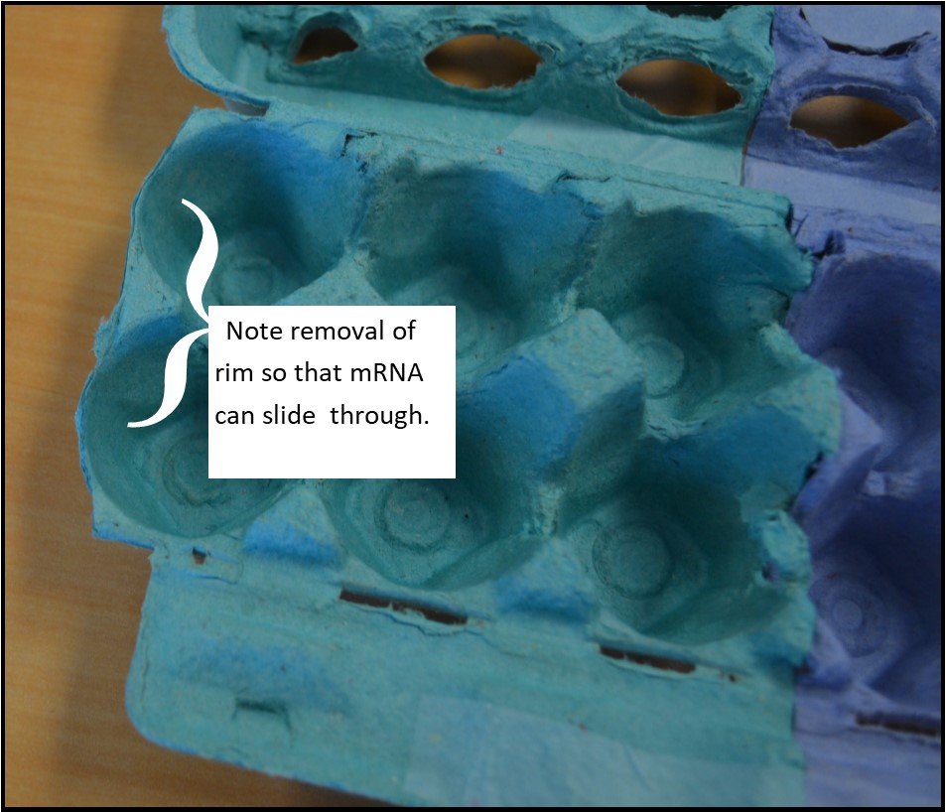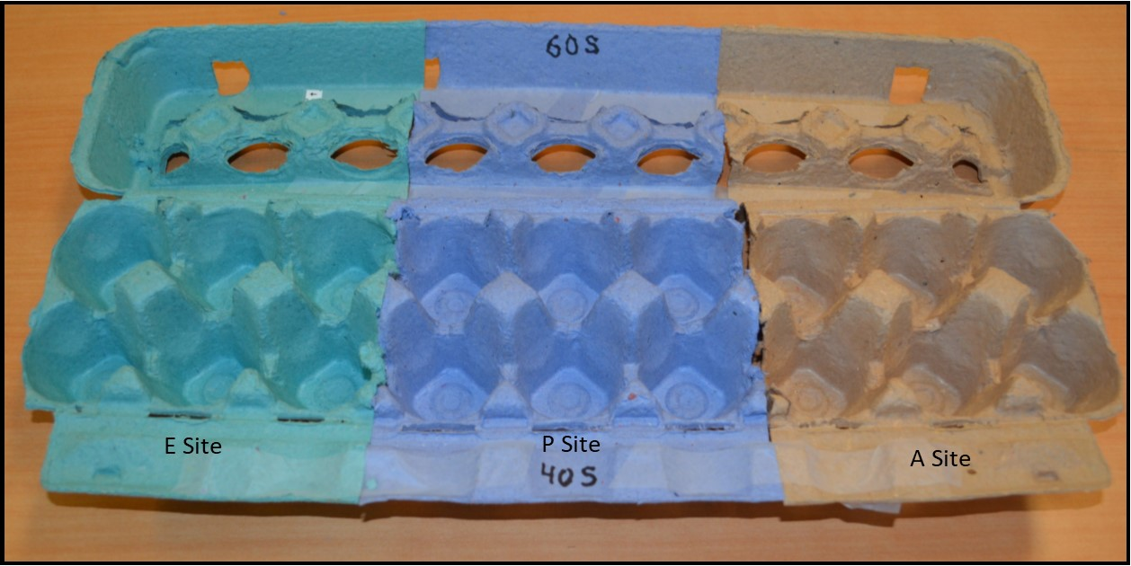
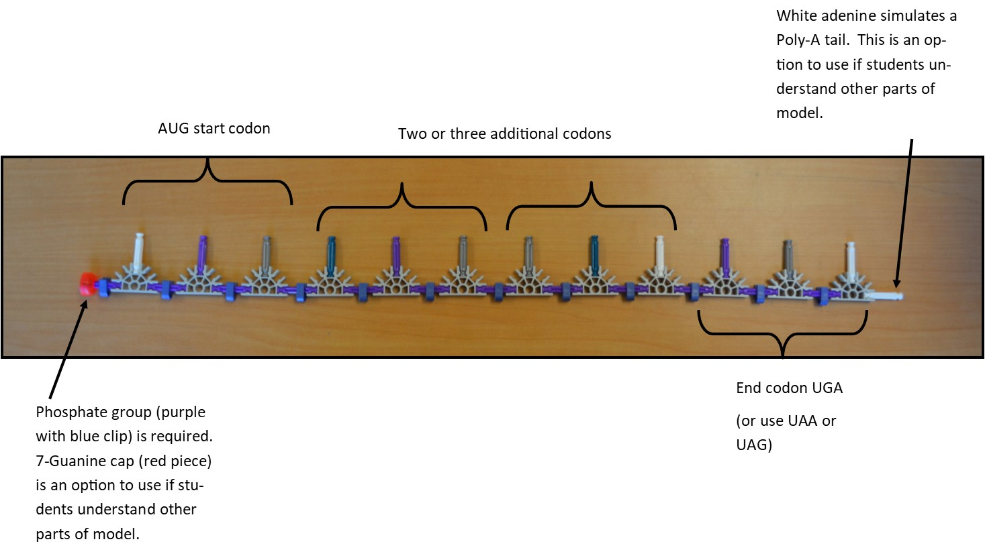

This work is licensed under the Creative Commons Attribution-ShareAlike 4.0 International License. To view a copy of this license, visit http://creativecommons.org/licenses/by-sa/4.0/ or send a letter to Creative Commons, PO Box 1866, Mountain View, CA 94042, USA.

Name __________________________ Name ____________________________
Name __________________________ Name ____________________________
Name __________________________
Codon | Amino Acid | Anticodon

