Investigating the Structure of Ionic Compounds
Electrolysis means to break with electricity. In this short experiment, you will investigate the structure of Copper (II) chloride by performing electrolysis. Copper (II) chloride is highly toxic if swallowed or inhaled. Do not eat or drink while working with Copper (II) chloride. Use caution when obtaining the Copper (II) chloride and wash hands thoroughly after working with this compound.

1. Set up an electrolysis apparatus by taping two pieces of pencil graphite to the inside of another 100-mL beaker. Hook the tips of the 9-V connector wire to the pieces of pencil graphite. Tape them in place, making sure that there is contact between the wire and the graphite.

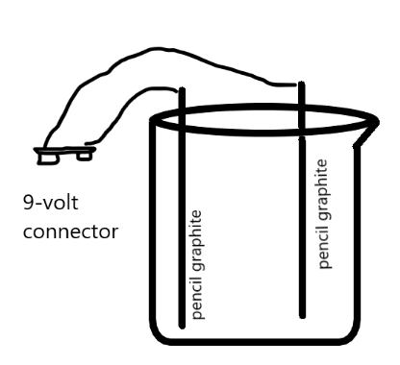

2. Pour 30mL distilled water into the beaker with the graphite electrodes. Place a piece of white paper beneath the beaker.

3. Connect the 9-Volt battery and allow the electrolysis process to proceed for three minutes. Describe what happens. Disconnect the battery.

4. Using the balance, obtain 0.5 grams of Copper (II) chloride in a 100-mL beaker. List at least three physical properties of this compound.

5. Dissolve the copper (II) chloride in 30 mL of distilled water pour the distilled water from your beaker into the graduated cylinder. Pour the copper (II) chloride solution into the electrolysis apparatus.

6. Connect the 9-Volt battery and allow the electrolysis process to proceed for ten minutes.

7. As the electrolysis proceeds, list your observations. Take special note of any changes that occur over the next 10 minutes. Note which changes take place at the positive electrode and at the negative electrode.

_____________________________________________________________________________________
_____________________________________________________________________________________
_____________________________________________________________________________________
_____________________________________________________________________________________
_____________________________________________________________________________________

8. Watch a video animation of an ionic compound dissolving in solution. In the space below, sketch a particle diagram illustrating the ions from Copper (II) chloride after they have dissolved in the water.

9. As a group, propose an explanation for the observations that you have made during the electrolysis activity at the beginning of the class. Illustrate your explanation as a particle diagram on a whiteboard or chart paper divided into two halves, as shown in the figure below. Provide evidence and reasoning based on your understanding of how current flows and how ions dissolve in solution. Be sure to include the following in your drawing. Be prepared to share your explantation with the rest of the class.
- Solute particles, including charges
- Motion of the particles with arrows indicating motion
- Positive electrode
- Negative electrode

Illustration and Explanation
Evidence

10. Explain how the structure of the ionic compound Copper (II) chloride is related to today’s activity.

_____________________________________________________________________________________

_____________________________________________________________________________________

_____________________________________________________________________________________

11. Post your picture and explanation so that it is suitable for the whole class to view.

