TEAM Lesson Plan Template
Teacher: Dr. Jason DeVito
Subject/Grade: Mathematics, Expressions and Equations, Grade 8
Lesson Title: Bug Race
STANDARDS | Identify what you intend to teach. State, Common Core, ACT College Readiness Standards and/or State Competencies; Enduring Understandings and Essential Questions.
SMP1 Make sense of problems and persevere in solving them.
SMP3 Construct viable arguments and critique the reasoning of others.
SMP4 Model with mathematics.

Math Literacy Skill 4. Write mathematical arguments.

7.RP.A.2 Recognize and represent proportional relationships between quantities.

8.EE.B.5 Graph proportional relationships, interpreting the unit rate as the slope of the graph. Compare two different proportional relationships represented in different ways. For example, compare a distance-time graph to a distance-time equation to determine which of two moving objects has greater speed.

OBJECTIVE(s)/Sub-Objectives | Connect prior learning to new learning. Clear, Specific, Observable, Demanding, High Quality, Measurable, Aligned to Standard(s), and Integrated with other subjects, build on prior student knowledge  Student-Friendly (I Can Statement)
I can understand data presented in a variety of formats, including graphs, tables, and equations.
I can understand speed as the slope of a line in a graph.
I can understand speed as the sloe of a line in an equation.
I can figure out which bug won the race!

MATERIALS AND RESOURCES | Content-related: Clearly supports lesson objective(s); rigorous & relevant; Incorporates multimedia & resources beyond the textbook.
Activities & Materials
_x_ Laptop/Computer; _x_ Projector; used at end to show movie of race from .gif files.
_x_ Worksheets/Handouts Ten copies of the Data.doc file with one copy cut into half-sheets; One copy each of Data A.doc, Data B.doc, . . . , Data I.doc.
_x_ Room for 9 different stations to which students will rotate; _x_ Writing surface at each station
_x_ Pencils and rulers for each of 9 groups of students; Students will need to draw graphs at each station.
What if the technology is not working? Skip the movie at the end. Students can still complete the activity and answer all questions.
Routine for distributing materials; Materials are placed at stations before class.

ACCOMMODATIONS/ADAPTATIONS | Learning styles and interests. Anticipate learning difficulties, regularly incorporate student interests & cultural heritage; differentiate instructional methods.
Modifications/Plans for Diverse Learners
Differentiation
----- Content Most students will determine the format to which to convert by looking at their data sheet. For some students, it may be appropriate to tell them, for example “Convert this information to a graph where laps are on the horizontal axis and time is on the vertical axis.”
----- Process For some students it may be appropriate to break the assignment into smaller parts. Rather than converting each format to each of the others in one day, have these students convert Data A to the Data B format, then try converting Data A to the Data C format at another time.
----- Product Most students will draw their new graphs from scratch. For some students, it may be appropriate to provide them with graph paper on which to draw, or even graphs, without data, prepared in the proper format.

Accommodations
__x_ Preferential Seating If a student has mobility issues, it may be better to move the worksheets from station to station rather than have students move. At the appropriate time, simply have students pass their “DataX.doc” file to the right (or left, the point being to get it to the next group).
_x__ Small Group Students will work in small groups and should discuss problems to help each other find answers.

Early Finishers: If a group is consistently finishing each station faster than others, have them, in addition to converting to the specified format, express the given bug’s speed as a numerical value (in laps/minute) and record this value on Their copy of their notes.
Once students have returned to their seats, if a group correctly identifies the order in which the bugs finish the race, then they should express each bug’s speed as a numerical value. If they finish that, too, then they should have quiet free time at their desks to read, study, or do homework.

MOTIVATING STUDENTS/ANTICIPATORY SET | “Hook”: Engage students’ attention and focus on learning. Personally meaningful and relevant.
Tell the story of the race. Nine bugs are going to run a race involving many laps on a circular race course. Each bug warms up by running/crawling a few laps at a constant speed. Each of 9 students, whose names begin with A,B,C,D,E,F,G,H, and I, (Andrew, Ben, Christy, Damien, Elizabeth, Frank, Gina, Hector, Isabella) watches only one of these warmups. Each student reports some kind of data relating the number of laps with the time taken. However, each student used a different format to report the data! We have to find a way to compare the reports to figure out the order in which the bugs will finish the race.

INSTRUCTIONAL PROCEDURES | Step-by-Step Procedures-Lesson Sequence: Basic to Complex. Lesson includes visuals, modeling, logical sequencing and segmenting (beginning, middle, ending); essential information; concise communication; grouping strategies; differentiated instructional strategies to provide intervention & extension; seamless routines; varied instructional strategies; key concepts & ideas highlighted regularly.
Introduction
We have looked at a variety of ways to represent speed. We can interpret speed as the slope of line. We can interpret speed as a unit rate. We can interpret speed as a ratio of distance to time. Today we will work together to convert from a variety of these interpretations to a variety of others.
Work an example: Suppose Lucy walks 3 miles in one hour. We might draw either of the two graphs:
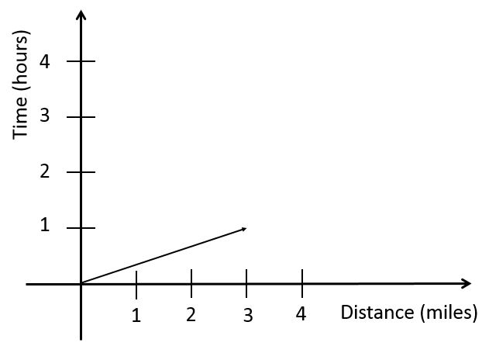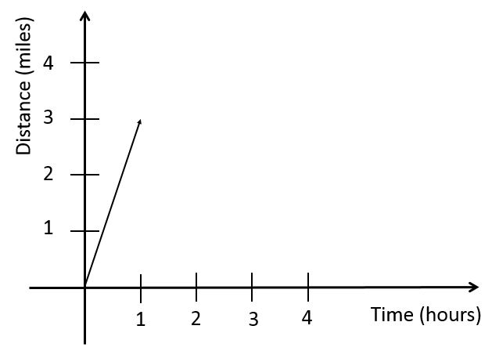
Or we might write the equation d = 3 t where d represents distance in miles and t represents time in hours. Each of these looks different, but each correctly represents the situation.
Motivating Students
_x_ Game When a group believes that they have identified the winning bug, they should announce “We have a winner.” The teacher will move to the group, and they will show the winning bug IN WRITING so no one can hear their answer. The teacher will make a note of the group and their answer. The teacher will not say whether they are right or wrong. At the end of class, the teacher will reveal the first group to have correctly identified the winning bug. They will get a small prize or privilege.
_x_ Verbal Reinforcement throughout the activity
_x_ Small Reward at the end of the activity for the winning team
Presenting Instructional Content
_x_ Lecture/Notes brief example during introduction _x_ Game
_x_ Discussion Students will discuss solutions within their groups
Instructional strategies:
Modeling and Guided Practice Before class, establish 9 stations. Each will need a writing surface. At each station, place a printed copy of Data.doc, a few pencils, a few pieces of scratch paper, and a ruler. In addition, at the first station place 1) a printed copy of Answer A.doc and 2) Andrew’s data from Data.doc. At the second station, place 1) a printed copy of Answer B.doc and 2) Ben’s data from Data.doc. Continue: at each station place a copy of the appropriate blank answer sheet and the data for a particular bug from the story, ending with 1) a printed copy of Answer I.doc and 2) Isabella’s data from Data.doc at station 9.
After providing the introduction and examples, separate students into nine groups, and have each group move to a station. As a whole group, flip through the data provided in Data.doc. Discuss the format. Is it a graph? A table? An Equation? For graphs, which quantity is represented on the horizontal axis?
Have students write their names on the first page of the “Answer X.doc” worksheet. The group at Station 1 should identify Ben’s format from Data.doc. All other groups need to identify Andrew’s format. Explain that they are to do two things: 1) Convert the data at the station to the indicated format and 2) Explain why the answer is correct. Emphasize that they will only convert to one format at this station; they will not move on to the next set of answer blanks. Ask a student to explain what they are supposed to do. Give them five minutes to convert formats and explain why their answer is correct.
Monitor student work and provide encouragement. Encourage neatness.
When it is time to rotate, have students pick up the copy of Data.doc, but leave everything else at the station. The group will keep that copy of Data.doc and may make notes on it. Have students rotate to the next station. After rotation, the groups at Stations 1 and 2 should identify Christy’s format. All other groups should identify Ben’s format. They can determine this by finding the first blank page in the “Answer X.doc” printout at their station. Have students write their names on the first blank page of the “Answer X.doc” printout at their station, and give them five minutes to make the conversion and explain why their answer is correct.
Continue to rotate until all pages of each “Answer X.doc” are completed.
Ask students, “What have we accomplished?” (Answer: We have expressed each bug’s speed in each student’s data format. Now we can compare each bug’s speed to the other bugs’ speeds using whichever format that we want.)
At this point, students may return to their seats or visit the various stations to compare bug speeds. Now the goal of the students is to figure out which bug is fastest by comparing answers across different answer sheets. If you want to determine whether, for example, bug A or bug G is faster, you can see how Andrew recorded bug A's data (as a line of slope 1/4), then on answer sheet G, you can see how Andrew would have recorded bug G's data. (as a line of slope 1). Since 1/4 < 1, bug G must be faster.
Regardless of which group first correctly identifies the winning bug, all groups should work to find the order of the bugs’ speeds, from slowest to fastest.

Encourage students to make lots of varied comparisons until the final order is revealed.
The order is A < C < D < I < G < H < E < F < B, so bug B wins the race.

Regain the whole group’s attention. Show the movie of the bug race allbugs.gif to let students see the various bugs’ speeds. It should be clear which bug is fastest and which is the slowest.
Check for Understanding (CFU) –
What am I doing for students that progress at different rates? Provide verbal encouragement, and have students within groups assist each other. If a group is consistently waiting for other groups to finish, remind them that they should be taking notes on their Data sheet so that they can compare the various bugs’ speeds.
What do I do if they get it? Each of the conversions is a bit different, so it will not be obvious that students get everything until they have completed their work at each station. However, if students are doing well, reduce the amount of time at each station.
What do I do if they don’t get it? If students struggle, point out that for each conversion, all they need are two things: 1) Which quantity is represented on which axis? and 2) Two points on the line (one of which will always be (0,0) ). From these two pieces of information they can construct a line and select the appropriate points to convert to any of the formats.
QUESTIONING/THINKING/PROBLEM SOLVING (embedded throughout) | Balanced mix of question types. Utilizes Blooms Taxonomy/Webb’s Depth of Knowledge; high frequency; purposeful & coherent; require active responses; balance based on volunteers/non-volunteers, ability, & gender; lead to further inquiry & self-directed learning. Implement four types of thinking (Analytical, Practical, Creative, & Research-based) & Teach/Reinforce problem-solving types. Provide opportunities for students to generate ideas & alternatives; analyze, evaluate & explain information from multiple perspectives & viewpoints.
Questioning
Knowledge:
Which quantity is represented on the horizontal axis?

Comprehension:
At time zero, how many laps had each bug completed?
What does the slope represent?
Does (fill in the name from the story)’s bug speed up and slow down, or move at a constant rate?

Application:
Can you identify two points from the given representation? How could you express these points using the other representation?
Which bug won the race? Which came in last?

Analysis:
How do you know your answer is correct?
What have we accomplished?
For a given bug, if we swap the axes from horizontal-time/vertical-distance to horizontal-distance/vertical-time, what happens to the slope?

Synthesis:
Evaluation:

Thinking
__ Practical – While the bug race is fictional, races actually happen, so this is a real world scenario. The fact that different people will provide information in a variety of formats is an actual real-world fact. We need to be able to interpret whichever format someone uses.
__ Creative– Students may use a variety of techniques to make their conversions, including drawing pictures, making additional tables, or acting out the roles of various bugs.
__ Analytical – At each station students analyze the bugs’ speeds and explain their reasoning. At the end of the activity, they compare the bugs’ speeds.
__ Research-based – Each station exposes students to a different way of representing data.
*What am I going to do to give Ss opportunity to?
1. Generate variety of ideas: Students have to discuss why they know that their answers are correct. There are several ways to know. They can discuss lines in terms of pairs of points, a point and a rate of change, or as a table, for example.
2. Analyze problems from multiple viewpoints: Through discussion within groups, students should realize that their peers have different ways of understanding linear data.

Problem Solving Note: Teach 2 or more types of problem solving (NOTE: Clearly identify where you will use each of these in your lesson; do not just check the box!)
_x__ Abstraction Hector’s representation uses a variable, which is quite abstract. Isabella’s data set contains only one point. Students have to supply an additional point (0,0) by interpreting the starting line and starting time abstractly.
_x__ Drawing conclusions/Justifying Solutions Students have to explain their reasoning at each station.
_x__ Identifying Relevant/Irrelevant Information In each data set, two points provide enough information to answer the question, but most of the data sets provide many more points. Also, students have to pay attention to which quantity is on which axis.
_x__ Creating and Designing Students have to create graphs, tables, and equations.

GROUPING | Maximize student understanding & learning Varied group composition (race, gender, ability, & age); clearly understood roles, responsibilities & group work expectations; accountability for group & individual work; student opportunities for goal setting, reflection & evaluation of learning.
- Students work in nine heterogeneous groups
- A member of each group will be a timekeeper, and another will be the recorder who writes on the sheet at each station.
- Verbal instructions will provide expectations for each role.
- Groups will provide an answer at each station and will produce an answer to the question “Which bug won? The competed answer sheets will be available for assessment.

ASSESSMENT | Formative and/or summative assessment. A variety of assessments, including rubrics, measure achievement of objectives and informs instruction.
Assessments:
_x__ Teacher Made Test At a later date a test question or questions will ask students to convert from one representation of linear data to another as in the activity.
_x__ Group Assignment The completed Answer sheets provide a means for formative assessment to see if students know how to convert from various representations of linear data to other representations.
_x__ Questions/Answers The “How do you know your answer is correct?” question for each answer will allow an assessment of students’ depth of understanding.

CLOSURE | Reflection/Wrap Up. Summarizing, reminding, reflecting, restarting, connecting.
- Review/Summary: After showing the movie of all the bugs racing, summarize: Today we looked at a variety of ways to represent linear data and unit rates. We dealt with the very real problem that different people will give us information in different formats. Which bug was the fastest? __________ After getting the answer to this question from the whole group, recognize the small group which first correctly answered the question.
- Preview for next lesson: link what they did to day with where they are going next.
- Upcoming assignments: remind them of any upcoming assignments.
Let’s review our I Can statements…… Use equity cards to get three students to read the first three I can statements:
I can understand data presented in a variety of formats, including graphs, tables, and equations.
I can understand speed as the slope of a line in a graph.
I can understand speed as the sloe of a line in an equation.

Follow-up Activities/Extension

Reflection: You must reflect on every lesson you teach.

NOTES:
This work is licensed under the Creative Commons Attribution-ShareAlike 4.0 International License. To view a copy of this license, visit http://creativecommons.org/licenses/by-sa/4.0/ or send a letter to Creative Commons, PO Box 1866, Mountain View, CA 94042, USA.

