Name:_______________ Name:_______________ Name:_______________

Name:_______________ Date:________________

Fractions using power solids

1. List the four solids (cylinder, cone, hemisphere, sphere) in order from least volume to greatest volume.

2. Suppose the sphere has a volume of 1 cubic unit. What are the volumes of the cylinder, cone, and hemisphere?

3. Plot your answers in step 2 on the following number line.

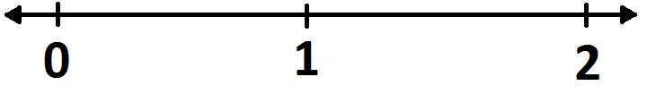

4. In question 2, you should have seen that the volume of the cylinder is 1 1/2 cubic units. The number 1 1/2 is equal to the fraction 3/2. Use this to fill in the blanks.

We can perfectly fill the cylinder ___ times using the sphere _____ times.

5. Suppose we instead have the volume of the hemisphere equal to 1 cubic unit. Using your answer to question 2, compute the volume of the sphere and cylinder.

6. Plot your answers to question 5 on the following number line.

7. By pouring water from one solid to another, how can you verify your answer to question 5?

8. Suppose that the volume of the cylinder is 1 cubic unit. What are the volumes of the hemisphere and sphere?

