Name:_______________ Name:_______________ Name:_______________
Name:_______________ Date:________________

Discovery Park of America Sign

The goal of this exercise is to estimate the number of squares in the Discovery Park of America sign.

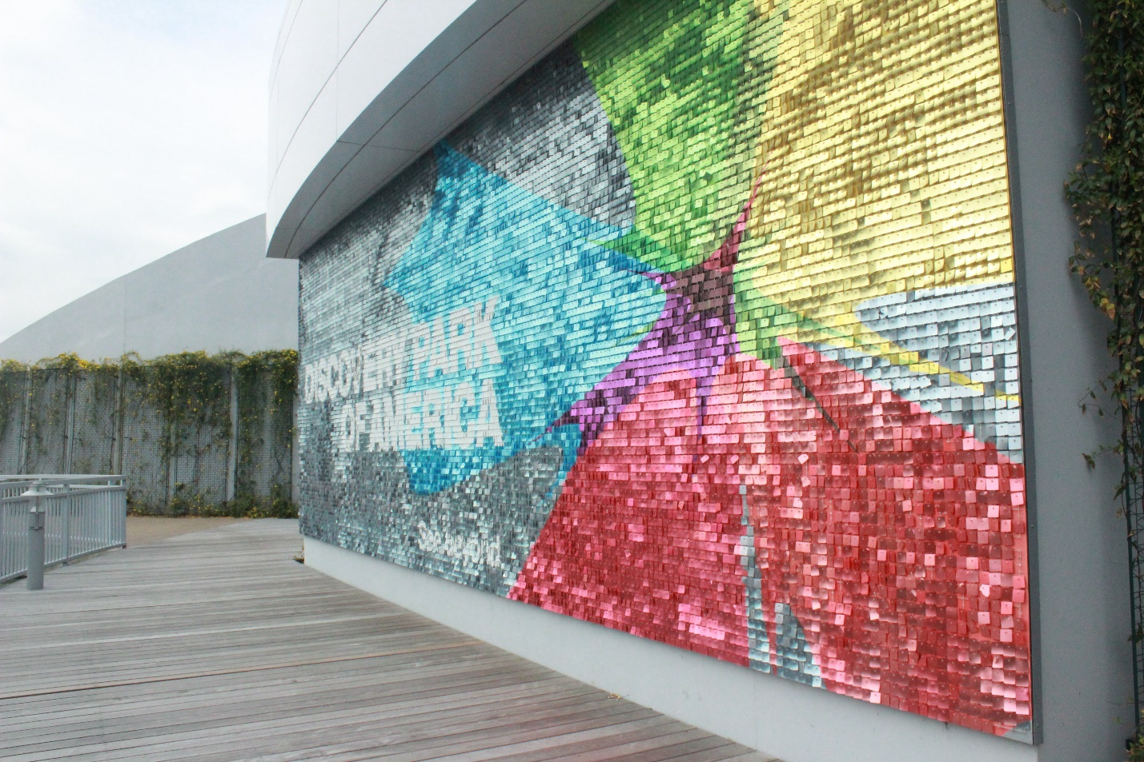

1. A dollar bill has length 6.14 inches. Estimate the length of each square.

2. In square inches, what is the area of each square?

3. The staff at Discovery Park were kind enough to provide the dimensions of the sign. The sign is 11 feet high and 32 feet wide. What is the total area of the sign in square feet?

4. What is the total area of the sign in square inches?

5. Using your answers to question 5 and question 2, how many little squares make up the sign?

6. How many squares fit vertically on the sign? How many fit horizontally?

7. Using your answer to question 6, how many small squares make up the sign?

8. Do your answers to questions 5 and 7 match? If not, what could explain the discrepancy? Which do you think is a better estimate? Why?

9. The actual number of squares is ASK YOUR TEACHER to reveal the number . How does your estimate compare? What explains the discrepancy?

10. Suppose the length and width of each square both shrink to half their size. How many squares fill up the sign now?

11. If the height of the sign were to double, how many squares would fit on the sign?

12. Estimate how many squares make up the white "D" in the phrase "Discovery Park".

