Discovery Park of America Sign

Source: Me

Standard: 7.G.A.1., 7.G.B.5

Goal: Introduce/explore area formulas for rectangles, understand scale.

Set up: Minimal. Make sure you know the dimensions of a dollar bill.

In class:
Act 1 - Introduce the problem

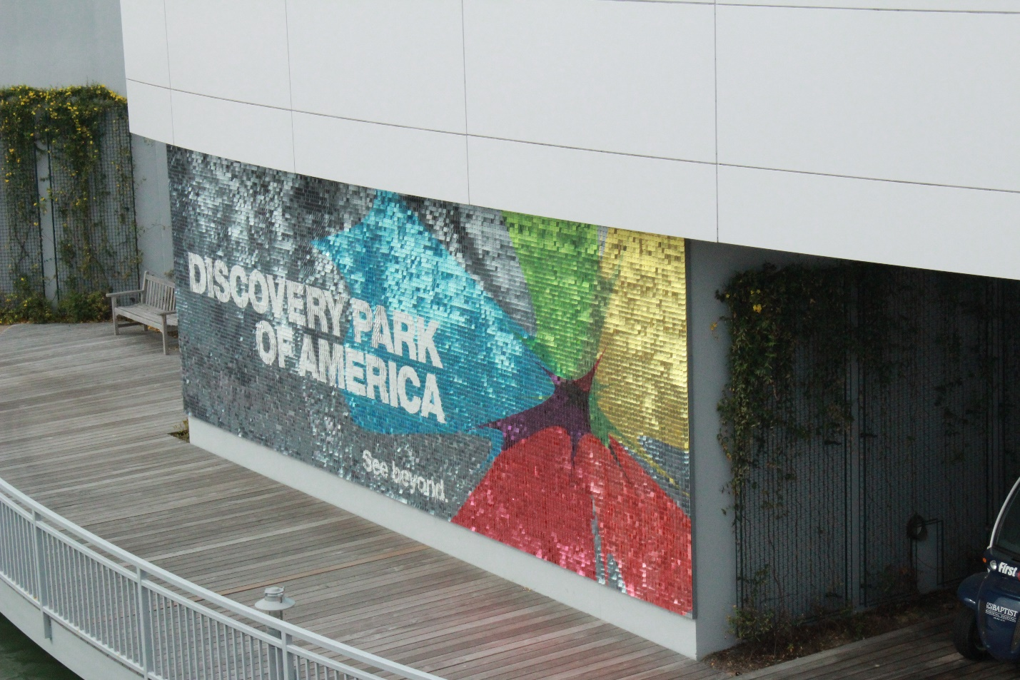

Ask the students the following questions.
1. How many little squares do you think this sign is made out of?
2. What's a number you know is too big?
3. What's a number you know is too small?

Act 2 - Introduce the tools needed to solve the problem, and solve it
Ask the following question:

4. What information do I need to know in order to answer question 1? (The students should, through the course of discussion, realize that area is the key, and that they also need some way of measuring the size of a square.)

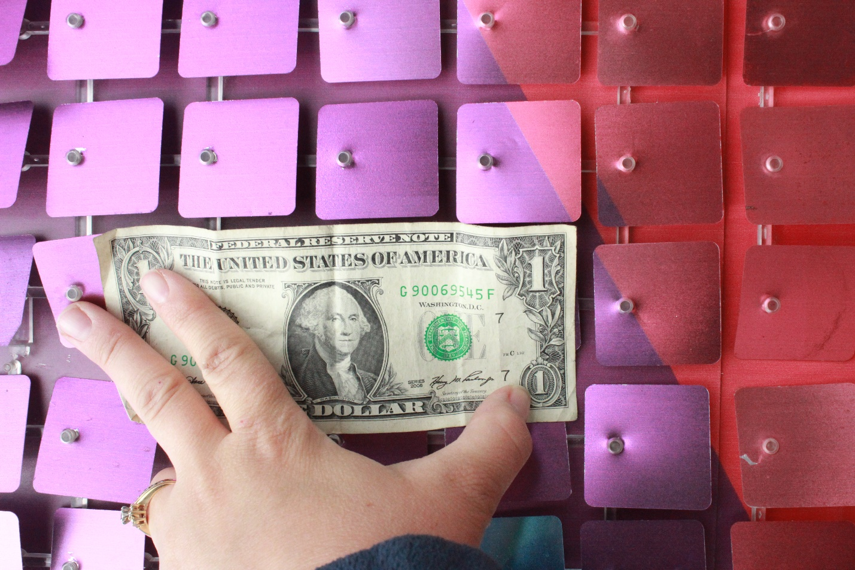
That's not the information we wanted! But maybe it's enough. There are close to 3.5 squares per dollar bill. A dollar bill has length 6.14 inches. So, the length of a square is roughly 6.14/3.5 inches, which is approxmiates 1.75 inches.

Thus, the area of each square is roughly 1.75^2 square inches, that is, 3.0625 square inches.

We also need to know how big the sign is. I emailed Discovery Park of America, and they informed me that the height is 11 feet and the width is 32 feet. In inches, this is 132 inches by 384 inches.

This gives it an area of 132 * 384 = 50688 square inches. Since the area of a tiny square is roughly 3.0625 square inches, there must be roughly 16, 552 squares.

Act 3: Reveal the answer.

In the same discovery park email they revealed that there are 77 squares up and down and 224 for the width. Thus, the total number is actually 17284.

Follow up questions:
1. What can account for the discrepancy between our guess and the actual answer?

2. If the individual square size was doubled, how many squares would be necessary?

