Names:_______________

Date:________________

Pythagorean Theorem with Boxes

1. Which box do you have?

2. Measure the length, width, and height. What do you get? Be sure to include units!
Length =

Width =

Height =

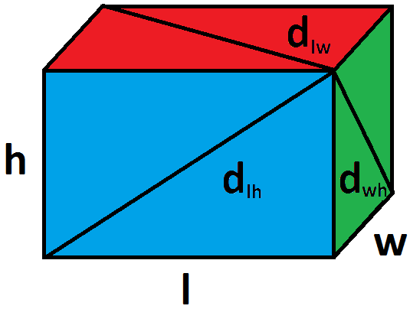
3. Measure the three diagonals, d_{lh}, d_{lw}, d_{wh}. What do you get? Be sure to include units!

d_{lh} =

d_{lw} =

d_{wh} =

4. Using the Pythagorean theorem, compute d_{lh}, d_{lw}, and d_{wh}.

d_{lh}:

d_{lw}:

d_{wh}:

5. Do your answers to 4 and 5 match? Why or why not?

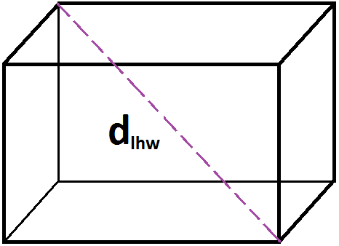

6. Try to measure d_{lhw}. What do you get?

7. Can you create a formula for d_{lhw} in terms of d_{lh} and w?

8. Can you create a formula for d_{lhw} in terms of d_{lw} and h?

9. Can you create a formula for d_{lhw} in terms of d_{hw} and l?

10. Can you create a formula for d_{lhw} in terms of l, w, and h?

11. What numerical value do your formulas predict for d_{lhw} for your box? How does it compare to your measurement in problem 6? What can explain the discrepancy?

12. In terms of l, h, and w, what do you get if you compute
$d_{lh}^{2}+d_{wh}^{2}-d_{lw}^{2}$ ?

13. Describe how you could compute h from knowledge of d_{lh}, d_{wh}, and d_{wl}.

14. If a box has l = 2 ft, h = 3 ft, and w = 4 ft, then d_{hw} = 5 ft, but d_{lh} and d_{lw} are not integers. Can you find an example where d_{lh} is the only lenght which is not an integer?

15. If a box has l = 44 cm, h = 117 cm, and w = 240 cm, then each of d_{hw}, d_{lh}, and d_{lw} work out to be integers. What are their values?

16. Can you think of an example for which all 7 lengths (l, h, w, d_{lh}, d_{lw}, d_{hw}, d_{lwh}) are all integers?

