TEAM Lesson Plan Template
Teacher: Dr. Amanda Niedzialomski
Subject/Grade: Mathematics (Fractions) / 3rd Grade
Lesson Title: Math Stacks Fraction Equivalence Game
STANDARDS | Identify what you intend to teach. State, Common Core, ACT College Readiness Standards and/or State Competencies; Enduring Understandings and Essential Questions.
MP2. Reason abstractly and quantitatively

3.NF.A.1 Understand a unit fraction, 1/b, as the quantity formed by 1 part when a whole is partitioned into b equal parts; understand a non-unit fraction, n/b, as the quantity formed by n parts of size 1/b. For example, 3/4 represents a quantity formed by 3 parts of size 1/4.

3.NF.A.2 Understand a fraction as a number on the number line. Represent fractions on a number line.
a. Represent a fraction 1/b on a number line diagram by defining the interval from 0 to 1 as the whole and partitioning it into b equal parts. Recognize that each part has size 1/b and that the endpoint locates the number 1/b on the number line. For example, on a number line from 0 to 1, students can partition it into 4 equal parts and recognize that each part represents a length of 1/4 and the first part has an endpoint at 1/4 on the number line.
b. Represent a fraction n/b on a number line diagram by marking off n lengths 1/b from 0. Recognize that the resulting interval has size n/b and that its endpoint locates the number n/b on the number line. For example, 5/3 is the distance from 0 when there are 5 iterations of 1/3.

3.NF.A.3 Explain equivalence of fractions and compare fractions by reasoning about their size.
a. Understand two fractions as equivalent (equal) if they are the same size or the same point on a number line.
b. Recognize and generate simple equivalent fractions (e.g., 1/2 = 2/4, 4/6 = 2/3) and explain why the fractions are equivalent using a visual fraction model.
c. Express whole numbers as fractions and recognize fractions that are equivalent to whole numbers. For example, express 3 in the form 3 = 3/1; recognize that 6/1= 6; locate 4/4 and 1 at the same point on a number line diagram.
d. Compare two fractions with the same numerator or the same denominator by reasoning about their size. Recognize that comparisons are valid only when the two fractions refer to the same whole. Use the symbols >, =, or < to show the relationship and justify the conclusions.

OBJECTIVE(s)/Sub-Objectives | Connect prior learning to new learning. Clear, Specific, Observable, Demanding, High Quality, Measurable, Aligned to Standard(s), and Integrated with other subjects, build on prior student knowledge  Student-Friendly (I Can Statement)
I can recognize fractions in different forms.

I can match two equivalent fractions.

MATERIALS AND RESOURCES | Content-related: Clearly supports lesson objective(s); rigorous & relevant; Incorporates multimedia & resources beyond the textbook.
Materials
Large Math Stacks Cards (Original 60-card deck)
Small rewards for winning teams and participation
What if the technology is not working? This is a low-tech activity.
Routine for distributing materials: Student desks/tables are arranged to be the playing surface, with enough space for a 15-card grid. Allow enough space between the tables for walking to any part of the grid. Place the 15 numerical “starter cards” faceup in a 3 by 15 grid on the tables. The remaining cards are placed on a neighboring table in a facedown stack.
ACCOMMODATIONS/ADAPTATIONS | Learning styles and interests. Anticipate learning difficulties, regularly incorporate student interests & cultural heritage; differentiate instructional methods.
Modifications/Plans for Diverse Learners
Differentiation
__x__ Content It is possible to differentiate the level of play by selecting only certain cards to be used. A subset of fractions can be used; for example, play could be limited to unit fractions. Or, the match cards could be limited to certain types; for example, the number line cards could be omitted.

Accommodations
If navigating around the tables is a difficulty, cards can instead be hung on the classroom board/wall using magnets or tape.

MOTIVATING STUDENTS/ANTICIPATORY SET | “Hook”: Engage students’ attention and focus on learning. Personally meaningful and relevant.
Show a picture of smiling kids playing cards and excitedly announce that today, we get to play a game!

https://www.eaieducation.com/images/products/530150_L2.jpg
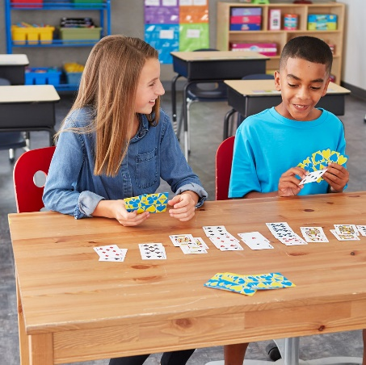

INSTRUCTIONAL PROCEDURES | Step-by-Step Procedures-Lesson Sequence: Basic to Complex. Lesson includes visuals, modeling, logical sequencing and segmenting (beginning, middle, ending); essential information; concise communication; grouping strategies; differentiated instructional strategies to provide intervention & extension; seamless routines; varied instructional strategies; key concepts & ideas highlighted regularly.
Introduction Remind students of different visual fraction models. Show them an example card of each type: a shaded portion of a circle, a shaded portion of repeated shapes, and a point on the number line. Discuss what we have learned about equivalent fractions and reducing fractions (e.g. 2/4 = 1/2).
Instructions for the Game Divide students into four teams. Student desks/tables are arranged to be the playing surface, with enough space for a 15-card grid. Allow enough space between the tables for walking to any part of the grid. Place the 15 numerical fraction cards, called the “starter cards,” faceup in a 3 by 15 grid on the tables. The remaining cards are shuffled and placed on a neighboring table in a facedown stack. These cards are called the “match cards” and they form the draw pile.
Teams take turns drawing a match card and placing it in the stack of cards equivalent to the match card (see image). Team members should take turns as the team representative that draws the match card; this team representative may consult with the rest of their team to decide which stack is equivalent to the drawn card. With the teacher acting as referee, teams will lose their match card and pass it to the next team if they place it on the wrong stack. Once a stack reaches 4 cards, the stack can be picked up by the player who placed the fourth card. The game ends when all of the match cards have been placed on the grid. The team with the most stacks at the end of play wins.
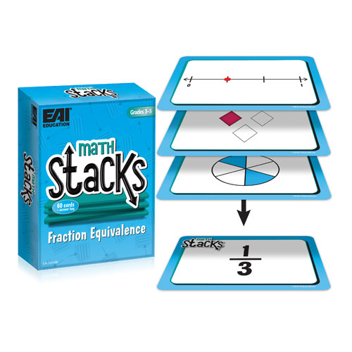
Motivating Students
_x_ Game: Students play the Math Stacks: Fractions Equivalence game in teams.
_x_ Review: The game is a review of different ways to visually express a fraction and simple fraction equivalence. Students are reminded of these concepts before gameplay begins.
_x_ Verbal Reinforcement: The teacher will monitor students throughout the activity to provide reinforcement.
_x_ Small Rewards: Small rewards may be given to reward winning teams and other participators.
Presenting Instructional Content
_x_ Game: Students play the Math Stacks: Fractions Equivalence game in teams.
_x_ Discussion: A class discussion reviewing relevant concepts will occur before gameplay begins.
Instructional strategies:
Modeling and Guided Practice – Teacher models gameplay by drawing a few match cards and placing them on the appropriate stacks. The match cards are then retrieved and the draw pile is shuffled before the game begins.
Check for Understanding (CFU) –
What am I doing for students that progress at different rates?
Encourage teammates to help each other.
What do I do if they don’t get it?
Limit the types of cards in play. For example, starter cards could be limited to unit fractions. If a particular type of match card is causing difficulty, that type may be omitted for the current game, and then reviewed later.

QUESTIONING/THINKING/PROBLEM SOLVING (embedded throughout) | Balanced mix of question types. Utilizes Blooms Taxonomy/Webb’s Depth of Knowledge; high frequency; purposeful & coherent; require active responses; balance based on volunteers/non-volunteers, ability, & gender; lead to further inquiry & self-directed learning. Implement four types of thinking (Analytical, Practical, Creative, & Research-based) & Teach/Reinforce problem-solving types. Provide opportunities for students to generate ideas & alternatives; analyze, evaluate & explain information from multiple perspectives & viewpoints.
Questioning
Knowledge:
What fraction does this card represent?
What are equivalent fractions?

Comprehension:
How do we graph a fraction on the number line?
What is 3/6 equivalent to?

Application:
Can you find two different visual models that represent equivalent fractions?
Analysis:

Synthesis:

Evaluation:

Thinking
_x_ Practical – Students apply their knowledge of fractions to play the math stacks game.
_x_ Analytical – Students compare cards to find equivalent fraction matches (and avoid placing cards on nonequivalent stacks). Teammates explain to each other why a card should be placed on a certain stack.
Problem Solving
__x__ Abstraction: Students must not only match a visual model with a numerical fraction but also compare two different visual models and evaluate their equivalence.
__x__ Categorization: Students categorize all cards into equivalent stacks.
__x__ Drawing conclusions/Justifying Solutions: Teams must conclude to which stack their drawn card belongs. This may involve discussion and justification amongst the team.

GROUPING | Maximize student understanding & learning Varied group composition (race, gender, ability, & age); clearly understood roles, responsibilities & group work expectations; accountability for group & individual work; student opportunities for goal setting, reflection & evaluation of learning.
- The four teams are heterogeneous groups.
- Team members will know their expectations from the instructions before the game begins, and from reinforcement from the referee (teacher).

ASSESSMENT | Formative and/or summative assessment. A variety of assessments, including rubrics, measure achievement of objectives and informs instruction.
Assessments:
__x__Teacher Made Test A future test or worksheet may reproduce this activity with pictures. Have the students match two columns of fractions, with some in each column represented numerically and some represented by diverse visual models.
__x__Teacher Observation The teacher will directly observe each student’s participation and success during gameplay.
*Students should achieve _____% mastery of this objective: ________________________________
CLOSURE | Reflection/Wrap Up. Summarizing, reminding, reflecting, restarting, connecting.
Here is your exit ticket for today On the card, shade some shapes so that the shaded shapes represent 2/3 of the total number of shapes.

Reflection: You must reflect on every lesson you teach.

NOTES:

This work is licensed under the Creative Commons Attribution-ShareAlike 4.0 International License. To view a copy of this license, visit http://creativecommons.org/licenses/by-sa/4.0/ or send a letter to Creative Commons, PO Box 1866, Mountain View, CA 94042, USA.

