Building Models
An example using the kinetic theory of gases
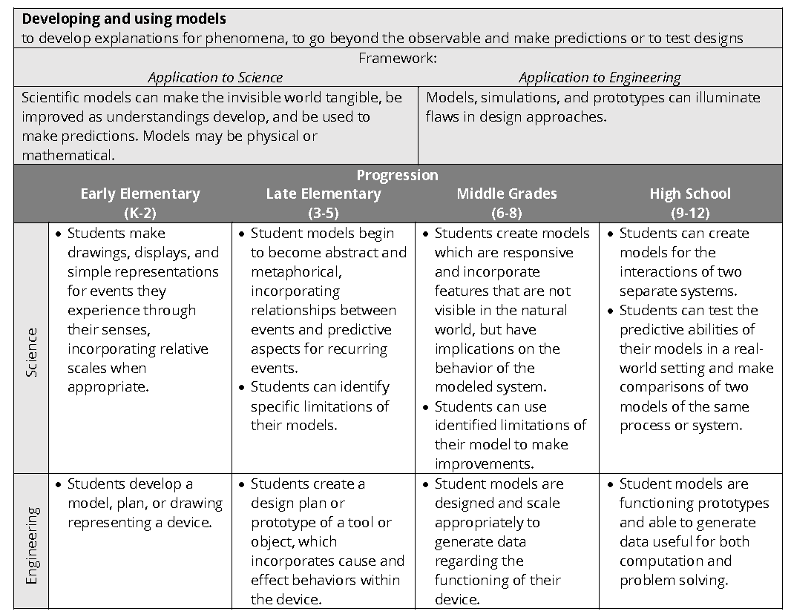

Goal:
-Build a model of the air pressure inside a balloon
-Link the concepts of energy (in this case kinetic energy, the energy of motion, and temperature.

Physical models can lead to algebraic (mathematical) models.
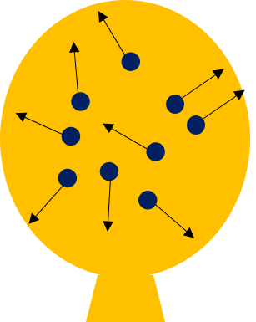
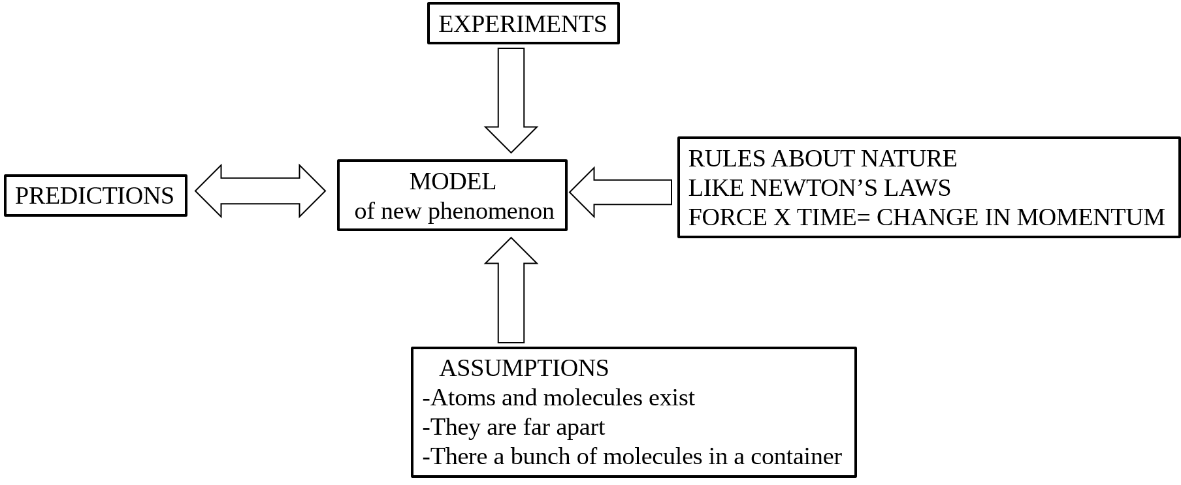

Particle theory of matter and pressure inside a balloon. Air molecules make collisions
with the walls of the balloon to exert an average force on the walls of the balloon.

Example Assessment:

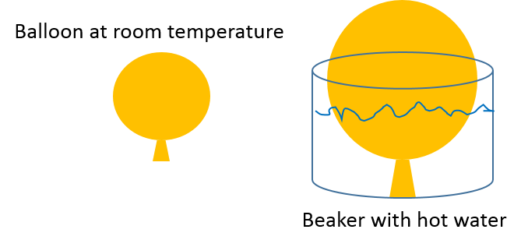
Shuri blew up a balloon little bit, tied the balloon, and placed it in a beaker of hot water. She watched as the balloon grew larger. When she removed the balloon from the beaker the balloon slowly shrank back to its original size.

1) Construct a model to explain what Shuri observed.

2) Predict what would happen when the room temperature balloon is placed in ice water.

3) How does your model in (1) align with your prediction for the balloon in ice water?

4) State a claim (draw a conclusion) that relates the motion of particles to thermal energy using evidence from Shuri’s observations.

OTHER NOTES:
HEAT

HEAT and Temperature
Matter is made up of atoms (Greeks).

Atoms are in continuous random motion (solid, liquid, or gas). This theory is called Kinetic Theory (kinetic means moving).

Forces involved between the atoms/molecules are electrical in nature. Based on the macroscopic properties, we can distinguish three common states of matter: solid, liquid, gas.

Kinetic Theory

Atom: The smallest particle of an element that has all the element’s chemical properties, composed of a nucleus and a number of surrounding electrons.

Temperature is a measure of the random motion of atoms/molecules. More specifically, it measures the average KE of atoms and molecules in a body. In other words, temperature is directly proportional to the KE of the particles that are in the systems (atoms/molecules).

Three states of matter (actually four if you include the plasma state):

Solid: matter tends to keep its shape, it will deform slightly if squashed or stretched. Atoms/molecules are constantly in vibrational motion around their fixed sites, but stay on the average around the same fixed point. If heated, the atoms/molecules vibrate more. Strong forces exist between the particles. Atoms/molecules are close to each other.

FLUIDS (Liquids and gases)
Liquid: matter in this state can flow, while maintaining a constant total volume. Liquid fills a container from bottom up, and take up the shape of the container. Particles (atoms, molecules) are in vibrational motion as well as free to move around. There are not as close together as they are in solid state. There are moderately strong forces between the particles. The particles are grouped together in small groups. If heated, particles move faster, further heating may result in breakage of the bonding between the particles (boiling).

Gas: Matter takes up the shape of the container. Volume of the gas depends on the container volume. Particles freely move around, and have hardly any force on each other expect during the collision. If heated, they move quicker.

Thermal Energy: The molecules of substances are constantly jiggling (random translational motion) in some sort of back-and-forth vibratory motion. This overallenergy of molecules’ motional energy (KE), when you add all of the molecules’ kinetic energies, is called THERMAL ENERGY.

Internal Energy: In addition to thermal energy (KE), molecules have also energy due to their position with respect to each other (Potential energy (PE)). The grand total of all KE and PE of all molecules of a substance is called Internal Energy. A substance doesn’t contain heat, it contains internal energy.
Temperature:
The quantity that tells how warm or cold something is with respect to a standard is called TEMPERATURE. Temperature is a measure of the random motion of atoms/molecules. More specifically, it measures the average KE of atoms and molecules in a body. In other words, temperature is directly proportional to the KE of the particles that are in the systems (atoms/molecules).

Heat:
Thermal energy that is transferred from one body to another because of temperature difference between the bodies.

Thermal Equilibrium:
When two bodies A and B are in thermal equilibrium, the net exchange of energy is zero. In other words, each body, on the average, doesn’t give or take energy from the other.
If two bodies A and B are each in thermal equilibrium with a third body, then they are in thermal equilibrium with each other.

More on Energy, Heat, Temperature
Temperature is a measure of average kinetic energy of molecules/atoms. Absolute zero temperature is the lowest possible temperature that a substance may have. At absolute zero temperature, the molecules have the minimum kinetic energy.
Note the word average: it means add all of the KEs and divide by the number of particles (molecules/atom). For example, a 2 liters boiling water has twice the molecular KE as 1 liter boiling water. However, they both have the same av. KE (or temperature).

T ↔ Average KE of atoms/molecules

Atom: The smallest particle of an element that has all the element’s chemical properties, composed of a nucleus and a number of surrounding electrons.
Internal energy: It is the grand total of all energies inside a substance, which is the sum of all the potential and kinetic energies of the molecules or atoms. A substance doesn’t contain heat, it contains internal energy.

When a substance gives absorbs or gives off heat, its internal energy changes. When substances absorb heat, the molecules may or may not jostle faster. For example, when ice melts, it first absorbs heat without an increase in molecular kinetic energy (this is called Latent Heat) during which the substance goes through a change of state (phase change) from solid to liquid. Later, additional heat added can increase its temperature. In this case, Heat is the transfer of energy from a higher temperature object to a lower temperature object. Heat flow continues until the two objects reach the same temperature (thermal equilibrium).

