TEAM Lesson Plan Template
Teacher: Dr. Jeremy Entner
Subject/Grade: Probability and Statistics / 7th Grade / High School
Lesson Title: How Should you Spin a Spinner?
STANDARDS | Identify what you intend to teach. State, Common Core, ACT College Readiness Standards and/or State Competencies; Enduring Understandings and Essential Questions.
SMP3. Construct viable arguments and critique the reasoning of others.
SMP5. Use appropriate tools strategically.
SMP6. Attend to precision.

6.SP.B.4 Display a single set of numerical data using dot plots (line plots), box plots, pie charts and stem plots.

7.SP.C.7 Develop a probability model and use it to find probabilities of events. Compare probabilities from a model to observed frequencies; if the agreement is not good, explain possible sources of the discrepancy.

S.IC.E.18 Apply the properties of a Chi-square distribution in appropriate situations in order to make inferences about a data set.

(Relies on 4.MD.C.5 as a skill 4.MD.C.5 Recognize angles as geometric shapes that are formed wherever two
rays share a common endpoint, and understand concepts of angle measurement)

OBJECTIVE(s)/Sub-Objectives | Connect prior learning to new learning. Clear, Specific, Observable, Demanding, High Quality, Measurable, Aligned to Standard(s), and Integrated with other subjects, build on prior student knowledge  Student-Friendly (I Can Statement)
I can estimate probabilities on a spinner.

High School: I can apply a χ² test to measure the goodness of fit of experimental data.

MATERIALS AND RESOURCES | Content-related: Clearly supports lesson objective(s); rigorous & relevant; Incorporates multimedia & resources beyond the textbook.
Activities & Materials
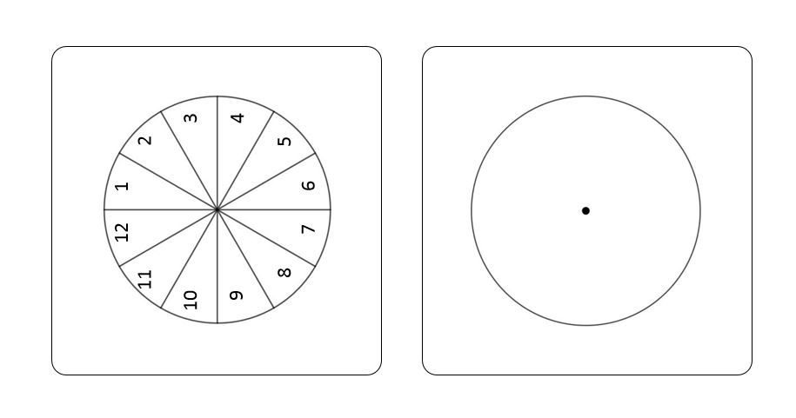
Spinner; tape; ruler/straightedge; protractors; calculator; stapler;
Spinner sheets like the one to the right:
and How to Spin Worksheet.

What if the technology is not working? This lesson does not call for much technology; calculators are helpful, but not necessary.
Routine for distributing materials. Pass them out.

ACCOMMODATIONS/ADAPTATIONS | Learning styles and interests. Anticipate learning difficulties, regularly incorporate student interests & cultural heritage; differentiate instructional methods.
Modifications/Plans for Diverse Learners (NOTE: Clearly identify where you will use each of these in your lesson; do not just check the box!)
Differentiation
----- Content.
----- Process.
-----Product ----- Tiered Assignments ----- Flexible Grouping
----- Learning Centers ____ Other __________________________________________

Accommodations
___ Preferential Seating ___ Extended Time ___ Small Group ___ Peer Tutoring
___ Modified Assignments ___ Other
Early Finishers:

MOTIVATING STUDENTS/ANTICIPATORY SET | “Hook”: Engage students’ attention and focus on learning. Personally meaningful and relevant.
Hold up a spinner and give it a spin. Where have we seen spinners? Has anyone watched Wheel of Fortune or The Price is Right?
INSTRUCTIONAL PROCEDURES | Step-by-Step Procedures-Lesson Sequence: Basic to Complex. Lesson includes visuals, modeling, logical sequencing and segmenting (beginning, middle, ending); essential information; concise communication; grouping strategies; differentiated instructional strategies to provide intervention & extension; seamless routines; varied instructional strategies; key concepts & ideas highlighted regularly.
Introduction
Today we are going to try to answer three questions about spinners. (Ask these, and allow students to discuss / answer)
- Does the spinner have an equal chance of landing in all sectors? ( yes )
- Does it matter who spins the spinner? ( no )
- Does it matter where you start the spinner from? ( no )
Motivating Students
_x_ Game Spin the spinners _x_ Verbal encouragement
Presenting Instructional Content
_x_ Hands-On _x_ Discussion
Instructional strategies:
Modeling and Guided Practice – Have students work in groups of 3 or 4 to complete the How to Spin a Spinner Worksheet. Prompt them with questions as necessary.
Check for Understanding (CFU) –
What am I doing for students that progress at different rates?
What do I do if they get it?
What do I do if they don’t get it? Encourage students to conduct the experiment of spinning the spinner many times and look at the results. From there try to get them to work backwards to explain the results in terms of the areas of sectors on the original spinner template.
QUESTIONING/THINKING/PROBLEM SOLVING (embedded throughout) | Balanced mix of question types. Utilizes Blooms Taxonomy/Webb’s Depth of Knowledge; high frequency; purposeful & coherent; require active responses; balance based on volunteers/non-volunteers, ability, & gender; lead to further inquiry & self-directed learning. Implement four types of thinking (Analytical, Practical, Creative, & Research-based) & Teach/Reinforce problem-solving types. Provide opportunities for students to generate ideas & alternatives; analyze, evaluate & explain information from multiple perspectives & viewpoints.
Questioning Most of the questions on the worksheet fall into the comprehension-analysis range. Questions here are to help students progress through the worksheet.
Knowledge:
Are all sectors of the circle the same size?
Can you measure the central angle with a protractor?
Does it matter where you draw the very first ray to create central angles in your blank template?

Comprehension:
About how many times should the spinner land on 1 if we spin 100 times?
Do we expect the spinner to land on 1 exactly answer to previous question many times?
What is a value that you know is too big? How do you know?
What is a value that you know is too small? How do you know?

Application:
If we spin a twelve-region spinner 100 times, how many times do we expect the spinner to land on each region? (about 8 1/3 times) Is it possible for the spinner to actually land on a region 8 1/3 times? ( no )

Analysis:
What does it mean for it to matter who spins?
What does it mean for it to matter where you spin from?
How would you check whether either of these matter?

Synthesis:

Evaluation:
Thinking
_x_ Practical – Students conduct an experiment with the spinner
_x_ Creative– Students label a spinner template
_x_ Analytical – Students have to relate angle measurements to probabilities and vice versa
_x_ Research-based – Students conduct an experiment with the spinner
*What am I going to do to give Ss opportunity to?
1. Generate variety of ideas:
2. Analyze problems from multiple viewpoints:

Problem Solving
_x_ Predicting Outcomes Students predict how often the spinner will land on each region before conducting the experiment
_x_ Observing and Experimenting Students conduct an experiment with the spinner

GROUPING | Maximize student understanding & learning Varied group composition (race, gender, ability, & age); clearly understood roles, responsibilities & group work expectations; accountability for group & individual work; student opportunities for goal setting, reflection & evaluation of learning.
- Students will work in heterogeneous groups of 3 (or 2).
- Each student will spin the spinner at some point, and someone will record each spin as described on the worksheet.
- Students will complete a worksheet.

ASSESSMENT | Formative and/or summative assessment. A variety of assessments, including rubrics, measure achievement of objectives and informs instruction.
Assessments:
_x_ Group Assignment The group worksheet provides a means for assessment

CLOSURE | Reflection/Wrap Up. Summarizing, reminding, reflecting, restarting, connecting.
- Review/Summary: After collecting worksheets, remind students that they have estimated probabilities from angles on a spinner template, and then they have constructed angles from probabilities. The sum of angle measures is a full circle. The sum of probabilities is 100% (or 1).
- Preview for next lesson: link what they did to day with where they are going next.
- Upcoming assignments: remind them of any upcoming assignments.
Here is your exit ticket for today…..
Follow-up Activities/Extension These may be designed to create a longer or more intense lesson. For example, if the class is able to cover the material in a lesson much faster than expected, extensions may prove helpful. Extensions may also be useful in various parts of a lesson where the teacher (and class) decides they should spend more time on a skill or topic.

Reflection: You must reflect on every lesson you teach.

NOTES:
This work is licensed under the Creative Commons Attribution-ShareAlike 4.0 International License. To view a copy of this license, visit http://creativecommons.org/licenses/by-sa/4.0/ or send a letter to Creative Commons, PO Box 1866, Mountain View, CA 94042, USA.

How to Spin a Spinner Worksheet

Name: ____________________ Name: ____________________

Name: ____________________ Name: ____________________

Work in a group of three (or two) students. You will need a spinner, a twelve-region spinner template sheet, some tape, a protractor, and perhaps a calculator. You will need to take turns spinning as indicated in the instructions. Tape your spinner to the twelve-region template. A 1.5 inch piece of tape on opposite sides is plenty of tape.

Part 1. Does it matter who spins?

Each group member in turn spins the spinner 100 times, always spinning from position #1. That is, place the pointer in the center of sector 1; spin; record the result with a tally mark; place the pointer in the center of sector 1; spin; record the result with a tally mark; repeat . . . After 100 times, a new group member becomes the spinner. A group member who is not spinning will record the result each time, and a third group member should hold the template steady.

After recording the results, look at them to see how they compare.

- Are each group member’s results exactly the same?

- Are the results close?

- Apply a χ² test to see if the results are close:

- If they are really different, what do you decide?

- If they are close, what do you decide?

(OVER)

Part 2. Does it matter where you start from?

Each group member in turn spins the spinner 100 times, but spinning from wherever the spinner last landed. If it lands on 6, spin from there. If it lands on 9, spin from there. Spin; record the result with a tally mark; Spin; record the result with a tally mark; repeat . . . A group member who is not spinning will record the result each time, and a third group member should hold the template steady.

After recording the results, look at them to see how they compare to results from Part 1.

- Are the results from Part 2 exactly the same as the results from Part 1?

- Are the results from Part 2 close to the results from Part 1?

- If you spun a different total number of times, would you think that the numbers would be the same? If there is a different total number of spins, what should you be computing?

Part 3. Look back over your data.

- Does it appear that each region has an equal chance of being landed on? Why or why not?

- What would you expect if each region has an equal chance of being landed on?

Table to record results from Part 1
Result | Group Member 1 | Group Member 2 | Group Member 3
1
2
3
4
5
6
7
8
9
10
11
12

Table to record results from Part 2
Result | Group Member 1 | Group Member 2 | Group Member 3
1
2
3
4
5
6
7
8
9
10
11
12

