TEAM Lesson Plan Template
Teacher: Dr. Jeremy Entner
Subject/Grade: Probability and Statistics / 7th Grade / High School
Lesson Title: Making Spinners
STANDARDS | Identify what you intend to teach. State, Common Core, ACT College Readiness Standards and/or State Competencies; Enduring Understandings and Essential Questions.
SMP3. Construct viable arguments and critique the reasoning of others.
SMP5. Use appropriate tools strategically.
SMP6. Attend to precision.

6.SP.B.4 Display a single set of numerical data using dot plots (line plots), box plots, pie charts and stem plots.

7.SP.C.7 Develop a probability model and use it to find probabilities of events. Compare probabilities from a model to observed frequencies; if the agreement is not good, explain possible sources of the discrepancy.

S.IC.E.18 Apply the properties of a Chi-square distribution in appropriate situations in order to make inferences about a data set.

(Relies on 4.MD.C.5 as a skill 4.MD.C.5 Recognize angles as geometric shapes that are formed wherever two
rays share a common endpoint, and understand concepts of angle measurement)

OBJECTIVE(s)/Sub-Objectives | Connect prior learning to new learning. Clear, Specific, Observable, Demanding, High Quality, Measurable, Aligned to Standard(s), and Integrated with other subjects, build on prior student knowledge  Student-Friendly (I Can Statement)
I can estimate probabilities on a spinner.

I can create a spinner with specified probabilities.

High School: I can apply a χ² test to measure the goodness of fit of experimental data.

MATERIALS AND RESOURCES | Content-related: Clearly supports lesson objective(s); rigorous & relevant; Incorporates multimedia & resources beyond the textbook.
Activities & Materials
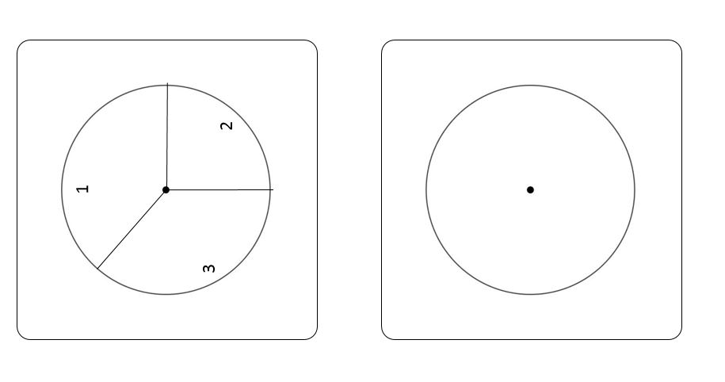
Spinner; tape; ruler/straightedge; protractors; calculator; stapler;
Spinner sheets like the one to the right:
and Spinner Matching Worksheet.

What if the technology is not working? This lesson does not call for much technology; calculators are helpful, but not necessary.
Routine for distributing materials. Pass them out.

ACCOMMODATIONS/ADAPTATIONS | Learning styles and interests. Anticipate learning difficulties, regularly incorporate student interests & cultural heritage; differentiate instructional methods.
Modifications/Plans for Diverse Learners (NOTE: Clearly identify where you will use each of these in your lesson; do not just check the box!)
Differentiation
----- Content Worksheets are provided with varying levels of difficulty based on different probability distributions. J is easier than K which is easier than L.
----- Process Most students will visually estimate probabilities “About 20% of the circle.” It is also appropriate to measure the central angles on the spinner template with a protractor to calculate probabilities. If using protractors, measure angles before taping the spinner to the template sheet.
-----Product ----- Tiered Assignments ----- Flexible Grouping
----- Learning Centers ____ Other __________________________________________

Accommodations
___ Preferential Seating ___ Extended Time ___ Small Group ___ Peer Tutoring
___ Modified Assignments ___ Other
Early Finishers:

MOTIVATING STUDENTS/ANTICIPATORY SET | “Hook”: Engage students’ attention and focus on learning. Personally meaningful and relevant.
Hold up a spinner and give it a spin. Ask what is different about it? (It has no label; there is no way to tell what the spinner stopped at.) Today we are going to look at some unusual spinners and then make our own spinner to give the probabilities that we want.
INSTRUCTIONAL PROCEDURES | Step-by-Step Procedures-Lesson Sequence: Basic to Complex. Lesson includes visuals, modeling, logical sequencing and segmenting (beginning, middle, ending); essential information; concise communication; grouping strategies; differentiated instructional strategies to provide intervention & extension; seamless routines; varied instructional strategies; key concepts & ideas highlighted regularly.
Introduction
When you learned to measure angles in the fourth grade, you learned that each central angle in a circle is a fraction of the whole circle. So, a 180º angle is ½ of a circle. One quarter of a circle is a 90º angle. To find which fraction of a circle is represented by an angle, measure the angle and divide by 360º . You can work with this number as a decimal or as a fraction. Today we are going to use this skill both to calculate probabilities and to construct angles to give desired probabilities.
Motivating Students
_x_ Game Spin the spinners _x_ Verbal encouragement
Presenting Instructional Content
_x_ Hands-On _x_ Discussion
Instructional strategies:
Modeling and Guided Practice – Have students work in groups of 3 or 4 to complete the Spinner Matching Worksheet. Prompt them with questions as necessary.
Check for Understanding (CFU) –
What am I doing for students that progress at different rates?
What do I do if they get it?
What do I do if they don’t get it? Encourage students to conduct the experiment of spinning the spinner many times and look at the results. From there try to get them to work backwards to explain the results in terms of the areas of sectors on the original spinner template.
Work examples for students to remind them how to convert from an angle measure to a fraction of the circle.
QUESTIONING/THINKING/PROBLEM SOLVING (embedded throughout) | Balanced mix of question types. Utilizes Blooms Taxonomy/Webb’s Depth of Knowledge; high frequency; purposeful & coherent; require active responses; balance based on volunteers/non-volunteers, ability, & gender; lead to further inquiry & self-directed learning. Implement four types of thinking (Analytical, Practical, Creative, & Research-based) & Teach/Reinforce problem-solving types. Provide opportunities for students to generate ideas & alternatives; analyze, evaluate & explain information from multiple perspectives & viewpoints.
Questioning Most of the questions on the worksheet fall into the comprehension-analysis range. Questions here are to help students progress through the worksheet.
Knowledge:
Which sector of the circle is largest?
Can you measure the central angle with a protractor?
Does it matter where you draw the very first ray to create central angles in your blank template?

Comprehension:
Would it help if you extended the rays of the angle?
If you add the measures of all the central angles, what should you get?
If you add the probabilities for each of the regions on the spinner, what should you get?
About how big is this angle (choose one that looks like 30 degrees or 90 degrees, or some other common measure)?
What is a value that you know is too big? How do you know?
What is a value that you know is too small? How do you know?

Application:
After you measure the angle and divide by 360º, can you express the fraction as a percentage?
If you want a sector on the spinner to represent a probability of 1/3, what should the measure of the central angle be?

Analysis:

Synthesis:

Evaluation:
Thinking
_x_ Practical – Students conduct an experiment with the spinner
_x_ Creative– Students label a spinner template
_x_ Analytical – Students have to relate angle measurements to probabilities and vice versa
_x_ Research-based – Students conduct an experiment with the spinner
*What am I going to do to give Ss opportunity to?
1. Generate variety of ideas:
2. Analyze problems from multiple viewpoints:

Problem Solving Note: Teach 2 or more types of problem solving (NOTE: Clearly identify where you will use each of these in your lesson; do not just check the box!)
_x__ Categorization Students categorize regions on the spinner as large or small
_x_ Predicting Outcomes Students predict how often the spinner will land on each region before conducting the experiment
_x_ Observing and Experimenting Students conduct an experiment with the spinner
_x__ Creating and Designing Students label a spinner template to correspond to given probabilities

GROUPING | Maximize student understanding & learning Varied group composition (race, gender, ability, & age); clearly understood roles, responsibilities & group work expectations; accountability for group & individual work; student opportunities for goal setting, reflection & evaluation of learning.
- Students will work in homogenous groups of 4 (or 3).
- The worksheet describes the roles of measurer, computer, and recorder.
- Students will complete a worksheet and a spinner template sheet.

ASSESSMENT | Formative and/or summative assessment. A variety of assessments, including rubrics, measure achievement of objectives and informs instruction.
Assessments:
_x_ Group Assignment The group worksheet provides a means for assessment

CLOSURE | Reflection/Wrap Up. Summarizing, reminding, reflecting, restarting, connecting.
- Review/Summary: After collecting worksheets, remind students that they have estimated probabilities from angles on a spinner template, and then they have constructed angles from probabilities. The sum of angle measures is a full circle. The sum of probabilities is 100% (or 1).
- Preview for next lesson: link what they did to day with where they are going next.
- Upcoming assignments: remind them of any upcoming assignments.
Here is your exit ticket for today….. What angle measure would we use on a spinner to represent a probability of 25%?
Follow-up Activities/Extension These may be designed to create a longer or more intense lesson. For example, if the class is able to cover the material in a lesson much faster than expected, extensions may prove helpful. Extensions may also be useful in various parts of a lesson where the teacher (and class) decides they should spend more time on a skill or topic.

Reflection: You must reflect on every lesson you teach.

NOTES:
This work is licensed under the Creative Commons Attribution-ShareAlike 4.0 International License. To view a copy of this license, visit http://creativecommons.org/licenses/by-sa/4.0/ or send a letter to Creative Commons, PO Box 1866, Mountain View, CA 94042, USA.

Spinner Matching Worksheet J

Name: ____________________ Name: ____________________

Name: ____________________ Name: ____________________ Spinner Template Sheet ___

Work in a group of three or four students. You will need a spinner, a spinner template sheet, a ruler, some tape, a protractor, and perhaps a calculator. One of you should measure. One of you should fill out the worksheet, and one of you should compute numbers.

Part 1. Write your spinner template sheet letter in the space above. The top template on your spinner template sheet has numbered regions. Answer the following questions:

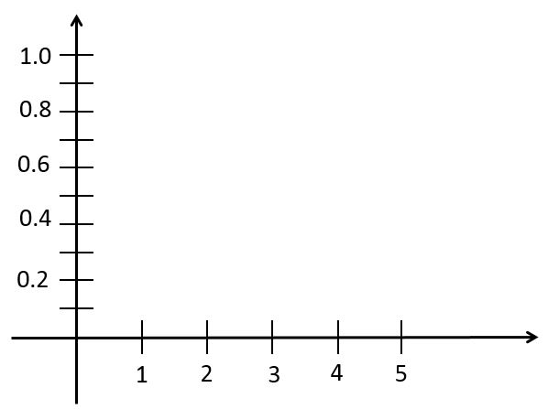
- Suppose that you spin the spinner many times and record the number that the pointer lands on each time. If you recorded these numbers on a histogram, what would the histogram look like? Draw it here:

- Which number or numbers would have the best chance of being landed on?
- Which number or numbers has the worst chance of being landed on?
- How can you check the guesses in questions 2 and 3?
- Tape your spinner to the template. A 1.5 inch piece of tape on opposite sides is plenty of tape. Can you check your guesses from questions 2 and 3 by spinning one time?
- If you spin the spinner 60 times, how many times would you expect the pointer to land on
1? _____ 2? _____ 3? _____ 4? _____ 5?_____
- Spin the spinner 60 times, recording the result of each spin on a separate sheet of paper. How many times did the pointer land on 1? _____ 2? _____ 3? _____ 4? _____ 5?_____
- Do you think your guesses from question 6 are wrong?
- Are your observed values close enough?

- What would happen if your guesses were really wrong?
- Apply a χ² goodness of fit test to your data. List your hypotheses, results, and conclusions below:

- What values would make you think you were wrong?

Part 2. Here is a probability distribution called J. Write this letter on your spinner template sheet beside the unlabeled template:
x | 1 | 2 | 3 | 4 | 5
P(x) | 1/3 | 1/3 | 1/3 | 0 | 0

- Label the blank spinner template so that its probabilities match the distribution in this table.
- How could you check that your spinner matches the table?

Remove your spinner from the spinner template sheet. Staple your worksheet to the spinner template sheet and turn them in.

Spinner Matching Worksheet K

Name: ____________________ Name: ____________________

Name: ____________________ Name: ____________________ Spinner Template Sheet ___

Work in a group of three or four students. You will need a spinner, a spinner template sheet, a ruler, some tape, a protractor, and perhaps a calculator. One of you should measure. One of you should fill out the worksheet, and one of you should compute numbers.

Part 1. Write your spinner template sheet letter in the space above. The top template on your spinner template sheet has numbered regions. Place your spinner on the template Answer the following questions:

- Suppose that you spin the spinner many times and record the number that the pointer lands on each time. If you recorded these numbers on a histogram, what would the histogram look like? Draw it here:

- Which number or numbers would have the best chance of being landed on?
- Which number or numbers has the worst chance of being landed on?
- How can you check the guesses in questions 2 and 3?
- Tape your spinner to the template. A 1.5 inch piece of tape on opposite sides is plenty of tape. Can you check your guesses from questions 2 and 3 by spinning one time?
- If you spin the spinner 60 times, how many times would you expect the pointer to land on
1? _____ 2? _____ 3? _____ 4? _____ 5?_____
- Spin the spinner 60 times, recording the result of each spin on a separate sheet of paper. How many times did the pointer land on 1? _____ 2? _____ 3? _____ 4? _____ 5?_____
- Do you think your guesses from question 6 are wrong?
- Are your observed values close enough?

- What would happen if your guesses were really wrong?
- Apply a χ² goodness of fit test to your data. List your hypotheses, results, and conclusions below:

- What values would make you think you were wrong?

Part 2. Here is a probability distribution called K. Write this letter on your spinner template sheet beside the unlabeled template:
x | 1 | 2 | 3 | 4 | 5
P(x) | 1/3 | 1/4 | 1/4 | 1/12 | 1/12

- Label the blank spinner template so that its probabilities match the distribution in this table.
- How could you check that your spinner matches the table?

Remove your spinner from the spinner template sheet. Staple your worksheet to the spinner template sheet and turn them in.

Spinner Matching Worksheet L

Name: ____________________ Name: ____________________

Name: ____________________ Name: ____________________ Spinner Template Sheet ___

Work in a group of three or four students. You will need a spinner, a spinner template sheet, a ruler, some tape, a protractor, and perhaps a calculator. One of you should measure. One of you should fill out the worksheet, and one of you should compute numbers.

Part 1. Write your spinner template sheet letter in the space above. The top template on your spinner template sheet has numbered regions. Answer the following questions:

- Suppose that you spin the spinner many times and record the number that the pointer lands on each time. If you recorded these numbers on a histogram, what would the histogram look like? Draw it here:

- Which number or numbers would have the best chance of being landed on?
- Which number or numbers has the worst chance of being landed on?
- How can you check the guesses in questions 2 and 3?
- Tape your spinner to the template. A 1.5 inch piece of tape on opposite sides is plenty of tape. Can you check your guesses from questions 2 and 3 by spinning one time?
- If you spin the spinner 60 times, how many times would you expect the pointer to land on
1? _____ 2? _____ 3? _____ 4? _____ 5?_____
- Spin the spinner 60 times, recording the result of each spin on a separate sheet of paper. How many times did the pointer land on 1? _____ 2? _____ 3? _____ 4? _____ 5?_____
- Do you think your guesses from question 6 are wrong?
- Are your observed values close enough?

- What would happen if your guesses were really wrong?
- Apply a χ² goodness of fit test to your data. List your hypotheses, results, and conclusions below:

- What values would make you think you were wrong?

Part 2. Here is a probability distribution called L. Write this letter on your spinner template sheet beside the unlabeled template:
x | 1 | 2 | 3 | 4 | 5
P(x) | 1/10 | 1/4 | 1/5 | 9/20 | 0

- Label the blank spinner template so that its probabilities match the distribution in this table.
- How could you check that your spinner matches the table?

Remove your spinner from the spinner template sheet. Staple your worksheet to the spinner template sheet and turn them in.

