Photosynthesis

Objectives
- To observe evidence for photosynthesis in leaf tissue samples
- To determine the conditions necessary for photosynthesis to occur

Background
Photosynthesis is an essential process for life as we know it on our planet. Photosynthetic organisms (primary producers) are capable of producing organic food molecules for consumer organisms such as ourselves. This relationship is also frequently described in terms of energy: organisms that can produce their own food are called autotrophs, and organisms that cannot produce their own food are called heterotrophs. For the most part, all the life energy on our planet comes from our sun, and this energy is absorbed by photosynthetic pigments in the chloroplast and used to convert CO₂ into glucose, which is subsequently stored as sucrose or starch. Another important byproduct of photosynthesis is the production of oxygen gas, which is necessary for aerobic organisms to perform aerobic respiration. The overall net equation for photosynthesis is as follows:
6CO₂ + 6H₂O + light energy C₆H₁₂O₆ + 6O₂
Note that this process involves a reduction of carbon from an oxidized form (CO₂) to a reduced from (sugar) that can be used by the cell. In this lab we will observe the process of photosynthesis in small leaf discs that you will make from spinach leaves or a similar plant. If we evacuate the air spaces in the spinach leaf discs and replace them with liquid, the leaf discs will sink in water. As they undergo photosynthesis, the oxygen gas that is produced will cause the leaf disks to float. Note that the bicarbonate buffer you will prepare will provide the CO₂ and H₂O:
HCO₃⁻ (bicarbonate) + H⁺ H₂CO₃ CO₂ + H₂O

Materials:

Three 10mL syringes
250 mL plastic beaker
Fresh spinach leaves
Drinking straws
Sodium bicarbonate (baking soda)
Distilled water
Dish detergent
Sharpie
120V lamps
Red, Green, Blue, and incandescent bulbs

Procedure:
- Prepare a 0.2% sodium bicarbonate solution by dissolving 0.4g sodium bicarbonate (baking soda) in 200mL water. Ensure the bicarbonate is well-dissolved.
- Add a drop of dish detergent to the bicarbonate solution.
- Select several large spinach leaves (you can try other greens if you have these, provided the leaves are green and reasonably fresh)
- Label the three syringes #1, #2, #3 and #4 with a Sharpie. Select three experimental conditions and a control condition, for example:
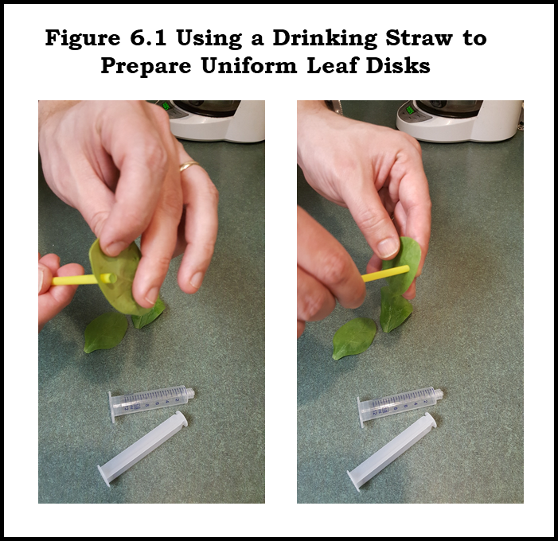
  - Effect of Bicarbonate vs. water:
    - Bicarbonate, lighted
    - Bicarbonate, dark (foil-wrapped)
    - Water, lighted
    - Water, dark (foil-wrapped)
  - Effect of light color:
    - Red light illuminated
    - Green light illuminated
    - Blue light illuminated
    - Dark (foil-wrapped)
  - Effect of leaf-disk treatment
    - White light illuminated
    - White light illuminated, boiled disks
    - Dark (foil-wrapped)
    - Dark (foil-wrapped), boiled disks
- Use a drinking straw to punch out forty leaf disks. Try to avoid veins in the leaves.
- Expel 10 leaf disks into each opened 30mL syringe. You can blow them out but take care to do this gently or they will come back at you! Repeat this with three more 30mL syringes so that you have 10 leaf disks in each.
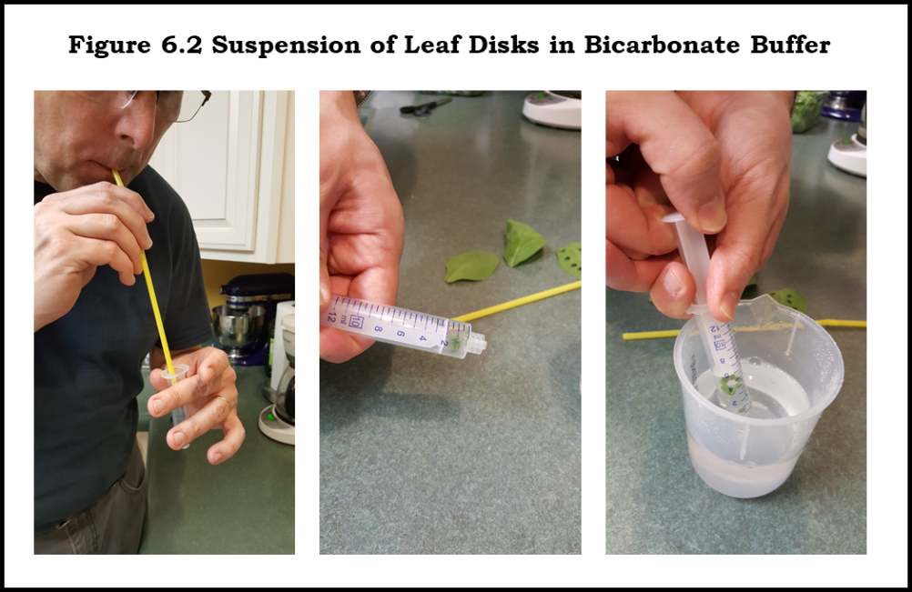
- Taking care not to crush any of the leaf disks, add the plunger and depress the plunger to the 5mL mark. Repeat for the other three syringes.
- Fill your syringes with the appropriate solution (bicarbonate or water). Your plunger should now be at approximately the 15mL mark.
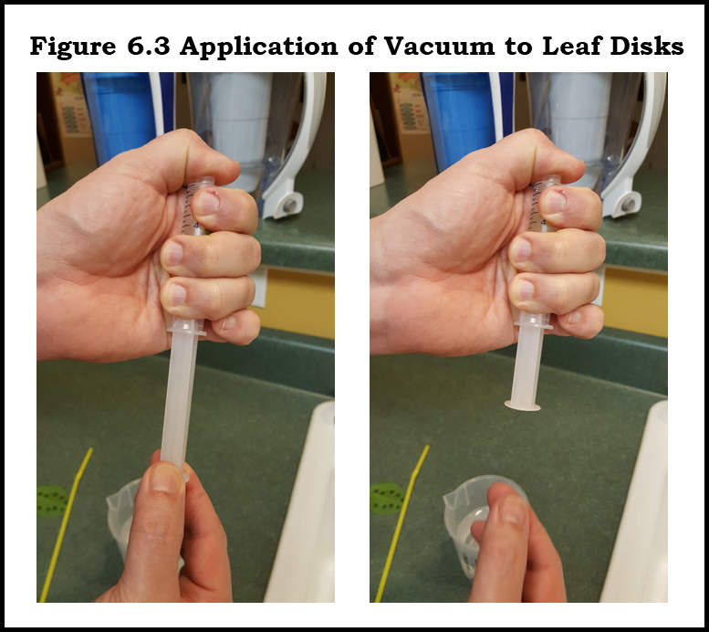
- Apply vacuum to each syringe by blocking the opening with your thumb and pulling the plunger out to the 30mL mark. Take care that you do not remove the plunger all the way from the syringe!. Hold the syringe for a count of 5 seconds and allow the plunger to snap back towards the solution. Continue to do this until the leaf disks have all sunk in the solution.
- Stand each syringe on its plunger in front of the appropriate light source

- Count the number of disks floating every 5 minutes:
Time | Syringe #1 | Syringe #2 | Syringe #3 | Syringe #4
Condition:
0 minutes
5 minutes
10 minutes
15 minutes
20 minutes
25 minutes
30 minutes

Review Questions
- About 200 years ago, Jan Baptista van Helmont did experiments on the nature of photosynthesis. He wanted to know where growing plants get the materials necessary for increases in size. He planted a tree seedling weighing 5 pounds in a barrel filled with 200 pounds of soil. He watered the tree regularly. Five years passed. Then van Helmont weighed the tree and the soil. The tree weighed 169 pounds, 3 ounces. The soil weighed 199 pounds, 14 ounces. Because the tree gained so much weight, and the soil lost so little, he concluded the tree had gained all its weight by absorbing water he added to the barrel. Given what you know about photosynthesis, why was he misguided? What really happened?
- Suppose that you grow algae or an aquatic plant like Elodea in the presence of ¹⁸O₂. Where does this isotopic label end up? What if you use ¹⁸O-labelled CO₂?
- What color would plants be if they absorbed all visible light wavelengths equally?
- Would frozen spinach leaves work as well as fresh? Why or why not? What about cooked spinach?

