Summer 2016

UTM Middle School STEM Workshop

**Workshop Facilitator**: Dr. Louis Kolitsch

**Subject/Grade**: Probabilities for Compound Events (Grade 8)

**Estimated time**: 1 hour

**Standard(s)**: TN Mathematics Standards

Grade 8: **8.SP.B.4** Find probabilities of compound events using organized lists, tables, tree

diagrams, and simulation. Understand that, just as with simple events, the

probability of a compound event is the fraction of outcomes in the sample space for which the compound event occurs. Represent sample spaces for compound events using methods such as organized lists, tables, and tree diagrams. For an event described in everyday language (e.g., "rolling double sixes"), identify the outcomes in the sample space which compose the event.

**Objective**: Use dominos to investigate probabilities of compound events.

**Materials and Resources**: Set of paper dominos; probability worksheet.

**Motivating Students/Anticipatory SET:**

Problem solving skills associated with the probabilities of compound events are often used to analyze health issues and social factors. For example, “determine the probability that an adult will have a heart attack if the adult is both female and over 50 years of age” or “determine the probability that a student will succeed in college if the student has a high school GPA greater than 3.0 and an ACT score less than 22.”

**Instructional procedures**:

* Give each group of 3 or 4 students a set of paper dominos and a probability worksheet.
* Guide the students’ thinking on each problem as you roam the room, but let the students argue amongst themselves.

**Questioning/Thinking/Problem Solving:**

* One common question from students about this activity is whether no dots in a section is even or odd.
* Remind students that for conditional probability, they are no longer focused on the entire sample space but on the subset corresponding to the given conditions.
* If using a Venn diagram, ask students which portion(s) of the diagram correspond to “A and B”; “A or B”; etc. You may also need to remind them what  means and tie that to sections of the Venn diagram.
* What is your interpretation of the probability you found in (problem 1), (problem 2), etc.
* What makes the probability you found in (problem 1) greater than the probability you found in (problem 2)? Provide an explanation.

**Follow-up Activities/Extensions**:

1. Use a double-nine set of dominos instead of a double-six set.

2. Change the descriptions of sets A, B, and C.

**Accommodations/Adaptations:**

Give students a real set of dominos or cut out the paper dominos to allow students to sort. Provide students with a Venn diagram they can label while they are sorting dominos.

**Closure:**

Following the activity, lead a group discussion to solidify concepts. In particular, ask students to describe how they determined:

* the probability of each set;
* the probability of the intersection of two sets (“and”);
* the probability of the union of two sets (“or”);
* the probability of the complement of a set; and
* the probability of one set given another.

Make connections between these probabilities. For example:

* P(A) + P() = 1
* P(A) + P(B) – P(A and B) = P(A or B)
* P(A | B) = [P(A and B)] / P(B)
* P(A and B) ≤ P(A or B)

**Assessment:**

Ask students to demonstrate their understanding of these concepts by giving them a new set of events A, B, and C or by giving them a different sample space (set of cards, attribute blocks, etc.).

**Teacher Reflections:**

To be completed after conducting the lesson.

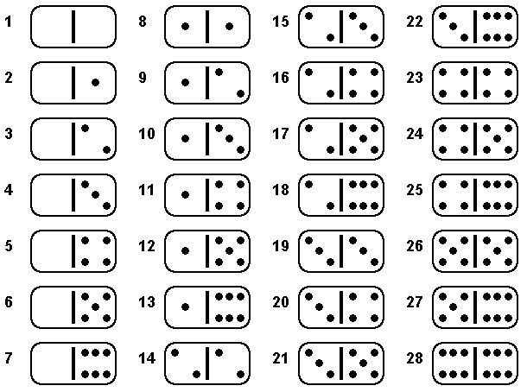

Consider the experiment of selecting one domino at random from a double-six set and observing the number of dots on it. Define events A, B, and C as follows.

Event A: The total number of dots on the domino is six

Event B: The number of dots in each section is the same

Event C: The number of dots in each section is odd

Determine each of the following.

P(A) = ________ P(B) = ________ P(C) = ________

P(A and B) = ________ P(A or B) = ________

P(A and C) = ________ P(A or C) = ________

P(B and C) = ________ P(B or C) = ________

P() = ________ P() = ________

P() = ________

P(A | B) = ________ P(B | A) = ________

P(C | A) = ________ P(C |) = ________

P( | C) = ________