TEAM Lesson Plan Template
Teacher: Dr. Amanda Niedzialomski
Subject/Grade: Mathematics (Fractions) / 4th Grade
Lesson Title: Recipes for Success with Fraction Multiplication
STANDARDS | Identify what you intend to teach. State, Common Core, ACT College Readiness Standards and/or State Competencies; Enduring Understandings and Essential Questions.
MP1. Make sense of problems and persevere in solving them
MP2. Reason abstractly and quantitatively
MP4. Model with mathematics
MP5. Use appropriate tools strategically

4.NF.B.4 Apply and extend understanding of multiplication as repeated addition to multiply a whole number by a fraction.
a. Understand a fraction a/b as a multiple of 1/b. For example, use a visual fraction model to represent 5/4 as the product 5 × 1/4, recording the conclusion by the equation 5/4 = 5 x 1/4.
b. Understand a multiple of a/b as a multiple of 1/b and use this understanding to multiply a whole number by a fraction. For example, use a visual fraction model to express 3 × 2/5 as 6 × 1/5, recognizing this product as 6/5. (In general, n x a/b = (n x a)/b = (n x a) x 1/b.)
c. Solve contextual problems involving multiplication of a whole number by a fraction (e.g., by using visual fraction models and equations to represent the problem). For example, if each person at a party will eat 3/8 of a pound of roast beef, and there will be 4 people at the party, how many pounds of roast beef will be needed? Between what two whole numbers does your answer lie?

OBJECTIVE(s)/Sub-Objectives | Connect prior learning to new learning. Clear, Specific, Observable, Demanding, High Quality, Measurable, Aligned to Standard(s), and Integrated with other subjects, build on prior student knowledge  Student-Friendly (I Can Statement)
I can multiply a unit fraction by a whole number.

I can multiply a fraction a/b by a whole number.

I can double a recipe.

MATERIALS AND RESOURCES | Content-related: Clearly supports lesson objective(s); rigorous & relevant; Incorporates multimedia & resources beyond the textbook.
Materials
Rulers
Crayons or colored pencils
Recipe Cards
Recipe Scaling Worksheets
What if the technology is not working? Skip the hook videos and simply describe to students the two ideas: Cooking for 2-4 people vs. cooking for 100 people.
Routine for distributing materials: Rulers and crayons are placed in multiple caddies around the room for students to access. When ready for them, worksheets and recipe cards are passed out to each student. First, the salad dressing recipe is distributed; then the rest of the materials are distributed.
ACCOMMODATIONS/ADAPTATIONS | Learning styles and interests. Anticipate learning difficulties, regularly incorporate student interests & cultural heritage; differentiate instructional methods.
Modifications/Plans for Diverse Learners
Differentiation
__x__ Content: For some students, it may be helpful to limit the scope of the assignment to multiplication of a unit fraction by a whole number. The recipe amounts can be changed to unit fraction quantities (or the recipe cards can be limited to only those having unit fraction quantities).
__x__ Process: For some students, it may be helpful to use the Fraction Model Multipliers to replicate the unit square model, rather than drawing everything from scratch.

Accommodations
___ Preferential Seating ___ Extended Time ___ Small Group ___ Peer Tutoring
___ Modified Assignments ___ Other
Early Finishers:
Early finishers can be given the recipe cards for cookies and pizza dough to work on. These will extend the activity and challenge them, as the quantities for these recipes are not all proper fractions.

MOTIVATING STUDENTS/ANTICIPATORY SET | “Hook”: Engage students’ attention and focus on learning. Personally meaningful and relevant.
Show the students Christina Lane’s website, Dessert for Two, and her recipe for a small batch of croissants, which yields four croissants:
https://www.dessertfortwo.com/a-small-batch-of-croissants/
Compare that to a professional pastry chef preparing a much larger batch of croissants:
https://www.instagram.com/p/CrTfwFvoSvD/
The quantities of ingredients are very different between the two!
INSTRUCTIONAL PROCEDURES | Step-by-Step Procedures-Lesson Sequence: Basic to Complex. Lesson includes visuals, modeling, logical sequencing and segmenting (beginning, middle, ending); essential information; concise communication; grouping strategies; differentiated instructional strategies to provide intervention & extension; seamless routines; varied instructional strategies; key concepts & ideas highlighted regularly.
Introduction Today our class has been tasked with converting some recipes that were written to serve a small number of people because we want to make enough food to serve a large number of people. Many of the ingredients are fractional quantities, so we need to understand fraction multiplication to accomplish this task.
For the first part of the lesson, students will take notes on multiplying fractions by whole numbers. The teacher will model these computations on the board, pausing for class questioning and discussions along the way. Begin by drawing a square to represent the unit square. How do we use a unit square to represent 1/4? Divide the square into 4 equal parts, and color one of the parts to represent 1/4. This is a representation for 1/4 – how can we represent 3 times as much? Continuing with the same unit square, represent 3 x 1/4 by coloring two additional parts of the square. When we take all the colored parts and compare them to the whole, what fraction do we have? Beside this visual model, write 3 x 1/4 = 1/4 + 1/4 + 1/4 = 3/4. Multiplication is the same as repeated addition.

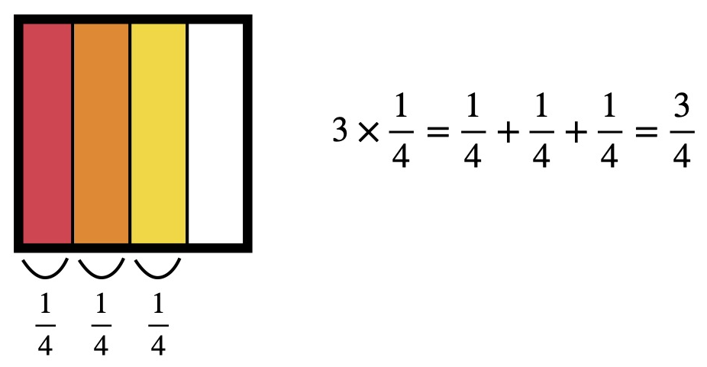

For the second problem, we use a unit square again to draw a visual model for 7 x 1/3. Begin in the same way by drawing a square to represent the unit square. Divide the square into 3 equal parts, and color one of the parts to represent 1/3. How can we represent 7/3? Will we need more than one unit square? How can you tell? Will we need more than two unit squares? How can you tell? After some discussion, guide students to draw three unit squares in a row, divide each of them into 3 equal parts, and color seven of those parts. What number does this represent? Beside this visual model, write 7 x 1/3 = 1/3 + 1/3 + 1/3 + 1/3 + 1/3 + 1/3 + 1/3 = 7/3.

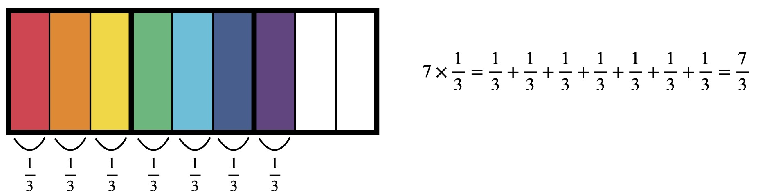

For one more example, again draw the unit square. Begin by modeling 3/5 – divide the square into 5 equal parts and shade 3 of them. Now we want to model 3 x 3/5. How many unit squares will we need? How can you tell? Divide each new unit square drawn into 5 equal parts. One representation of 3/5 has already been colored; two more representations of 3/5 are needed. To organize the model, particularly in this last example, it helps to change colors with each new group of 3 parts. So the original 3 parts might be colored red to signify 3/5, then 3 more colored orange, and then 3 more colored yellow. This represents 3 x 3/5. How many parts are colored? Next to this visual model, write 3 x 3/5 = 3/5 + 3/5 + 3/5 = 9/5.
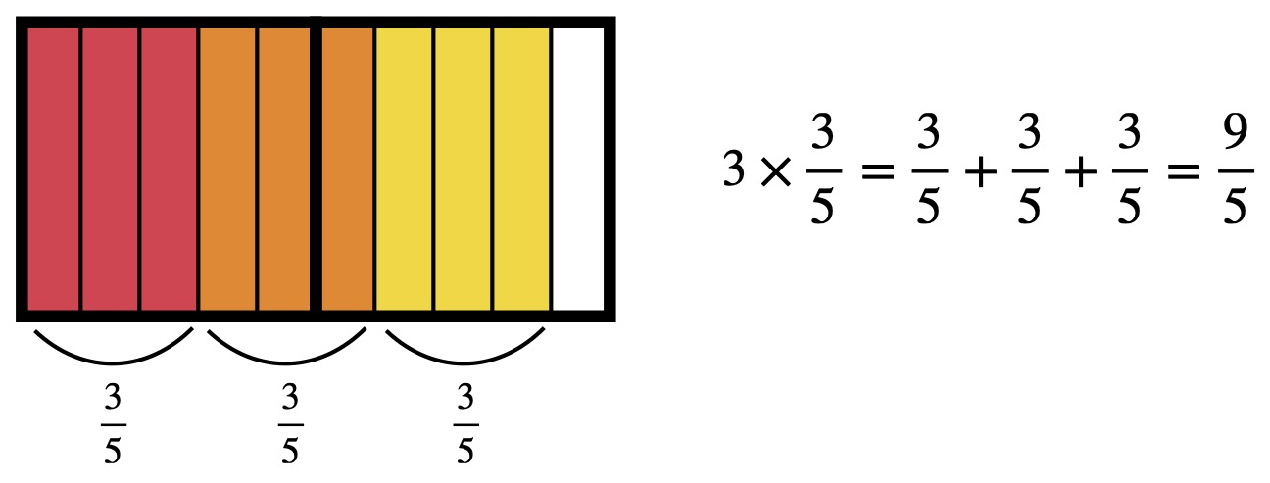
Distribute the salad dressing recipe and tell students that we have been asked as a class to double it. Give the students a minute with their partner(s) to discuss how we should do that. What does it mean to double a recipe? Can we use what we have been practicing to help us? Now the recipe cards and the Recipe Scaling Worksheets are distributed. Using this unit square technique, students will multiply each quantity in the recipe by a specified whole number. Students should record their unit square models and corresponding numerical equations on the worksheet. For the salad dressing recipe, ask the students to double the amounts and record the visual models and equations on their worksheets. For the fruit salad recipe, ask the students to triple the amounts and record the visual models and equations on their worksheets. And lastly, for the granola recipe, ask the students to convert the recipe by multiplying it by 5. Students work semi-independently, discussing with their partner(s) if they are stuck, and comparing results with their partner(s). Have the students compare/contrast their new recipes with the original. What do you notice? Can you tell that the new recipe will make more food? How?

Motivating Students
_x_ Verbal Reinforcement: The teacher will monitor students’ work throughout the activity to provide reinforcement.
_x_ Relate to Real World: Some students are familiar with preparing food and using recipes and some students are familiar with the foods on these recipe cards; food preparation and scaling recipes are real-world problems.
Presenting Instructional Content
_x_ Lecture/Notes: The first part of the lesson is a lecture/note-taking portion on multiplying a proper fraction by a whole number.
_x_ Work Examples: Students will work examples similar to those in their notes while doing the recipe worksheets.
_x_ Guided Practice: The teacher will monitor students’ progress and guide individuals and small groups as needed.
_x_ Modeling: The students are modeling the real-world problem of scaling a recipe and are using area models for fractions to understand multiplication.
Instructional strategies:
Modeling and Guided Practice - The teacher models multiplication of a proper fraction by a whole number using the same unit square model that the students use for this lesson. The teacher will monitor students’ work and ask questions to prompt them if they are stuck.
Check for Understanding (CFU) –
What am I doing for students that progress at different rates?
Encourage partners to help each other. Students are given more time if they need it. Early finishers can be given the recipe cards for cookies and pizza dough to work on. These will extend the activity and challenge them, as the quantities for these recipes are not all proper fractions.
What do I do if they get it?
Discuss how to extend this concept to multiplication of a mixed fraction by a whole number. Introduce the recipe cards for cookies and pizza dough.
What do I do if they don’t get it?
Review the concept of multiplication as repeated addition using two whole numbers. Review the concept of partitioning a square into equal parts to represent a fraction. Use Fraction Model Multiplier cards to help with the creation of the unit square models. Limit the scope of the assignment to multiplication of a proper fraction by a whole number.
QUESTIONING/THINKING/PROBLEM SOLVING (embedded throughout) | Balanced mix of question types. Utilizes Blooms Taxonomy/Webb’s Depth of Knowledge; high frequency; purposeful & coherent; require active responses; balance based on volunteers/non-volunteers, ability, & gender; lead to further inquiry & self-directed learning. Implement four types of thinking (Analytical, Practical, Creative, & Research-based) & Teach/Reinforce problem-solving types. Provide opportunities for students to generate ideas & alternatives; analyze, evaluate & explain information from multiple perspectives & viewpoints.
Questioning
Knowledge:
What is a unit square?
What does it mean to double a recipe?

Comprehension:
How do we use a unit square to represent 1/4?
How many unit squares do we need to represent 7/3?
How can you write the mixed fraction 1 ½ as an improper fraction?
Now that we have drawn the model, what fraction does it represent?

Application:
If this is a representation for 1/4 – how can we represent 3 times as much?
How can we use what we have learned to double this recipe?

Analysis:
Explain why the product $3×\frac{3}{5}$ needs two unit squares to model.
What do you notice when comparing/contrasting the resulting recipe to the original?
Can you tell that the new recipe will make more food? How?

Synthesis:
Can you explain how to decide how many unit squares a problem will need? Say, for $c×\frac{2}{5}$.
What about $c×\frac{a}{5}$? What about $c×\frac{a}{b}$?

Evaluation:
Is it possible to extend this method to an improper fraction times a whole number? Justify your conclusion.

Thinking
_x_ Practical – It is useful to be able to change the yield of a recipe to suit the needs of a larger group.
_x_ Creative – Students create their own visual fraction models; they can decide how to best divide their unit squares and how best to color the parts to express the product.
_x_ Analytical – Students compare/contrast their resulting recipes to the originals.
Problem Solving
__x__ Drawing conclusions/Justifying Solutions Students use unit square visual fraction models to justify their solutions.
__x__ Predicting Outcomes Students predict how many unit squares will be needed to represent the product.
__x__ Identifying Relevant/Irrelevant Information The recipe cards have information about the ingredients and the instructions for preparing the dish. Students must identify the quantities as the relevant information.
__x__ Creating and Designing Students create their own visual fraction models; they can decide how to best divide their unit squares and how best to color the parts to express the product.

GROUPING | Maximize student understanding & learning Varied group composition (race, gender, ability, & age); clearly understood roles, responsibilities & group work expectations; accountability for group & individual work; student opportunities for goal setting, reflection & evaluation of learning.
- Heterogeneous groups of 2 or 3
- Product. Students will complete the Recipe Scaling Worksheets

ASSESSMENT | Formative and/or summative assessment. A variety of assessments, including rubrics, measure achievement of objectives and informs instruction.
Assessments:
__x__ Teacher Made Test In a future assessment the teacher can ask the students to multiply a proper fraction by a whole number, and draw the corresponding unit square fraction model.
__x__Teacher Observation The teacher will directly observe the students’ success with this partner activity.
__x__ Solution to Real World Problem Completing the worksheet is solving a real-world problem of scaling a recipe.

*Students should achieve _____% mastery of this objective: ________________________________

CLOSURE | Reflection/Wrap Up. Summarizing, reminding, reflecting, restarting, connecting.
During the conclusion part of creating an effective lesson plan teachers must sum up the ideas learned from the lesson. A teacher should also relate this information to future and past coursework to provide students with a broad understanding of the ideas learned. It is important to allow students enough time to ask questions, assert assumptions, and summarize the lesson during this part of the lesson plan.
- Review/Summary: wrap up what has been learned and accomplished in the lesson (even if they are in the middle of an exercise, it is still important to summarize to the point where they are now). Ideally involve students in this synthesis.
- Preview for next lesson: link what they did today with where they are going next.
- Upcoming assignments: remind them of any upcoming assignments.
Today we…. Turn to your partner and…. Let’s review our I Can statements……
Here is your exit ticket for today…..
Follow-up Activities/Extension These may be designed to create a longer or more intense lesson. For example, if the class is able to cover the material in a lesson much faster than expected, extensions may prove helpful. Extensions may also be useful in various parts of a lesson where the teacher (and class) decides they should spend more time on a skill or topic.

Reflection: You must reflect on every lesson you teach.

NOTES:

This work is licensed under the Creative Commons Attribution-ShareAlike 4.0 International License. To view a copy of this license, visit http://creativecommons.org/licenses/by-sa/4.0/ or send a letter to Creative Commons, PO Box 1866, Mountain View, CA 94042, USA.

