TEAM Lesson Plan Template
Teacher: Dr. Amanda Niedzialomski
Subject/Grade: Mathematics (Fractions) / 5th Grade
Lesson Title: Recipes for Success with Fraction Multiplication
STANDARDS | Identify what you intend to teach. State, Common Core, ACT College Readiness Standards and/or State Competencies; Enduring Understandings and Essential Questions.
MP4. Model with mathematics
MP5. Use appropriate tools strategically
MP6. Attend to precision

5.NF.B.4 Apply and extend previous understandings of multiplication to multiply a fraction by a whole number or a fraction by a fraction.
b. Find the area of a rectangle with fractional side lengths by tiling it with unit squares of the appropriate unit fraction side lengths, and show that the area is the same as would be found by multiplying the side lengths. Multiply fractional side lengths to find areas of rectangles and represent fraction products as rectangular areas.

5.NF.B.5 Interpret multiplication as scaling (resizing).
a. Compare the size of a product to the size of one factor on the basis of the size of the other factor, without performing the indicated multiplication. For example, know if the product will be greater than, less than, or equal to the factors.
b. Explain why multiplying a given number by a fraction greater than 1 results in a product greater than the given number (recognizing multiplication by whole numbers greater than 1 as a familiar case); explain why multiplying a given number by a fraction between 0 and 1 results in a product less than the given number; and relate the principle of fraction equivalence a/b = (a x n)/(b x n) to the effect of multiplying a/b by 1.

5.NF.B.6 Solve real-world problems involving multiplication of fractions and mixed numbers by using visual fraction models or equations to represent the problem.

OBJECTIVE(s)/Sub-Objectives | Connect prior learning to new learning. Clear, Specific, Observable, Demanding, High Quality, Measurable, Aligned to Standard(s), and Integrated with other subjects, build on prior student knowledge  Student-Friendly (I Can Statement)
I can find the product of two proper fractions.

I can find the area of a rectangle with fractional lengths.

I can halve a recipe.

MATERIALS AND RESOURCES | Content-related: Clearly supports lesson objective(s); rigorous & relevant; Incorporates multimedia & resources beyond the textbook.
Materials
Meterstick
Crayons or colored pencils
Rulers
Unit Square Printouts
Fraction Model Multipliers
Document camera (doc cam)
Notebook or other paper
Recipe Cards (for each group)
Recipe Scaling Worksheets (for each student)

What if the technology is not working? If a document camera (doc cam) is unavailable, walk around the classroom to make sure all students can see the Fraction Model Multipliers example. If a computer/projector is unavailable, skip the hook and discuss the square footage of the classroom.
Routine for distributing materials: Before the lesson begins, the Fraction Model Multiplers card and overlay pair that shows “3/4 of 1/2” is found and reserved for the class demonstration. Other Fraction Model Multiplier cards and overlays are divided into piles for future distribution to small groups.
For the initial whole-group discussion, students need access to rulers, paper, and crayons (or colored pencils). The teacher uses the meterstick at the board during the discussion. When the Fraction Model Multipliers are introduced, the teacher uses the doc cam or walks around the classroom to show all students.
The Fraction Model Multipliers piles are passed around to the small groups. Finally, the recipe cards and worksheets are passed out to each group and student, respectively.
ACCOMMODATIONS/ADAPTATIONS | Learning styles and interests. Anticipate learning difficulties, regularly incorporate student interests & cultural heritage; differentiate instructional methods.
Modifications/Plans for Diverse Learners
Differentiation
__x__ Content: Some students may benefit from limiting the denominators of the factor fractions to small denominators, like 2, 3, or 4.
__x__ Process: Some students may benefit from using a unit square printout, rather than drawing a unit square each time. Other students may benefit from finding the desired product by using the Fraction Model Multipliers directly, rather than drawing the model on paper.

Accommodations
___ Preferential Seating ___ Extended Time ___ Small Group ___ Peer Tutoring
___ Modified Assignments ___ Other
Early Finishers: Early finishers can explore how to extend this process to include improper fractions. They can work on the extension recipe cards for cookies and pizza crust (which have improper fraction quantities).

MOTIVATING STUDENTS/ANTICIPATORY SET | “Hook”: Engage students’ attention and focus on learning. Personally meaningful and relevant.
Review that the area of a rectangle is length times width, and talk about scenarios where finding the area of a rectangle could be important, like measuring the square footage of a room or garden area. Watch one or both of these videos:
How to Calculate Square Footage | The Home Depot
https://youtu.be/p0WgkJG-B_Y
How to Figure Square Footage of a Vegetable Garden : Gardening & Landscaping
https://youtu.be/oGPfMX4aQ-Y

INSTRUCTIONAL PROCEDURES | Step-by-Step Procedures-Lesson Sequence: Basic to Complex. Lesson includes visuals, modeling, logical sequencing and segmenting (beginning, middle, ending); essential information; concise communication; grouping strategies; differentiated instructional strategies to provide intervention & extension; seamless routines; varied instructional strategies; key concepts & ideas highlighted regularly.
Introduction Review that the area of a rectangle is length times width, and talk about why finding the area of a rectangle is important (see hook). Do an example together with the class, like the area of a rectangle with length 4 and width 2.
Now, what if we wanted the area of a rectangle with length 3/4 and width 1/2? To obtain the fractional side lengths, we will draw this rectangle inside a unit square. Draw a large unit square on the board using a meterstick. What is the area of a unit square? How could we find it? Divide the top side of the square into 4 equal parts by adding appropriate marks on this side of the square. Divide the lefthand side of the square in half with a mark in the middle of the side. Using these marks and the meterstick as a guide, draw a rectangle inside the unit square, at the top-left corner, that has length 3/4 and width 1/2. Shade this rectangle to further distinguish it from the rest of the unit square.
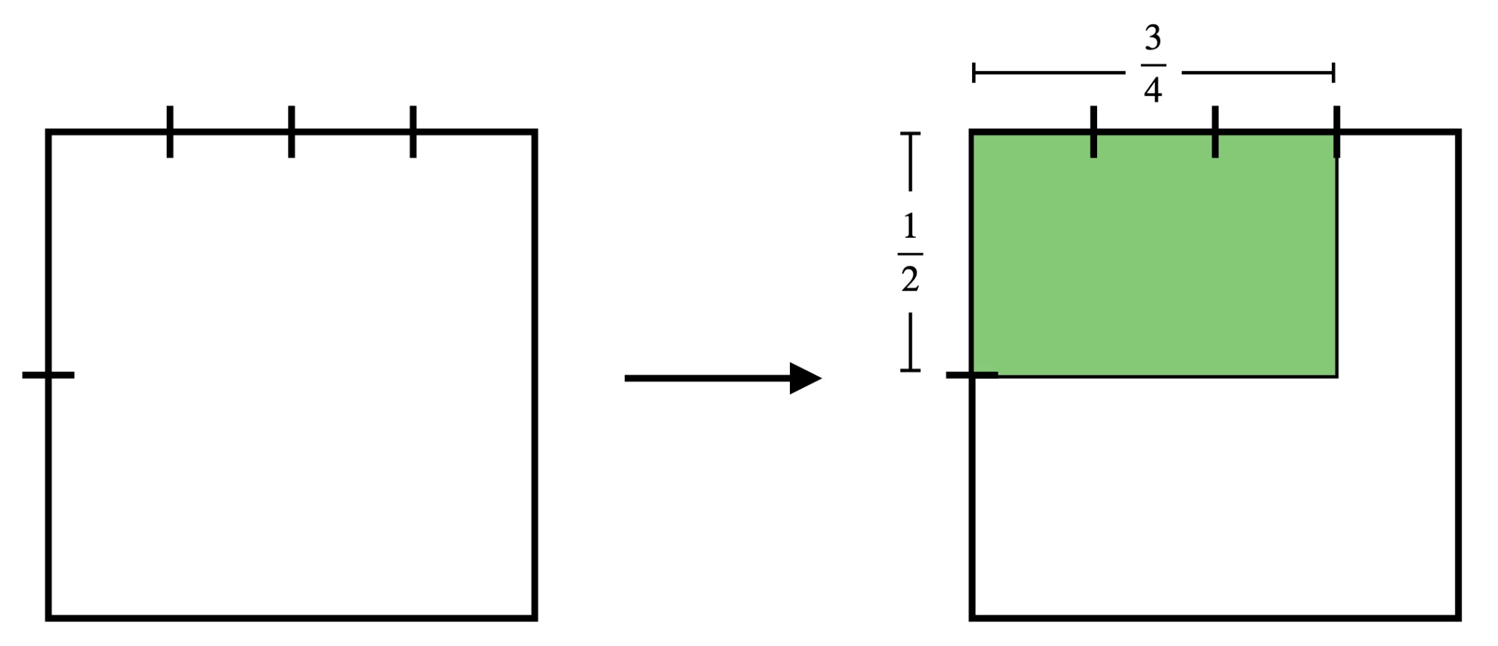
How could we determine the area of this rectangle with length 3/4 and width 1/2? To see it visually use the marks that we already made on the sides of the unit square and extend them as dotted lines into the square to create a grid.
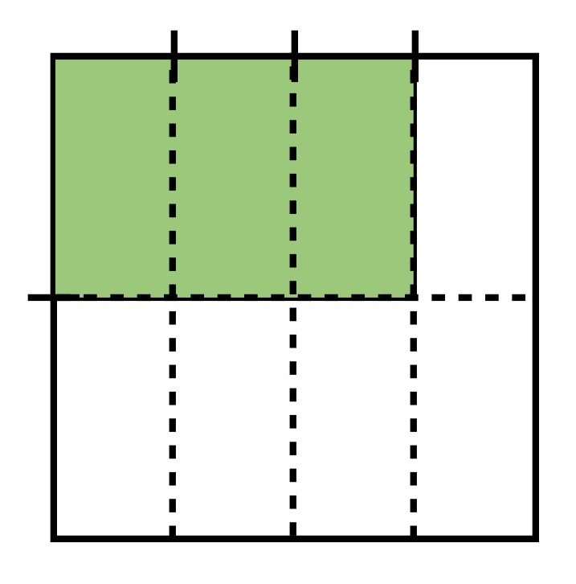
This process divides the unit square into 8 equal parts. Three of these parts form the rectangle in the top-left corner that we shaded. So, the area of the rectangle is the same as 3/8 of the area of the unit square. Since the area of the unit square is 1, the area of the rectangle is 3/8.

We can conclude (from this area model for multiplication) that the product 3/4 x 1/2 = 3/8. Do
we notice anything about the relationship between these numbers?

Now, introduce the Fraction Model Multiplers. Show the example 3/4 of 1/2, which gives the same picture you just created at the board. Use a doc cam or walk around the classroom so all students can see. The card and transparent overlay that show 3/4 of 1/2 look like this when stacked:
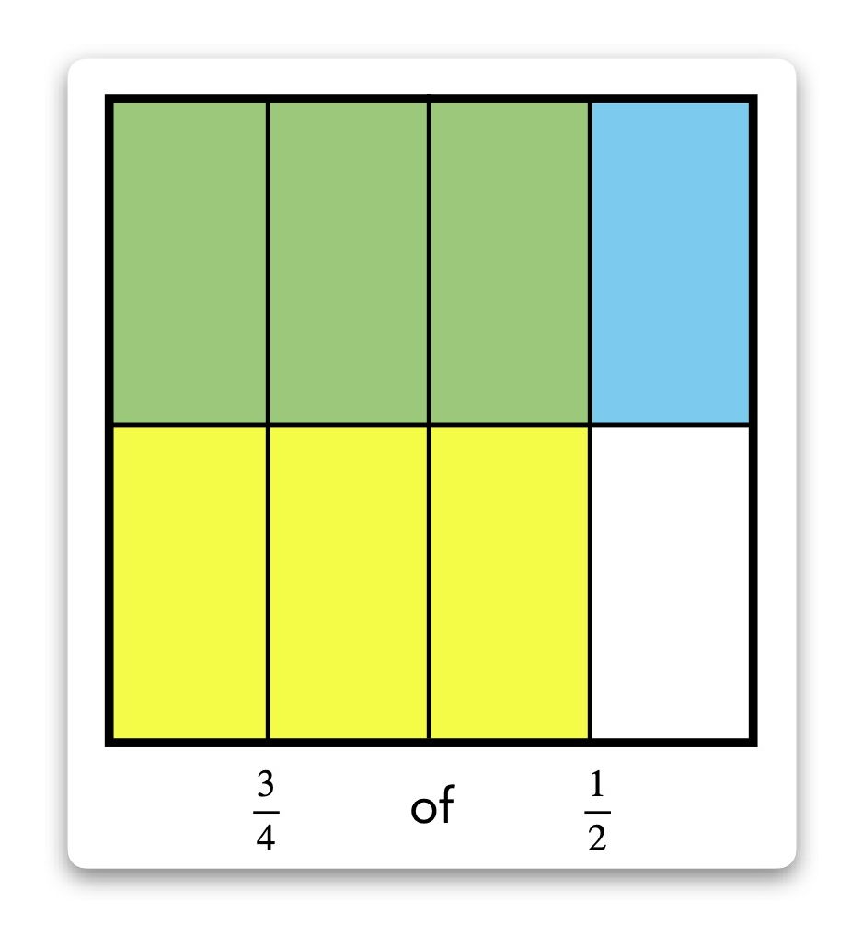
Notice that where the yellow and blue overlap to make green is the exact same rectangle we shaded on the board. What does the blue represent? What does the yellow represent? What does the green represent? Mention the terminology “3/4 of 1/2” and its equivalence to “3/4 times 1/2.” Demonstrate a few other examples with the Fraction Model Multipliers.

Separate the students into small groups of 3-4, and distribute the Fraction Model Multipliers cards and transparent overlays amongst the groups. Students experiment with them and write down as many statements as they can in a few minutes from the cards and overlays. After a few minutes, ask each group to say one or two of the statements they wrote down, and write these statements along with a sketch of the unit square visual on the board. Discuss the results. How do the numerators of the factor fractions relate to the visual model? How do the denominators of the factor fractions relate to the visual model? How do the factor fractions connect to the product? Do we notice any patterns? Do we see a numerical relationship?

Task the students to use the concepts of the Fraction Model Multipliers and the examples that have been done thus far to compute three examples of fraction products. These three examples are selected by the teacher and chosen to both avoid examples that are already written on the board and represent different scenarios that can arise. Examples could be 1/5 x 2/3, 1/10 x 1/2, and 5/6 x 3/4. These examples show a unit fraction times a non-unit fraction, a unit fraction times a unit fraction, and a non-unit fraction times a non-unit fraction. Students should draw the unit square area model for each product and write the numerical answer on paper. Groupmates compare answers and help each other. The teacher directly observes all students’ progress and provides verbal reinforcement.

As an example, let’s take 5/6 x 3/4. Students begin by drawing squares to represent a unit square (or they can instead use a unit square printout). Then one side of the square is marked to divide the side into 6 equal parts (for the first denominator). An adjacent side is marked to divide that side into 4 equal parts (for the second denominator). Using these markings, the square is turned into a rectangular grid, dividing the square into 24 equal parts. In the top left corner (for consistency with the Fraction Model Multipliers), shade a rectangle with length 5/6 and width 3/4, using the markings. Count the number of parts in this shaded rectangle – the number should be 15. So, 15 out of 24 total parts give a rectangle of dimensions 5/6 x 3/4. In other words, 5/6 x 3/4 = 15/24. The steps described could look like this:
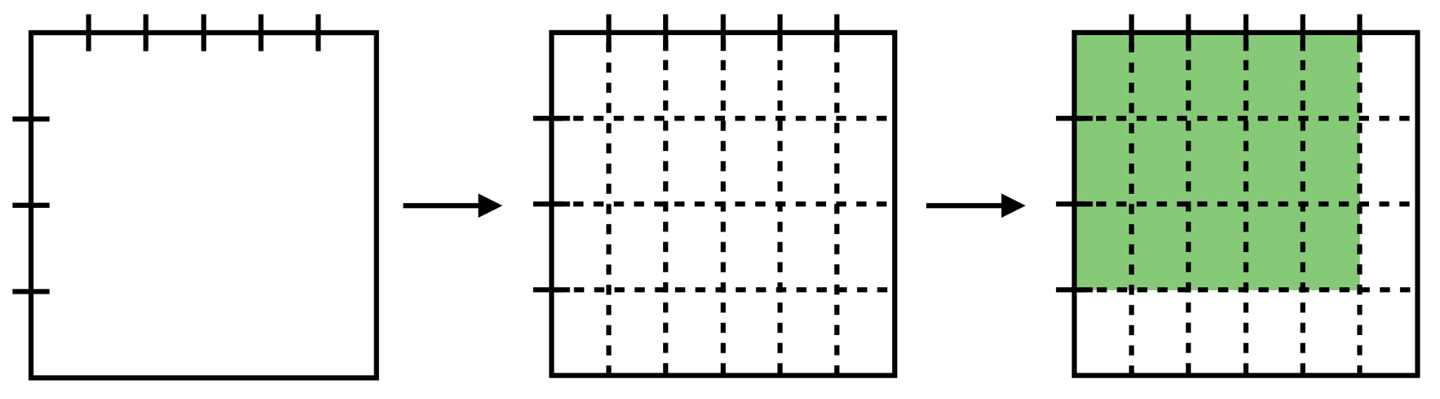
Or, equivalently, this:
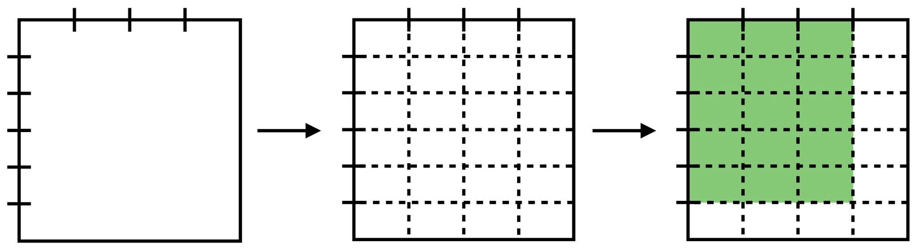
Students may also choose to color their squares to mimic the Fraction Model Multipliers, in which case their steps could look more like this:
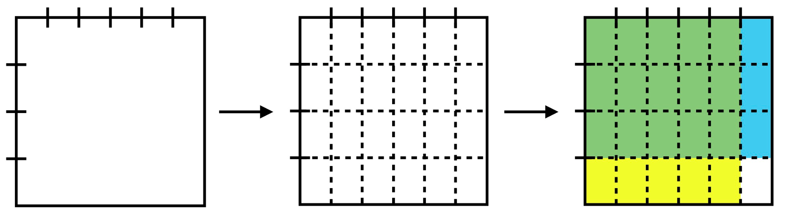
Or this:
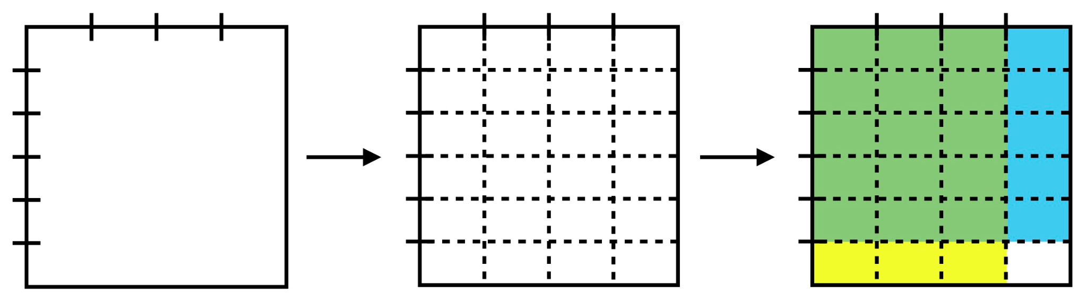

Note: These drawings can either be treated as rough sketches, where the students divide the sides of the unit square into approximately equal parts by “eyeballing it,” or they can use the ruler and be tasked with accurately measuring equal parts. If the students are tasked with accurately measuring, then a square with side length 12 cm is a good choice for unit square, as the mm markings on the ruler will align the markings for many different denominators, including 2, 3, 4, 5, 6, 8, 10, and 12. The unit square printout has a square with side length 12 cm.

Now the recipe cards and the Recipe Scaling Worksheets are distributed. A person who lives alone would like to make these recipes, but the amount of food that the recipes make is more than this person would like. This person would like for us to scale the recipes to suit their needs. For the salad dressing recipe, ask the students to multiply the amounts by 1/5 and record the visual models and results on their worksheets. For the fruit salad recipe, ask the students to multiply the amounts by 1/4 and record the visual models and results on their worksheets. And lastly, for the granola recipe, ask the students to convert the recipe by multiplying the amounts by 2/3 and record the models and results on the worksheets. Students take turns with the recipe cards within their groups and help each other as needed.

Motivating Students
_x_ Verbal Reinforcement: The teacher will monitor students’ work throughout the activity to provide reinforcement.
_x_ Relate to Real World: Some students are familiar with preparing food and using recipes and some students are familiar with the foods on these recipe cards; food preparation and scaling recipes are real-world problems.
Presenting Instructional Content
_x_ Hands-On: Students touch and interact with the Fraction Model Multipliers manipulatives.
_x_ Work Examples: Students work examples of proper fraction multiplication in a group setting.
_x_ Discussion: The whole group discusses the results and implications of the Fraction Model Multipliers.
_x_ Modeling: The students are modeling the real-world problem of scaling a recipe.
Instructional strategies:
Modeling and Guided Practice - The teacher models multiplication of proper fractions using the same unit square model that the students use for this lesson. The teacher models the Fraction Model Multipliers. The teacher will monitor students’ work and ask questions to prompt them if they are stuck.
Check for Understanding (CFU) –
What am I doing for students that progress at different rates?
Encourage partners to help each other. Students are given more time if they need it. Early finishers can be given the recipe cards for cookies and pizza dough to work on. These will extend the activity and challenge them, as the quantities for these recipes are not all proper fractions.
What do I do if they get it?
Discuss how to extend this concept to multiplication of a mixed fraction by a whole number. Introduce the recipe cards for cookies and pizza dough.

What do I do if they don’t get it?
Review the concepts of partitioning a line segment/square into equal parts to represent a fraction. Review the connection between area and multiplication. Limit the factor fractions to smaller denominators. Allow students to find the desired product by using the Fraction Model Multipliers directly, rather than drawing the model on paper.
QUESTIONING/THINKING/PROBLEM SOLVING (embedded throughout) | Balanced mix of question types. Utilizes Blooms Taxonomy/Webb’s Depth of Knowledge; high frequency; purposeful & coherent; require active responses; balance based on volunteers/non-volunteers, ability, & gender; lead to further inquiry & self-directed learning. Implement four types of thinking (Analytical, Practical, Creative, & Research-based) & Teach/Reinforce problem-solving types. Provide opportunities for students to generate ideas & alternatives; analyze, evaluate & explain information from multiple perspectives & viewpoints.
Questioning
Knowledge:
What is the equation for the area of a rectangle?
What is a unit square?
What does it mean to halve a recipe?

Comprehension:
What is the area of the unit square?
What is the area of a 2 x 4 rectangle?
How can you write the mixed fraction 1 ½ as an improper fraction?
Now that we have drawn the model, what fraction does it represent?

Application:
How do we partition a line segment into equal parts?
How can we use what we have learned to halve this recipe?
What is the product 3/4 x 1/2?

Analysis:
How could we determine the area of this rectangle with length 3/4 and width 1/2?
What do you notice when comparing/contrasting the resulting recipe to the original?
Can you tell that the new recipe will make less food? How?
Consider 3/4 x 1/2 = 3/8. Do we notice anything about the relationship between these numbers?

Synthesis:
Why is it important that we use a unit square?
How do the numerators of the factor fractions relate to the visual model?
How do the denominators of the factor fractions relate to the visual model?
How do the factor fractions connect to the product?

Evaluation:
Is it possible to extend this unit square/area method to include improper fractions? Justify your conclusion.

Thinking
_x_ Practical – It is useful to be able to change the yield of a recipe to suit the needs of a smaller group.
_x_ Creative – Students create their own visual fraction models; they can decide how to best divide their unit squares and how best to color the parts to express the product.
_x_ Analytical – Students compare/contrast their resulting recipes to the originals.
Problem Solving
__x__ Drawing conclusions/Justifying Solutions Students use unit square visual fraction models to justify their solutions.
__x__ Identifying Relevant/Irrelevant Information The recipe cards have information about the ingredients and the instructions for preparing the dish. Students must identify the quantities as the relevant information.
__x__ Generating Ideas Students are asked to notice patterns and generate ideas about the numerical relationships and operations at play in the equations that result from their area models.

GROUPING | Maximize student understanding & learning Varied group composition (race, gender, ability, & age); clearly understood roles, responsibilities & group work expectations; accountability for group & individual work; student opportunities for goal setting, reflection & evaluation of learning.
- Heterogeneous groups of 3 or 4
- Product. Students will complete the Recipe Scaling Worksheets

ASSESSMENT | Formative and/or summative assessment. A variety of assessments, including rubrics, measure achievement of objectives and informs instruction.
Assessments:
__x__ Teacher Made Test In a future assessment the teacher can ask the students to multiply proper fractions and draw the corresponding unit square/area fraction model.
__x__Teacher Observation The teacher will directly observe the students’ success with this group activity.
__x__ Solution to Real World Problem Completing the worksheet is solving a real-world problem of scaling a recipe.

*Students should achieve _____% mastery of this objective: ________________________________

CLOSURE | Reflection/Wrap Up. Summarizing, reminding, reflecting, restarting, connecting.
Today we we learned how to multiply fractions.
Let’s review our I Can statements: I can find the product of two proper fractions. I can find the area of a rectangle with fractional lengths. I can halve a recipe. Each of these tasks involves multiplying fractions.

Reflection: You must reflect on every lesson you teach.

NOTES:

This work is licensed under the Creative Commons Attribution-ShareAlike 4.0 International License. To view a copy of this license, visit http://creativecommons.org/licenses/by-sa/4.0/ or send a letter to Creative Commons, PO Box 1866, Mountain View, CA 94042, USA.

