How does a county spend its money?
This example demonstrates
- Using of real-world data to answer questions
- Creating and using pie charts
- Using data from one worksheet on a different worksheet in the same workbook.
This example uses data from Weakley, County Tennessee. The budget data comes from the county’s website http://www.weakleycountytn.gov/the-budget.html. The particular data used are from the 2017-2018 fiscal year at the following link, accessed on 5/15/2020: http://www.weakleycountytn.gov/uploads/1/0/7/5/107537459/resolution_2018-01.pdf

Weakley County
The Excel workbook titled “County Budget” contains four worksheets. The first, Weakley County, was used strictly for data entry. One has to type the budget categories and the amounts into Excel one cell at a time (software to convert .pdf documents to spreadsheets exists, but that is beyond the scope of this tutorial). Category names are in column A, amounts are in column B, and subtotals for broad categories are shown in column C. The category names and amounts in column B are entered from the .pdf document. The subtotals in column C are calculated in the spreadsheet. Accountants will wonder why the .pdf subtotal total and the Excel subtotal total for General County Operations differ by $1.

Category Totals
The worksheet titled “Category Totals,” summarizes the data from the “Weakley County” worksheet, showing only the category totals. Notice that column B is hidden. Hiding column B is not necessary, but doing so makes column C on this worksheet correspond to column C on the previous worksheet.
Select cell C1. The cell reference ='Weakley County'!C14 is to cell C14 on a different worksheet. Go back to the “Weakley County” worksheet. Select row 2, and insert a row so that the worksheet looks like this:
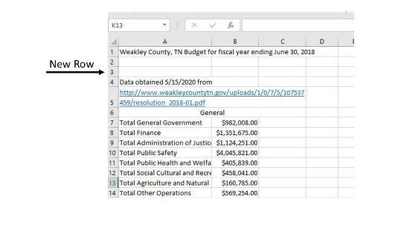.
Now return to the “Category Totals” worksheet and select cell C1. Notice that the reference is now to cell C15 on the other worksheet. The cell reference changed, but it still refers to the correct amount of money. Take a moment to type “refer to cell on another worksheet” in the help window, and select “Get Help on “refer to cell on another worksheet.”” In the help window, you should see Create an external reference (link) to a cell range in ... Take glance at the information there. The point is not to read it all now, but to remember that the help window is there.

There is also a pie chart on the “Category Totals” worksheet. The chart is a bit hard to read. There are at least three shades of blue, and categories with small budgets, such as “Tax Increment Financing” are listed in the legend but are invisible in the pie.

Sorter
Move to the “Sorter” worksheet. Cell C5 should contain the Schools budget of $31,665,439. Select the cell and look in the formula bar to see that the amount comes from cell C36 on the “Weakley County” worksheet. Now, select cells A1 through C11. (Left-click and hold in cell A1, then drag the cursor to cell C11 while continuing to hold the left mouse key). From the menu at the top of the page, select “Data.” Near the middle of the ribbon at the top of the page, select the word “Sort.” In the pop-up menu, Sort by Column C, Sort on Values, and Order Largest to Smallest. Click “OK.”
Notice that the list is sorted in descending order. Select cell C1. Notice that the schools budget moved on this worksheet, but the reference is still to the same cell on the “Weakley County” worksheet. We can manipulate the data however we want on this worksheet without damaging the original data. If we make a mistake here, it does not hurt the original data.

Organized
Move to the “Organized” worksheet. The data is sorted here much as it was on the “Sorter” worksheet. However, the smallest three categories have been combined as “Other.”
(If this were a class on pie charts, as opposed to a class on Excel, one would probably combine the smallest five categories, in this case anything under $1 million. A crowded pie chart is hard to read).
Select cell C9 to see how the categories were combined as a sum in one cell.
='Weakley County'!C19+'Weakley County'!C23+'Weakley County'!C70
There are two pie charts made from the data. Both are built from standard Excel templates. Notice how, with the sorted data, it is easier to read the chart and the legend together. “Schools” and “Cafeteria” are both shown in Shades of blue, but with the sorted list we know that “Schools” has to have the larger circular sector.
Select cells A1 through C9. In the menu at the top of the page, select “Insert” and then find the pie chart icon. Click on 2D pie. A pie chart should appear, and then additional menu items should appear. Try a few of these to change your pie chart. See which one you like best.

Conclusion
Does anyone remember the question? How does a county spend its money?
On schools.

This work is licensed under the Creative Commons Attribution-ShareAlike 4.0 International License. To view a copy of this license, visit http://creativecommons.org/licenses/by-sa/4.0/ or send a letter to Creative Commons, PO Box 1866, Mountain View, CA 94042, USA.

